|  |  |
| --- | --- |
| Assignment  Module 1: Basic Programming Concept | Abstract  In this assignment of module 1, There are 9 assignments from Day 2 to Day 10. Here I pasted the code and output screenshots for every problem statement and for snippet type questions I simply type the output with detailed explanation to support my output.  Sarang Deodhar  220350320026 |

**DAY – 2 (Assignment – 1)**

**Question 1.**

Write a C program to calculate volume of a box. A box can be represented by three quantities: length, width and height in inches. Volume can be calculated as:

volume = height * length * width

Take the input from user (using scanf) and print the volume as a result. Use float data types for all variables

**Code and Output :**

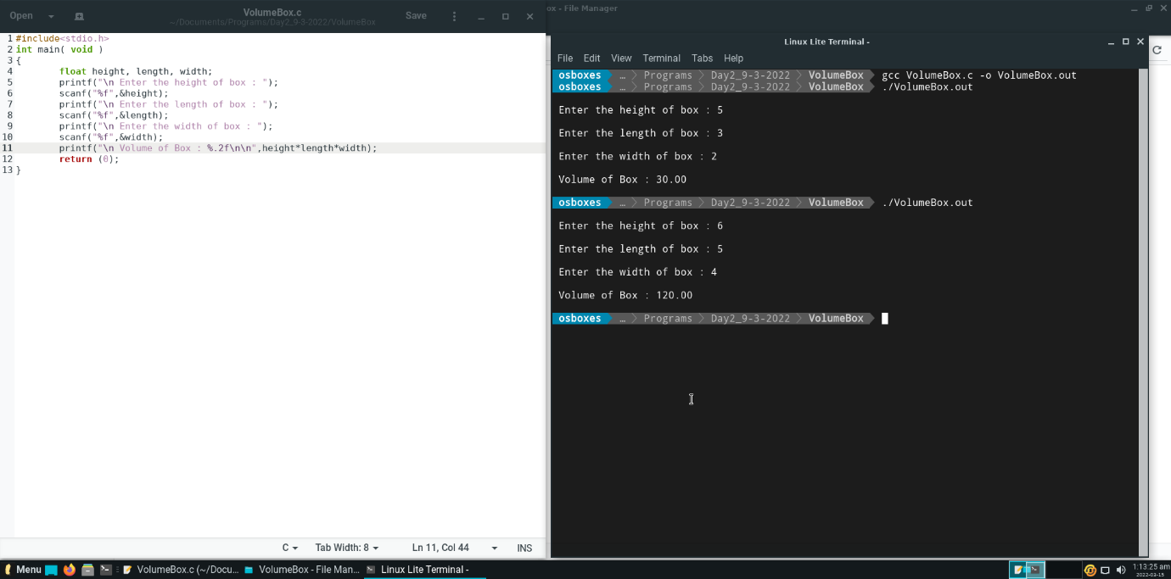

**Question 2.**

Write a program to calculate area and circumference of a circle using formula: 𝑎𝑟𝑒𝑎=𝜋𝑟2 and 𝑐𝑖𝑟𝑐𝑢𝑚𝑓𝑒𝑟𝑒𝑛𝑐𝑒=2𝜋r. Take the input r from the user.

Note: C doesn’t have an exponentiation operator, so that you will need to multiply x by itself repeatedly to compute powers of x. (For example, 𝑥∗𝑥 𝑖𝑠 𝑥2)

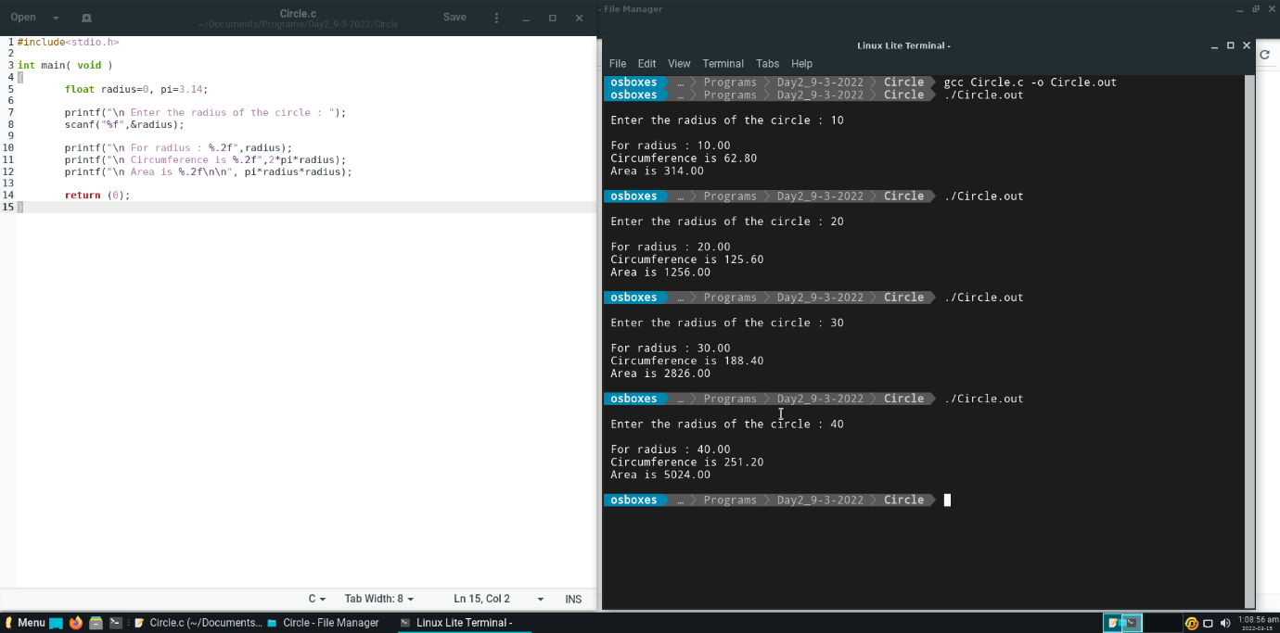**Code and Output :**

**­­­­Question 3.**

Write a program to calculate volume of a sphere with 10-meter radius, using the formula 𝑣=4/3𝜋𝑟3. Write the fraction 4/3 as 4.0f/3.0f (Also Try writing 4/3 and see what happens?). Use variable name for 𝜋 as PI and store value as 22.0f/7.0f. Modify same program and prompt the user to enter the radius.

**Code and Output :**

**3.1:**

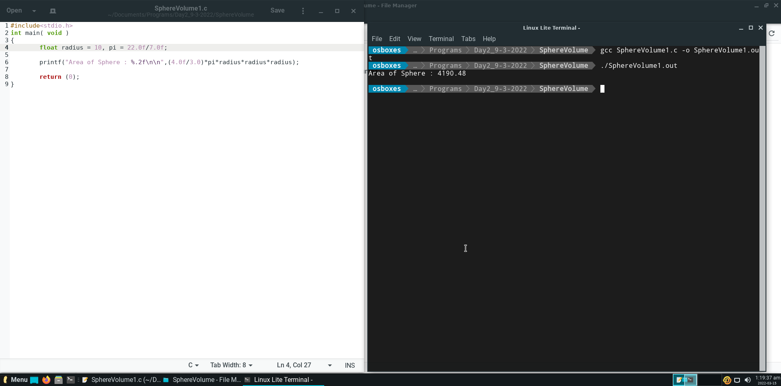

**3.2:**

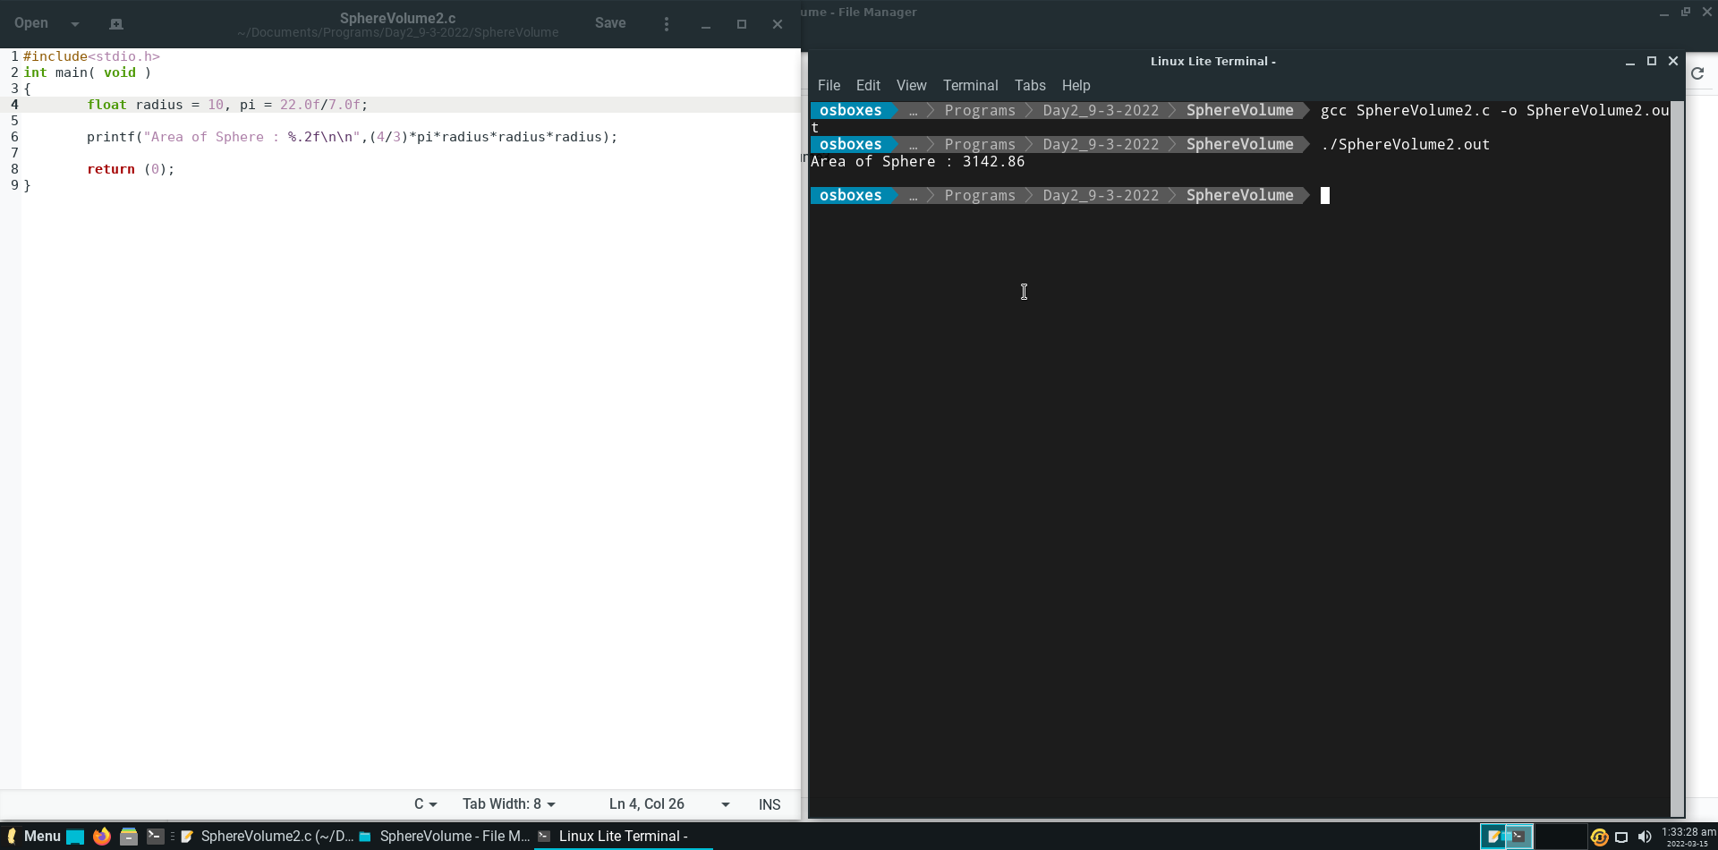

**3.3:**

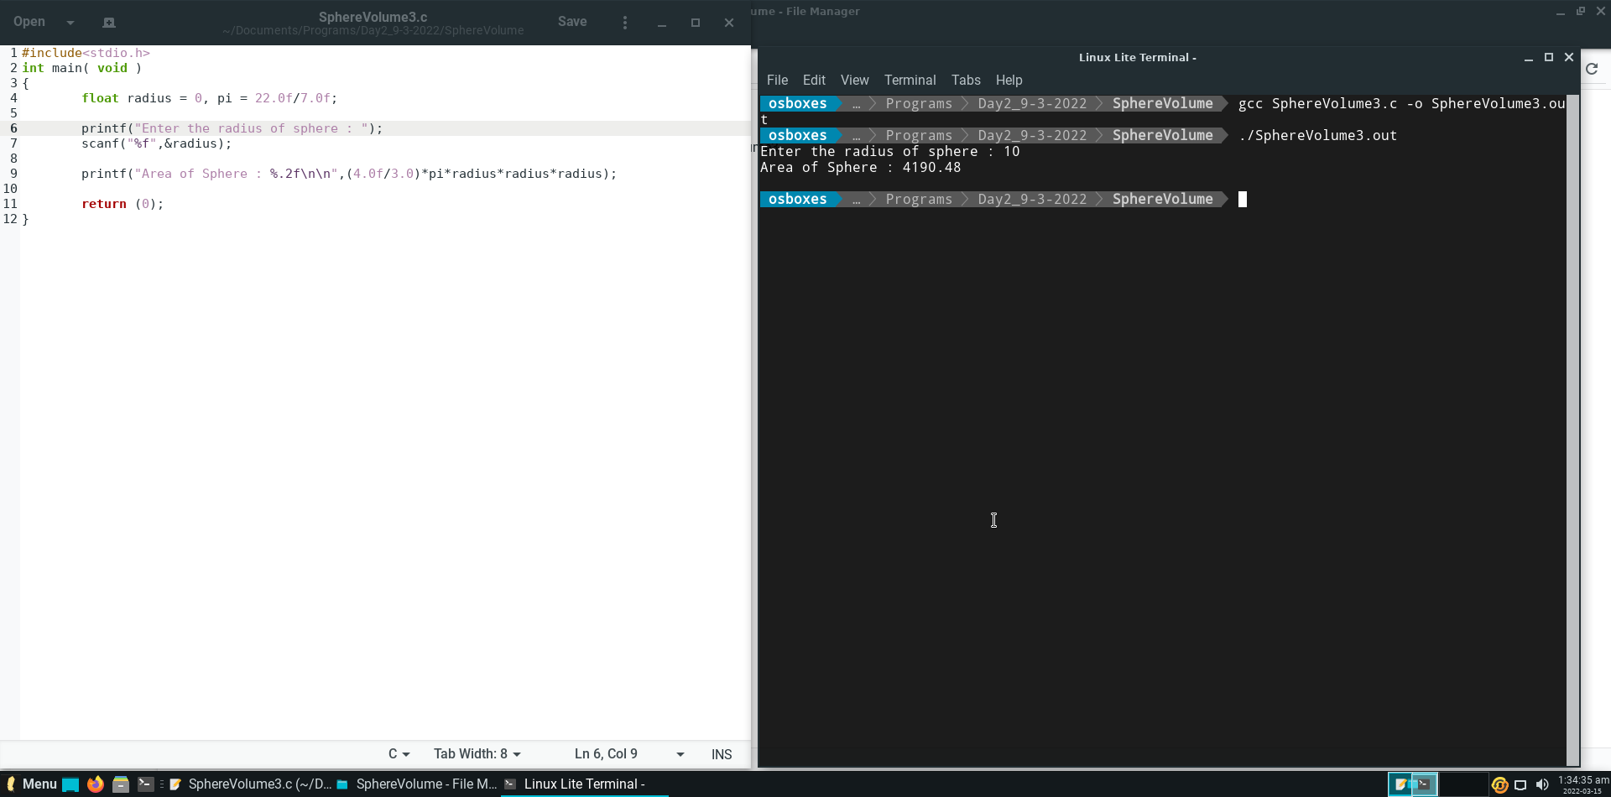

**Question 4.**

Write a program that asks the user to enter a value for x and then displays the value of the following polynomial: 6𝑥5+ 5𝑥4−4𝑥3+3𝑥2+2𝑥+1 .

**Code and Output :**

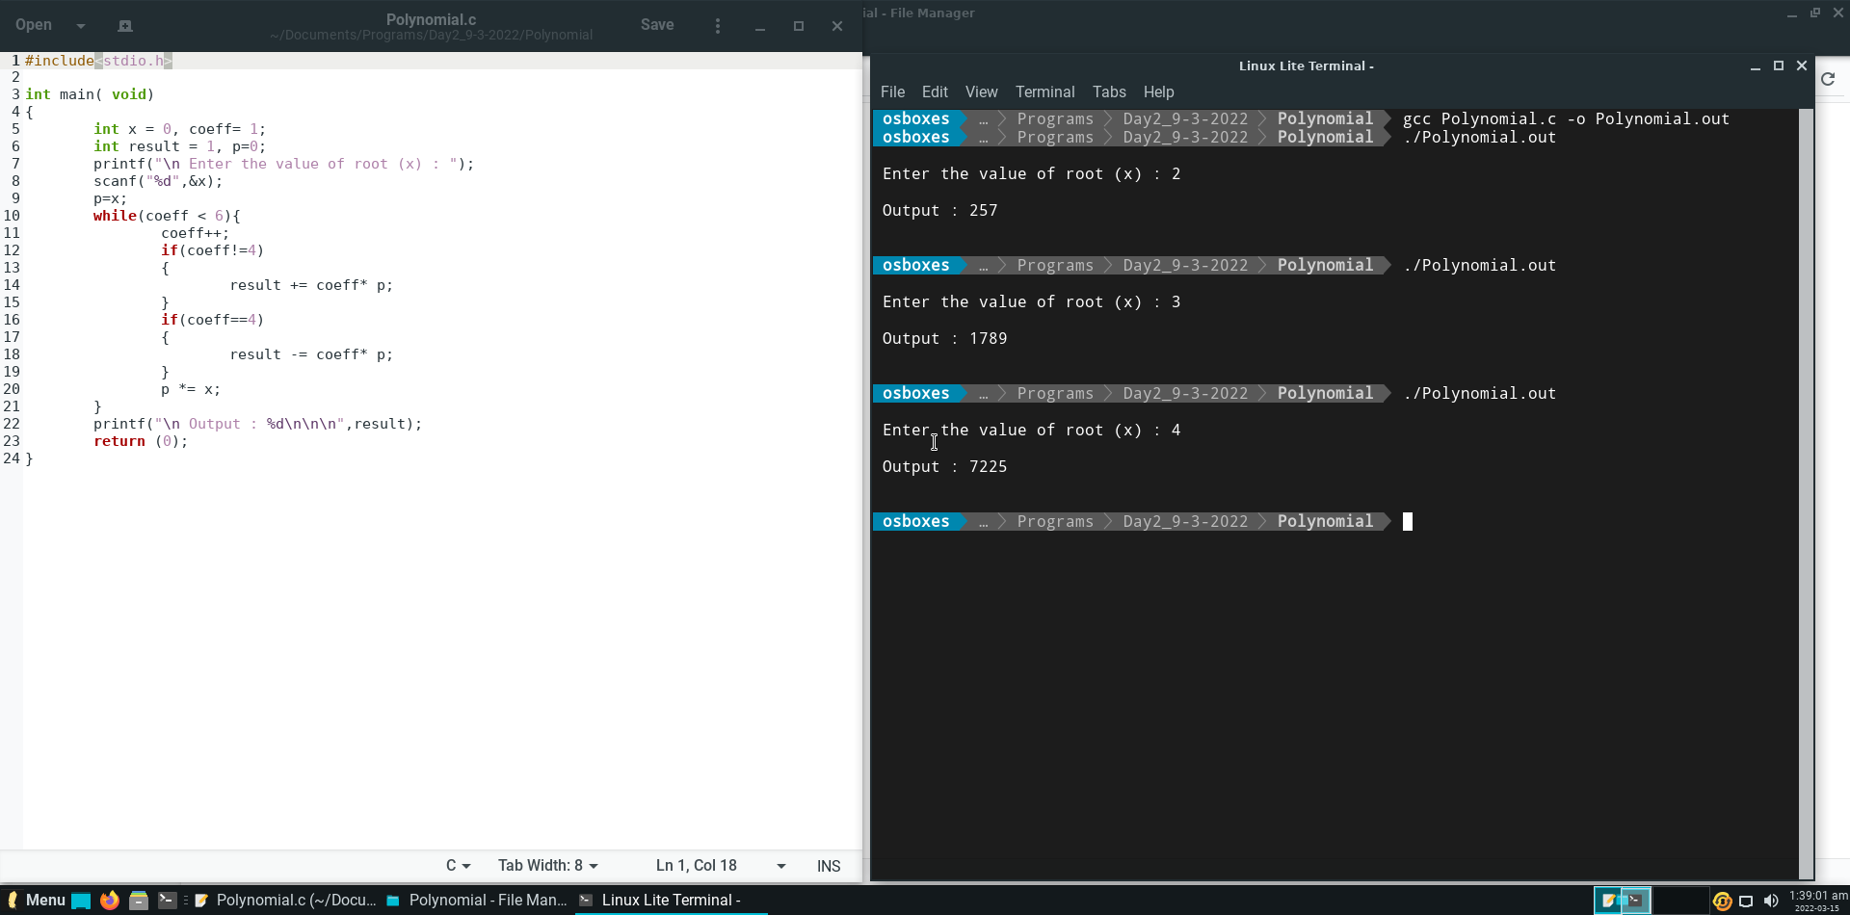

**Question 5.**

Write a program to calculate simple interest using formula: 𝑠𝑖=𝑝𝑟𝑖𝑛𝑐𝑖𝑝𝑙𝑒∗𝑟𝑎𝑡𝑒∗𝑡𝑖𝑚𝑒. Take all variable as float type.

**Code and Output :**

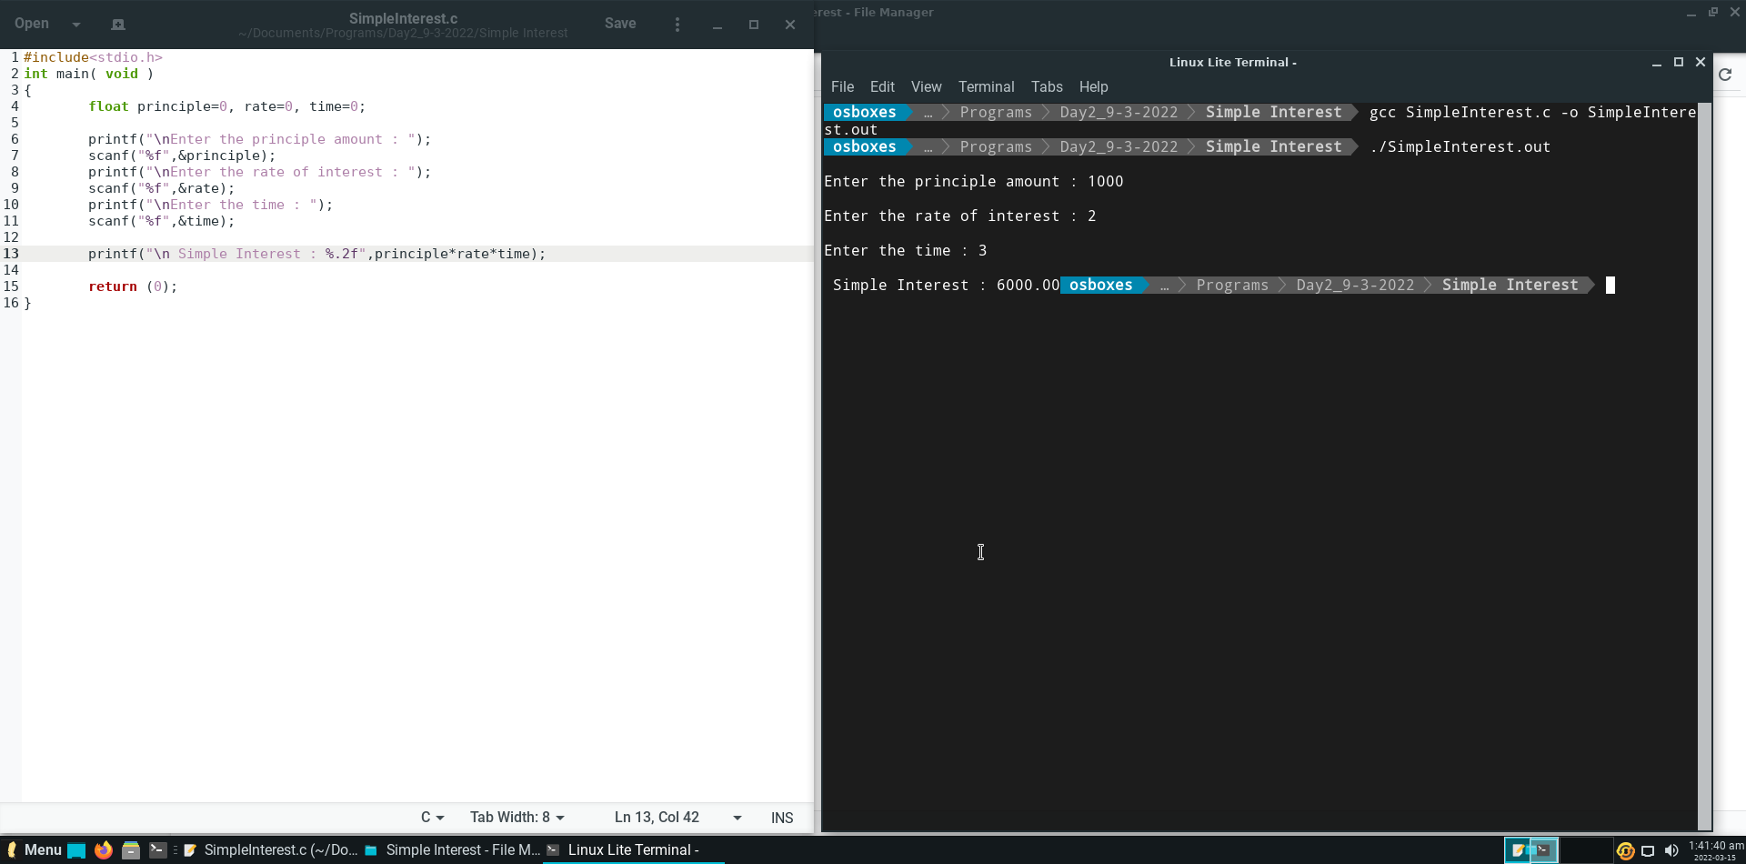

**DAY – 3 (Assignment – 2)**

**Question 1.**

Develop a C Program to perform operations (+,*,-,/ and %) on two whole numbers. Identify suitable data types of represent the numbers and resultant values.

**Code and Output :**

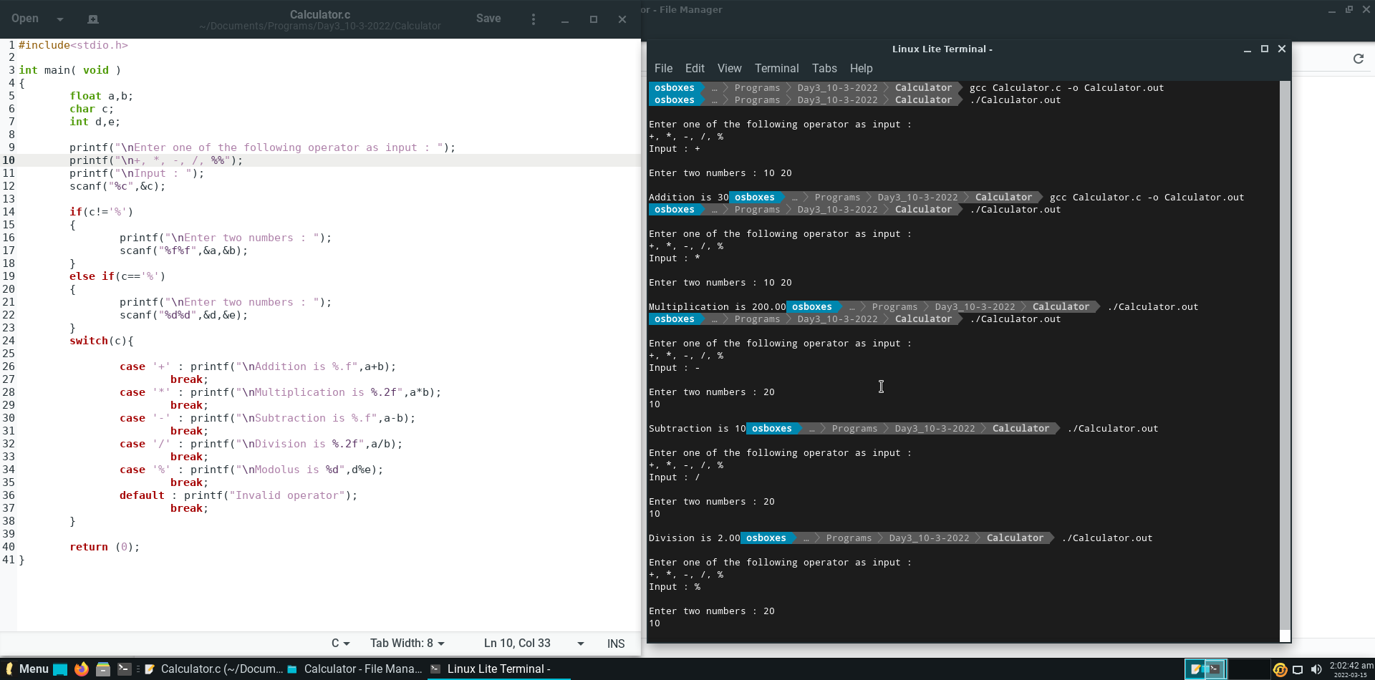

**Question 2.**

Write a program to demonstrate bitwise operators.

**Code and Output :**

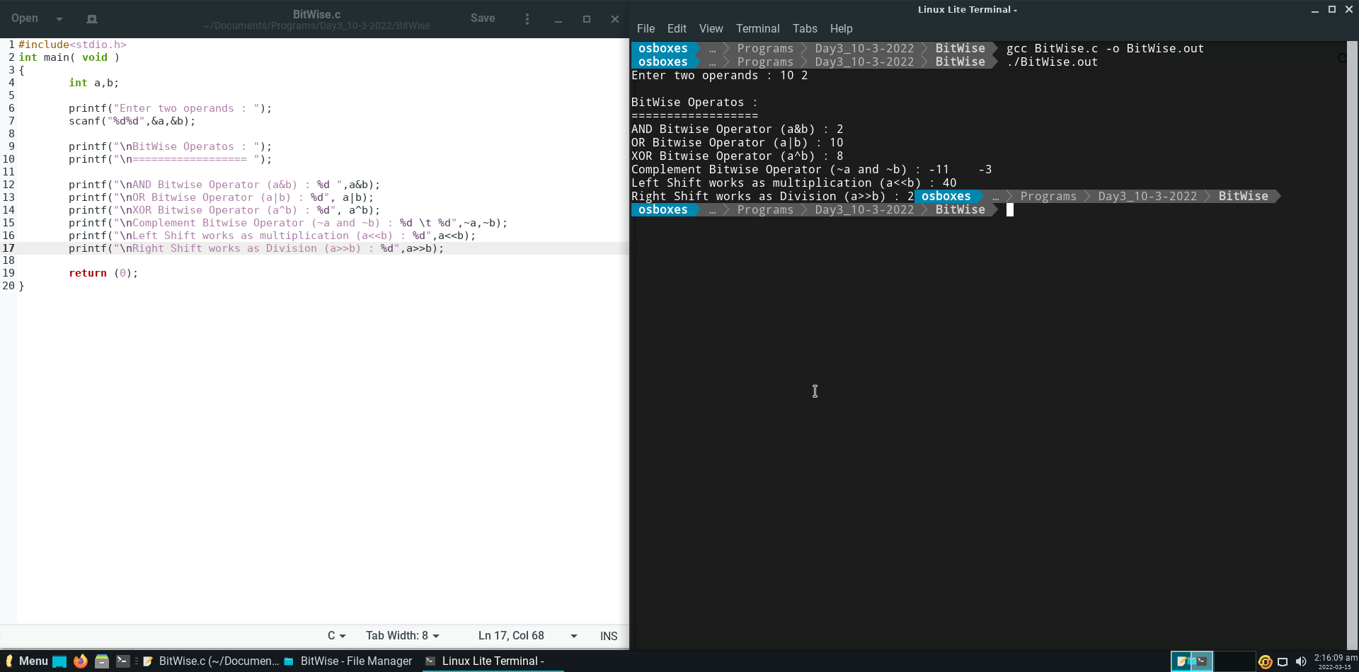

**Question 3.**

Develop a C program to add two operands and store the result in one of the operand using addition assignment operator.

**Code and Output :**

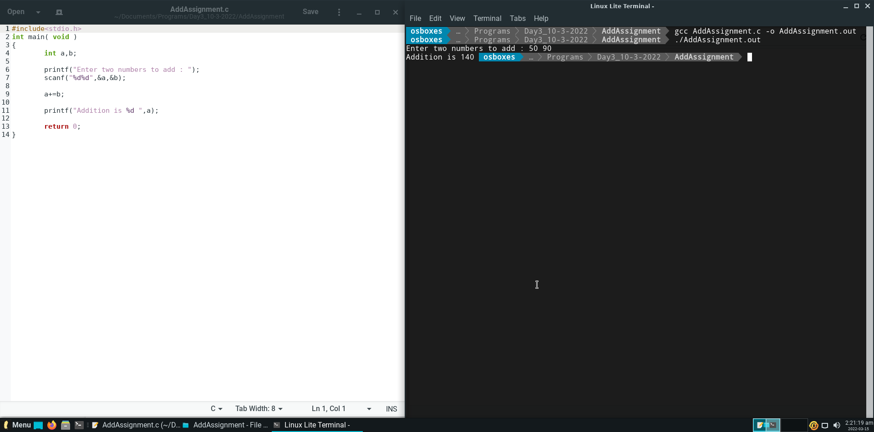

**Question 4.**

Write a C program to find the maximum of 2 numbers using Conditional operator.

**Code and Output :**

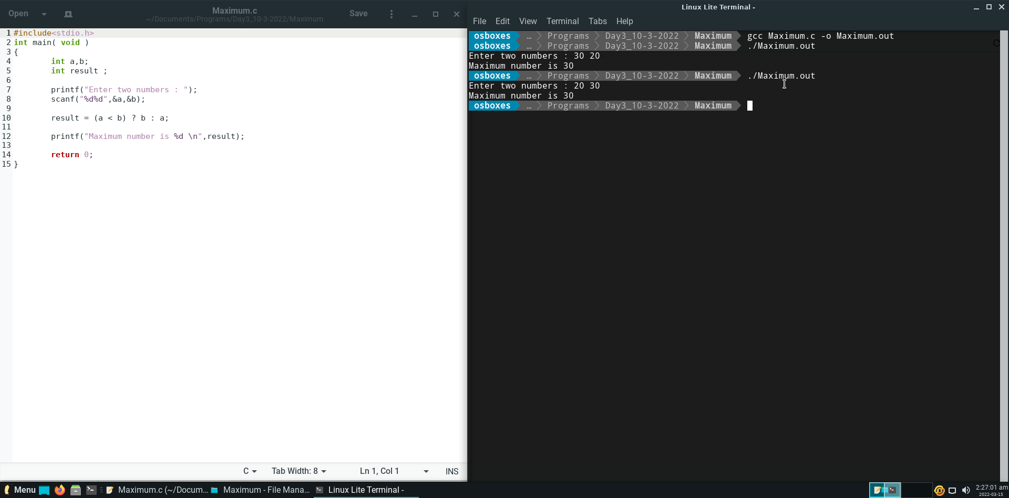

**DAY – 4 (Assignment – 3)**

**Question 1.**

Write a C program to check if a given Number is zero or Positive or Negative Using if...else statement.

**Code and Output :**

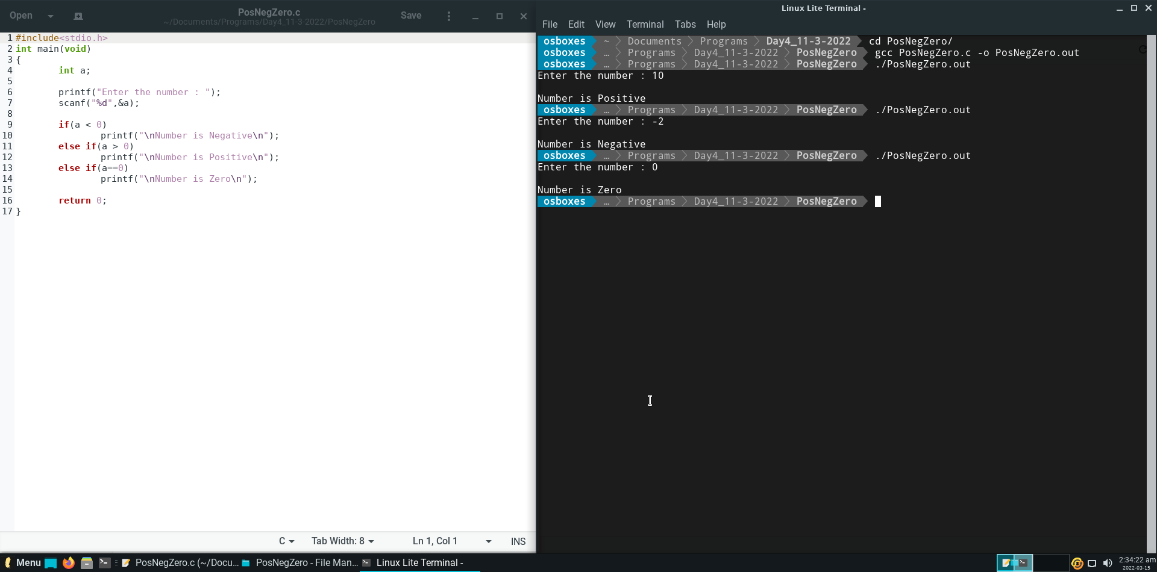

**Question 2.**

Write a C Program to find the Largest Integer among Three integers using if statement.

Note: To take input using single line Use scanf(“%d %d %d”, &num1, &num2, &num3).

**Code and Output :**

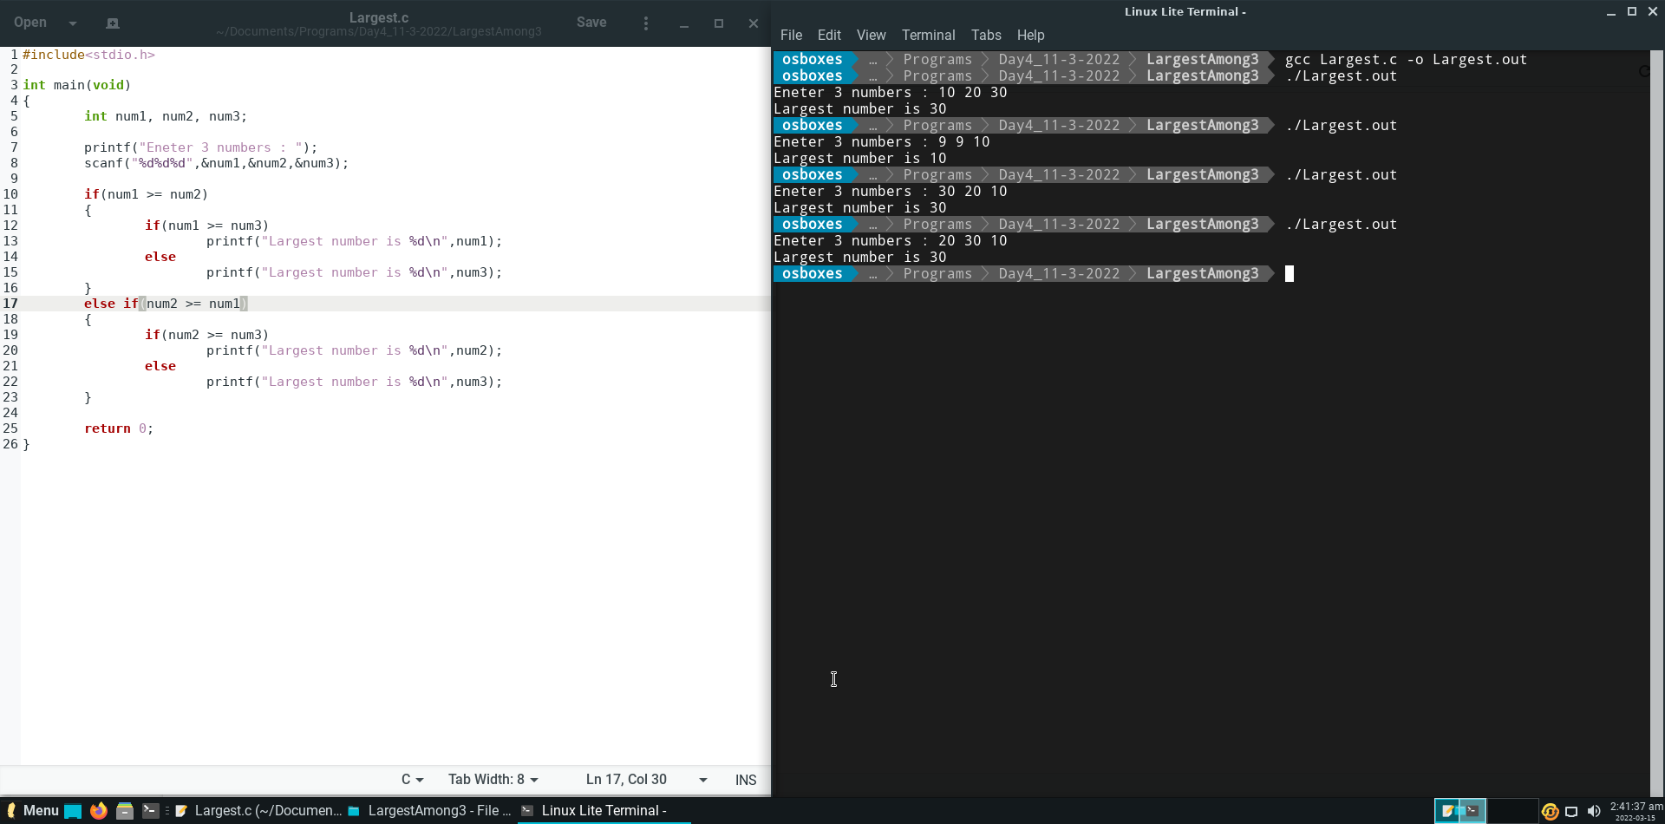

**Question 3.**

Write a C Program to find the Smallest Integer among Three integers using IF and Logical && operator.

**Code and Output :**

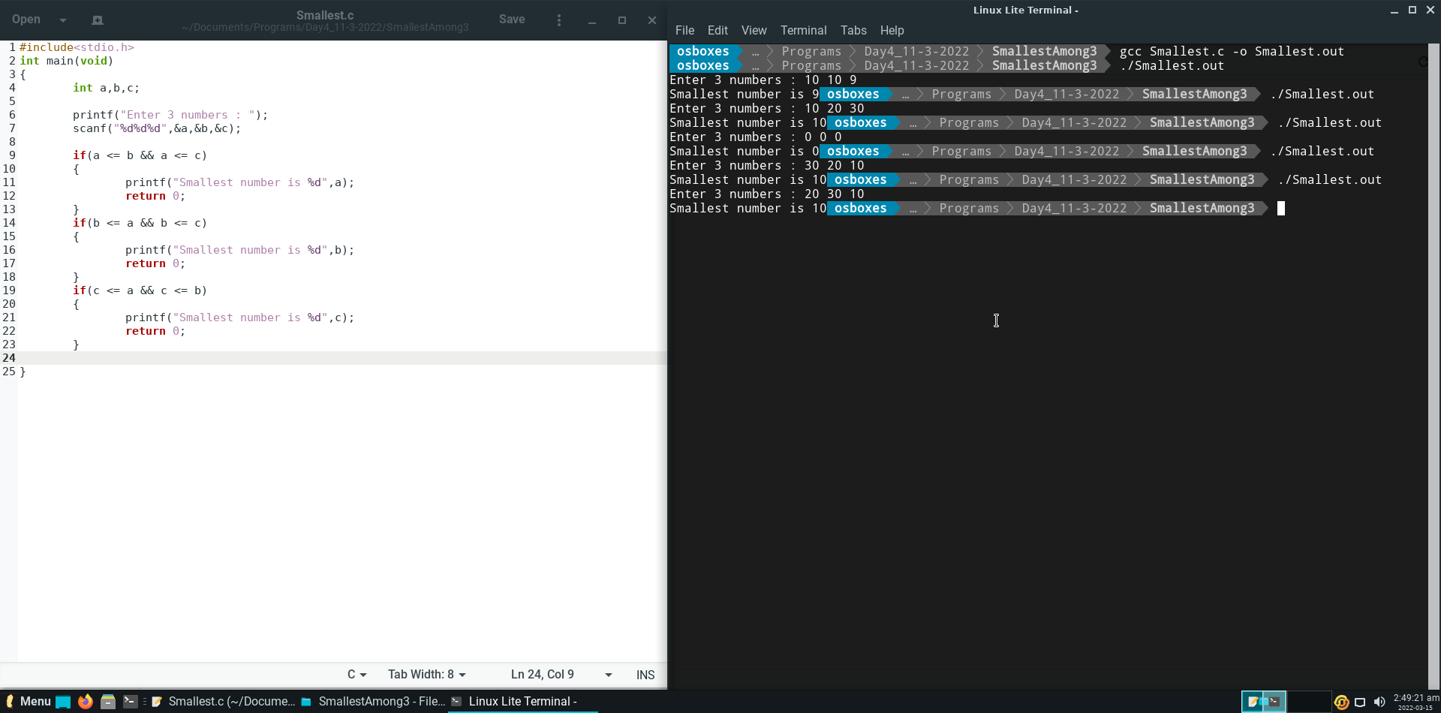

**Question 4.**

What is Output of following Programming?

**Output :**

CDAC 0

**Explaination :**

1) Assignment operator’s precedence is more than comma operator.

2) Assignment operator’s associativity is left to right and Comma operator’s associativity is right to left.

3) So, at first **zero** will assign in ‘i’ then comma operator returns the last value which is **3** and condition becomes **true**. So, it will print **CDAC** from true block and then it prints the value of i which is **0**.

**Question 5.**

What is the output of the following C code ?

**Output :**

38

**Explanation :**

a + a * -b / c % d + c * d is going to simplified and going to stored in result which is out final answer.

For above operators problem the precedence and associativity as :

Precedence Associativity

* Unary minus oprator right to left
* Muliplicatoin, division, modulus left to right
* Addition, subtraction left to right

**a = 12, b = 18, c = 7, d = 4**

a + a * -b / c % d + c * d => 12 + 12 * -18 / 7 % 4 + 7 * 4

12 – 216 / 7 % 4 + 7 * 4

12 – 30 % 4 + 7 * 4

12 – 2 + 7 * 4

12 – 2 + 28

10 + 28

**38**

**Question 6.**

What is the output of the following C code ?

**Output :**

11

**Explanation :**

As y = 10 and z = y + ( y == 10),

The precedence of ‘()’ parenthesis is largest,

So first (y==10) will execute is **true** so it will return **1**, then z will be,

Z = y + 1,

But y is 10 so **z = 11.**

**Question 7.**

What is the output of the following C code ?

**Output :**

5

**Explanation :**

We define h = 9 and the equation is b = 5 * 2 + 2 * 3 < h * 2 ? 5 : 3;

For above operators problem the precedence and associativity as :

Precedence Associativity

* Unary minus oprator right to left
* Muliplicatoin, division, modulus left to right
* Addition, subtraction left to right
* Ternary Conditional operator right to left

So the b = 5 * 2 + 2 * 3 < h * 2 ? 5 : 3 => b = 5 * 2 + 2 * 3 < h * 2 ? 5 : 3

b = 5 * 2 + 2 * 3 < 9 * 2 ? 5 : 3;

b = 10 + 2 * 3 < 9 * 2 ? 5 : 3;

b = 10 + 6 < 9 * 2 ? 5 : 3;

b = 10 + 6 < 18 ? 5 : 3;

b = 16 < 18 ? 5 : 3;

b = 1 ? 5 : 3;

**b = 5**

**Question 8.**

What is the output of the following C code ?

**Output :**

False

**Explanation :**

As post increament operator, first applies its value the increment.

So when **x = 0**, the condition will be false for -> if(x++)

The the value of x will be **1.**

So the condition will be true for -> if(x==1)

And print **False.**

**Question 9.**

What is the output of the following C code ?

**Output :**

False

**Explanation :**

The values are a=1, b=2, c=3;

So, for -> if(c>b>a)

if(3>2>1)

As relational operator associativity is left to right

So for **3 > 2** is **true** it returns **1** so the conditional will be if(1>1)

And it returns 0 which executes false section /second block.

Therefore, the output is **False**

**Question 10.**

What is the output of the following C code ?

**Output :**

Delhi

**Explanation :**

We declare a=1, b=-1 , c=0 , d; and equation is d = ++a && ++b || c--;

For above operators problem the precedence and associativity as :

Precedence Associativity

* PostFix incement/decrement left to right
* PreFix increment/decrement right to left
* Logical AND left to right
* Logical OR left to right

So the equation becomes => d = ++a && ++b || c—

d = ++1 && ++(-1) || 0—

d = ++1 && ++(-1) || 0—

d = 2 && ++(-1) || 0—

d = 2 && 0 || 0—

d = 0 || 0—

d = 0

and as operation on c is **post-decrement** at c=0, Therefore, now **c =-1**

so the first if condition => if(d) will be returns false and the second if condition will be check

and for the second condition => if(c) will be return always true so the true part will be print.

So the output will be **Delhi.**

**DAY – 5 (Assignment – 4)**

**Question 1.**

Write a C Program to Find the Smallest Number among Three Numbers (integer values) using Nested if-else statement.

**Output :**

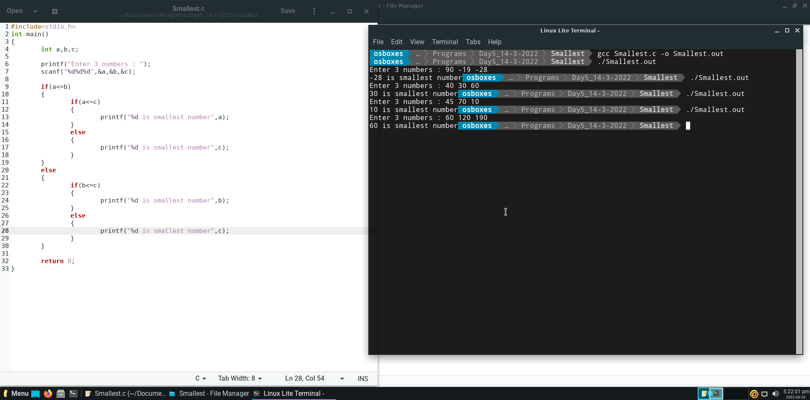

**Question 2.**

Write a program to find the factorial of a given number using while loop

5! = 5*4*3*2*1 6! = 6*5*4*3*2*1

0! = 1 1! = 1

-5! = 1 -10! = 1

**Output :** 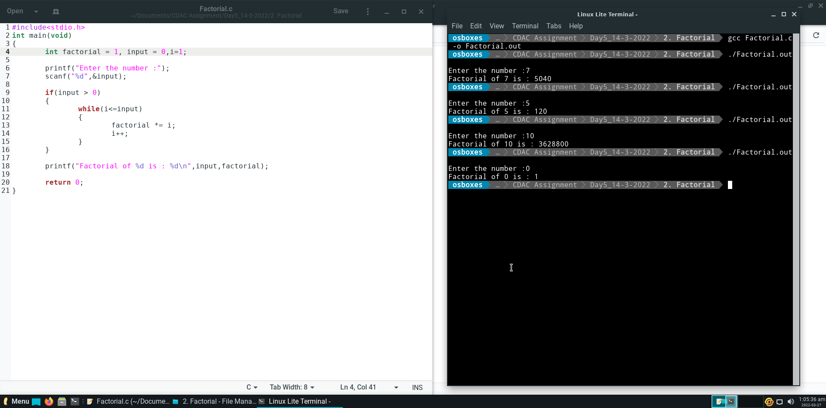

**Question 3.**

Write a C Program to find the Smallest Integer among Three integers using IF and Logical && operator.

**Output :**

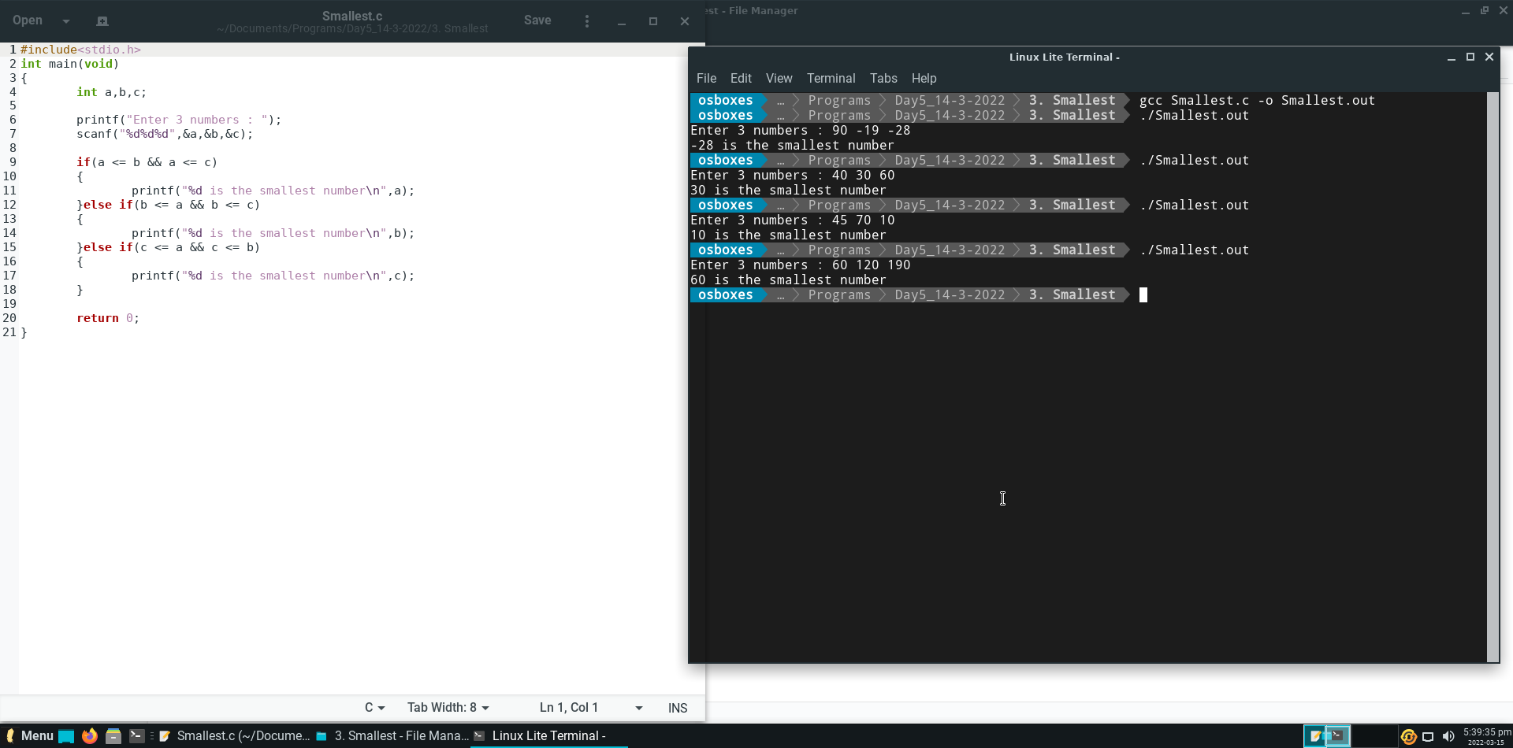

**Question 4.**

Write a C program to find power of a number using while loops. The base number (>0) and exponent (>=0) is taken from the test cases.

**Output :**

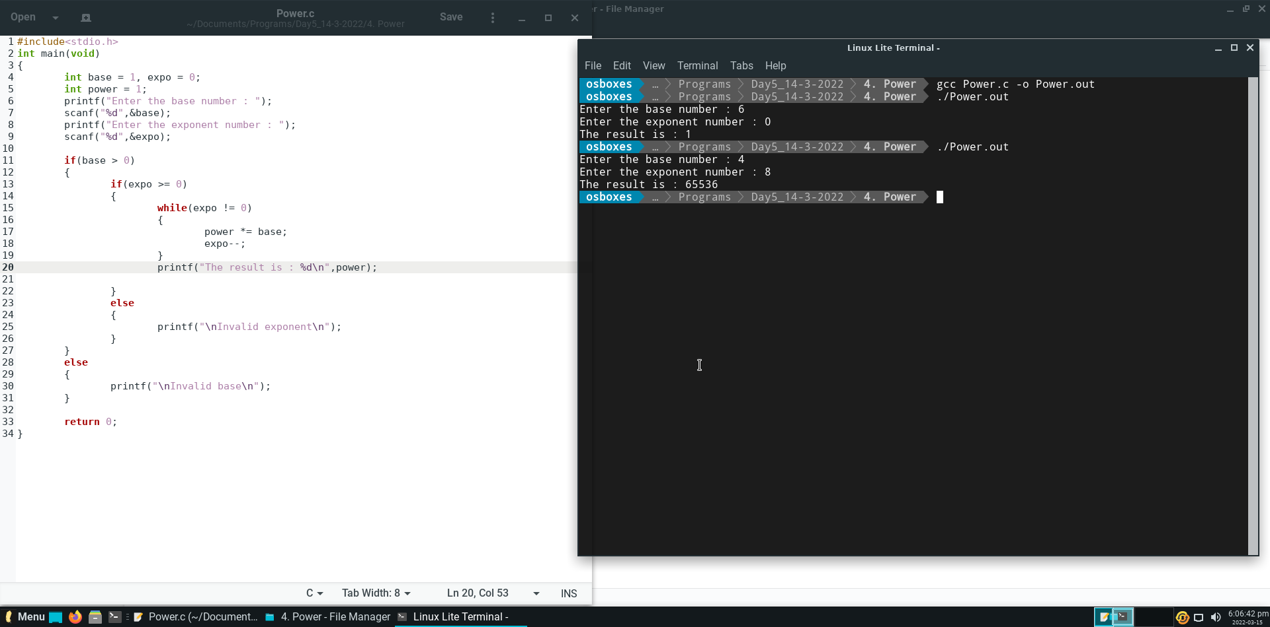

**Question 5.**

Write a C program to calculate the Sum of First and the Last Digit of a given Number. For example, if the number is 1234 the result is 1+4 = 5.

**Output :**

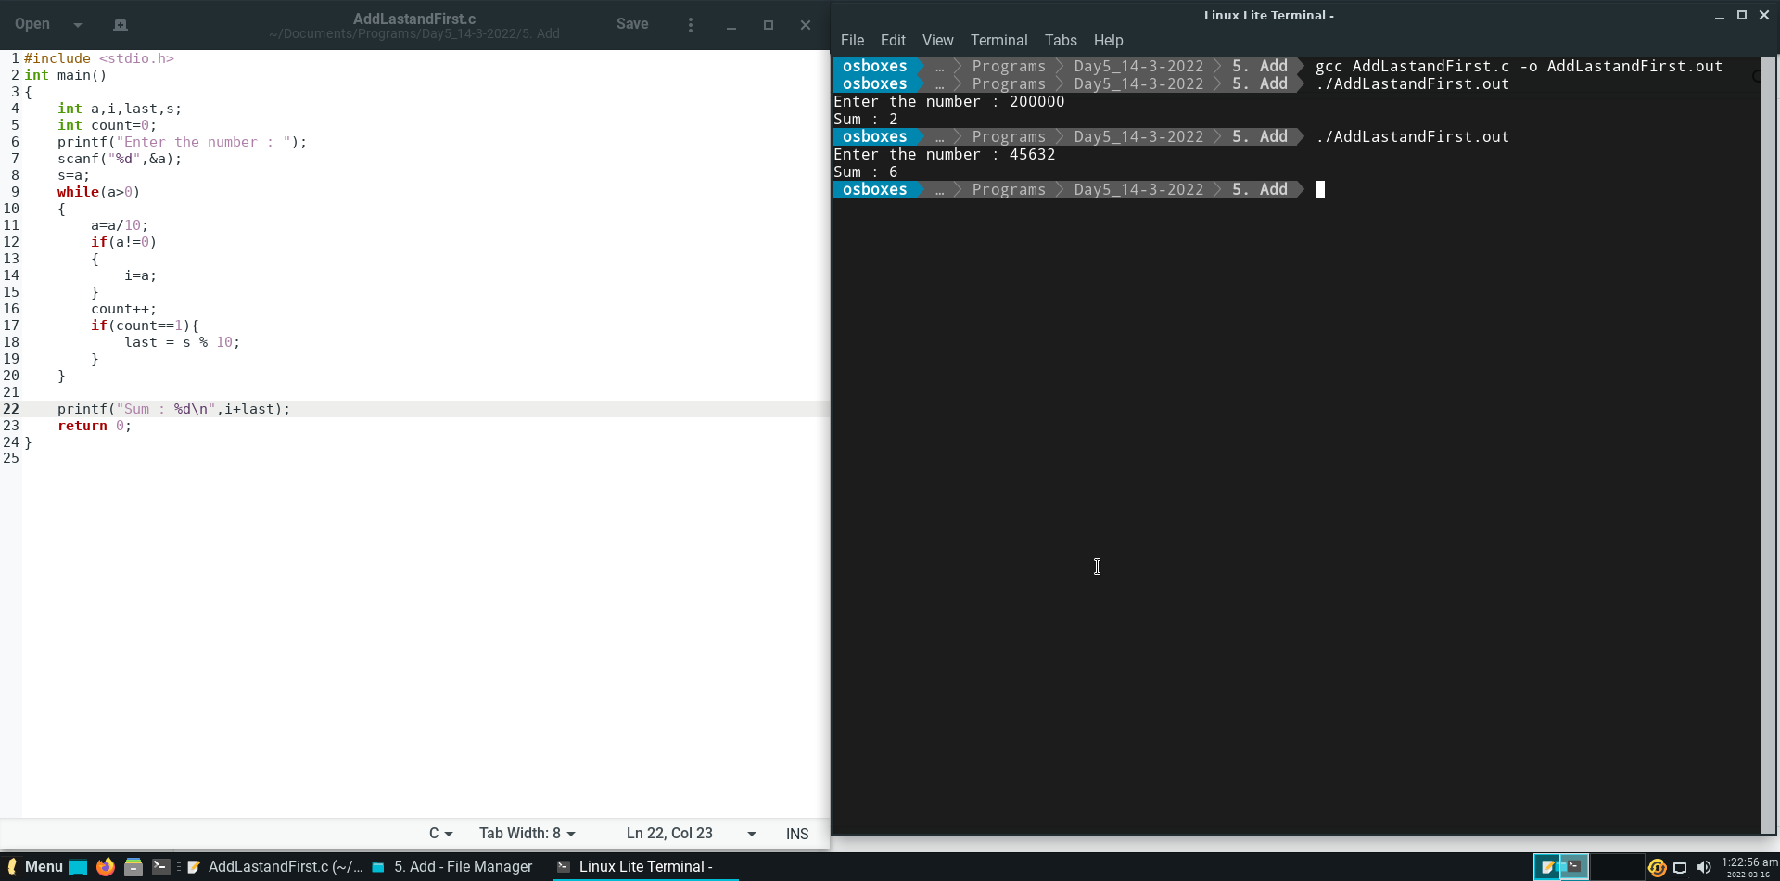

**Question 6.**

What is the purpose of the given program? N is the input number given by the user.

**Output :**

Enter an integer: 21

Output is = 12

**Explanation :**

In this given Snippet, User will input a number say 21 and store it in variable **n**.

Now the loop will begin till the **n** becomes **0**.

First line will store the unit place value of input number (n) into variable **y**.

Second line will store the value of y into x after increasing the **place** **value** of the current value of x by one step in every iteration.

The third line will divide the variable by 10 in order to maintain and end the loop.

That’s how at the end of the loop we get the **reversal of the input number.**

**Question 7.**

What is the output of the following C code ?

**Output :**

True

False

**Explanation :**

Initially the value of a is 1.

*postfix decrement operator first sets the value of the variable a then decreases the value.

So, here the value of **a** returns to the if condition which makes the condition true and prints **True** and the value of **a** decreases and become **0**.

prefix increment operator first increases the value of the variable **a** and becomes **1** then returns to if condition which makes the condition true and prints **False.**

**Question 8.**

What will be the output of the following code?

**Output :**

Compilation error.

**Explanation :**

Initially, the data type of si is declared as int but end there is statement :

**printf("%f",si);**

In this statement the format specifier is %f which is used for float.

This error can be rectified by **changing the data type of “si” from int to float.**

Then the output will be **1500.000000**.

**Question 9.**

What the following program will print?

**Output :**

a=65

**Explanation :**

Whenever we put **0** during initializing a number then that number will be considered as octal number.

In this question value of a is 0101 which is 101 in octal which implies 65 in decimal

That’s why output is a=65.

**Question 10.**

Choose the correct output of the following C code.

**Output :**

5 7

**Explanation :**

At first var1=10 and var2=6.

In first condition, var1 assign as 5 and 5 is returned to the condition which makes the condition **true.**

So the true blocks executes and the value of var2 is increases using postfix increment operator. Which results in var2 = 7 during the printing of values of var1 and var2.

That’s why the output becomes 5 7.

**Question 11.**

What will be the output (&& is logical AND operation)

**Output:**

0

1 1

**Explanation :**

Whenever we use && operator it checks the value of first operand if it is non-zero value then only it will check next value, but in this case the value of first operand is zero, so the result of (i++ && ++j) this statement is 0.

Here first operand is evaluated so the value of I is incremented and becomes 1 but as the second value was not executed the value of j remains same (j=1).

That’s why at the last print statement the value of I is 1 and j is 1.

**Question 12.**

Write a C program to count total number of digits of an Integer number (n).

**Output :**

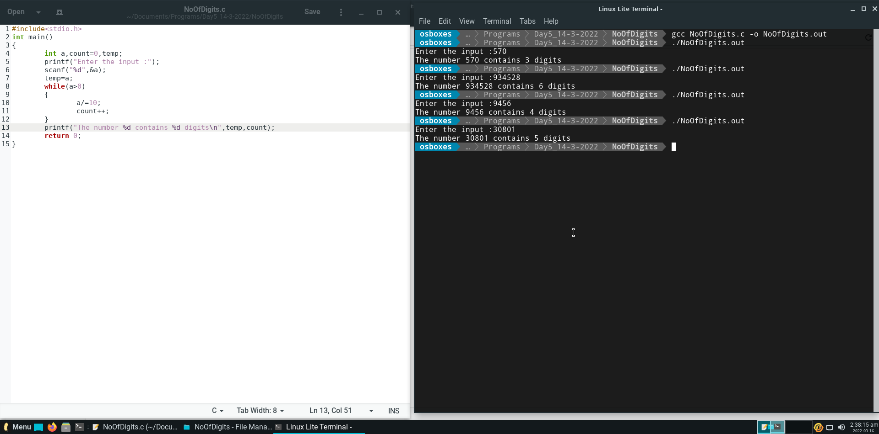

**Question 13.**

Write a C program to check whether the given number (n) can be expressed as power of two(2) or not. For example 8 can be expressed as 2^3.

**Output :**

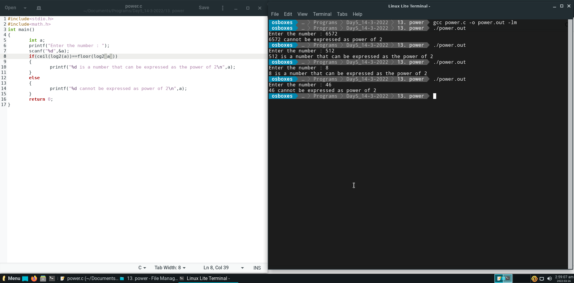

**Question 14.**

Write a C program to find sum of following series where the value of n is taken as input:

1+ 1/2 + 1/3 + 1/4 + 1/5 + .. 1/n

**Output :**

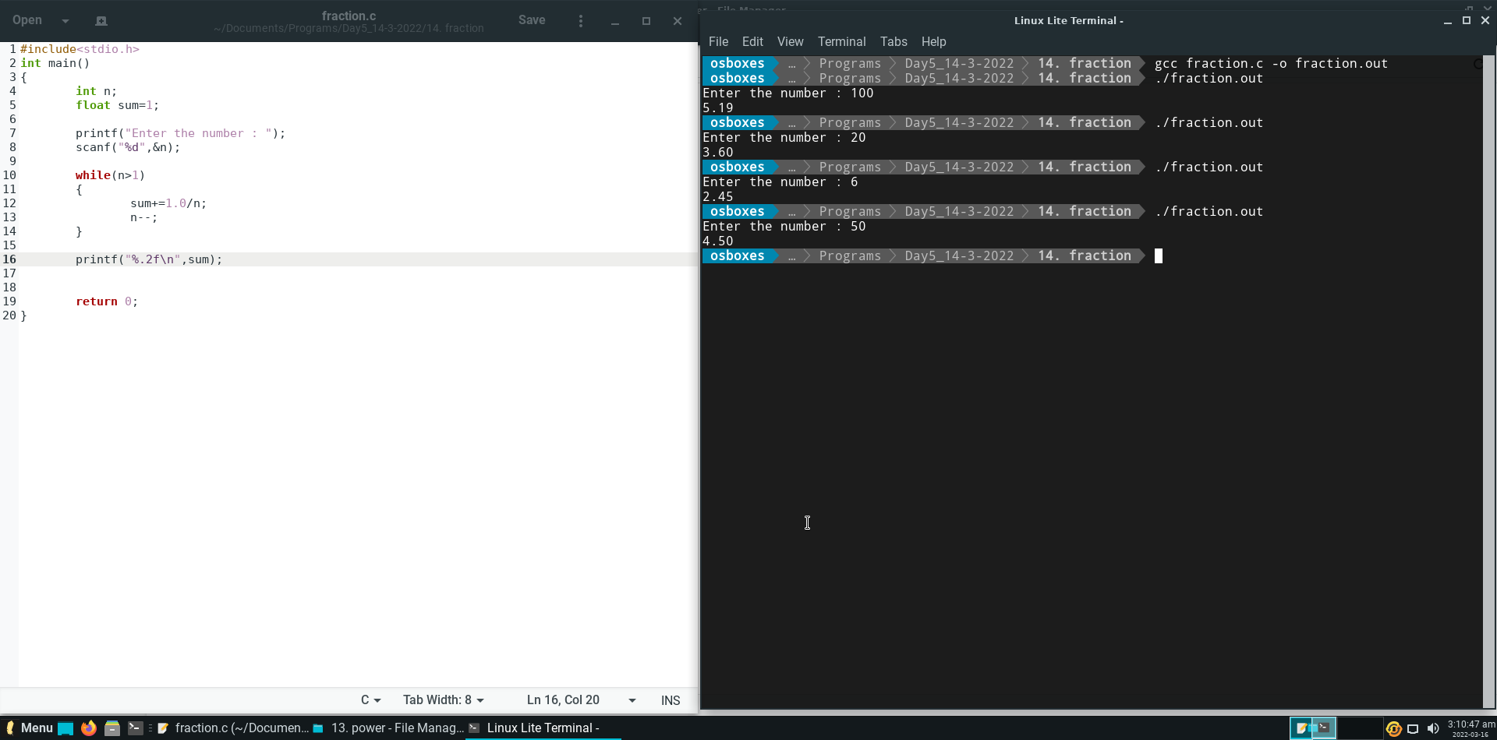

**Question 15.**

Write a C program to print the following Pyramid pattern upto Nth row. Where N (number of rows to be printed) is taken as input.

**Output :**

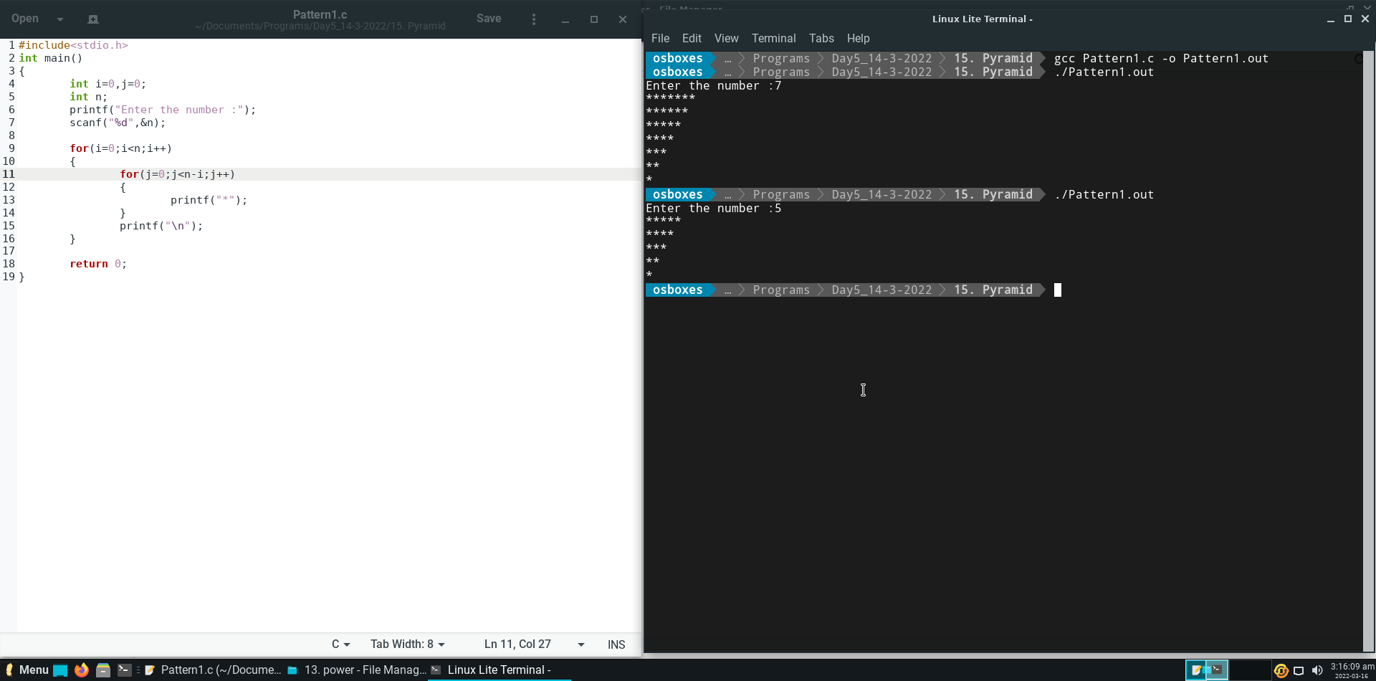

**Question 16.**

Write a C program to check whether a given number (n) is a perfect number or not?

(Perfect Number - A perfect number is a positive integer number which is equals to the sum of its proper positive divisors. For example 6 is a perfect number because its proper divisors are 1, 2, 3 and it’s sum is equals to 6.)

**Output :**

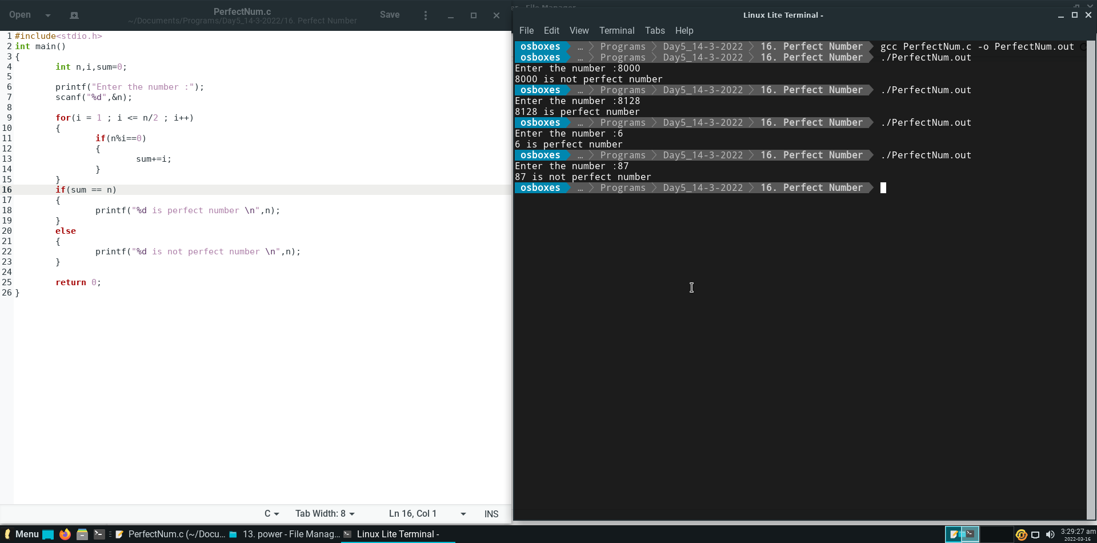

**Question 17.**

Write a program to find the GCD (Greatest Common Divisor) of 2 (two) numbers using 'for' loop. The two numbers are taken as input from the test cases.

**Output :**

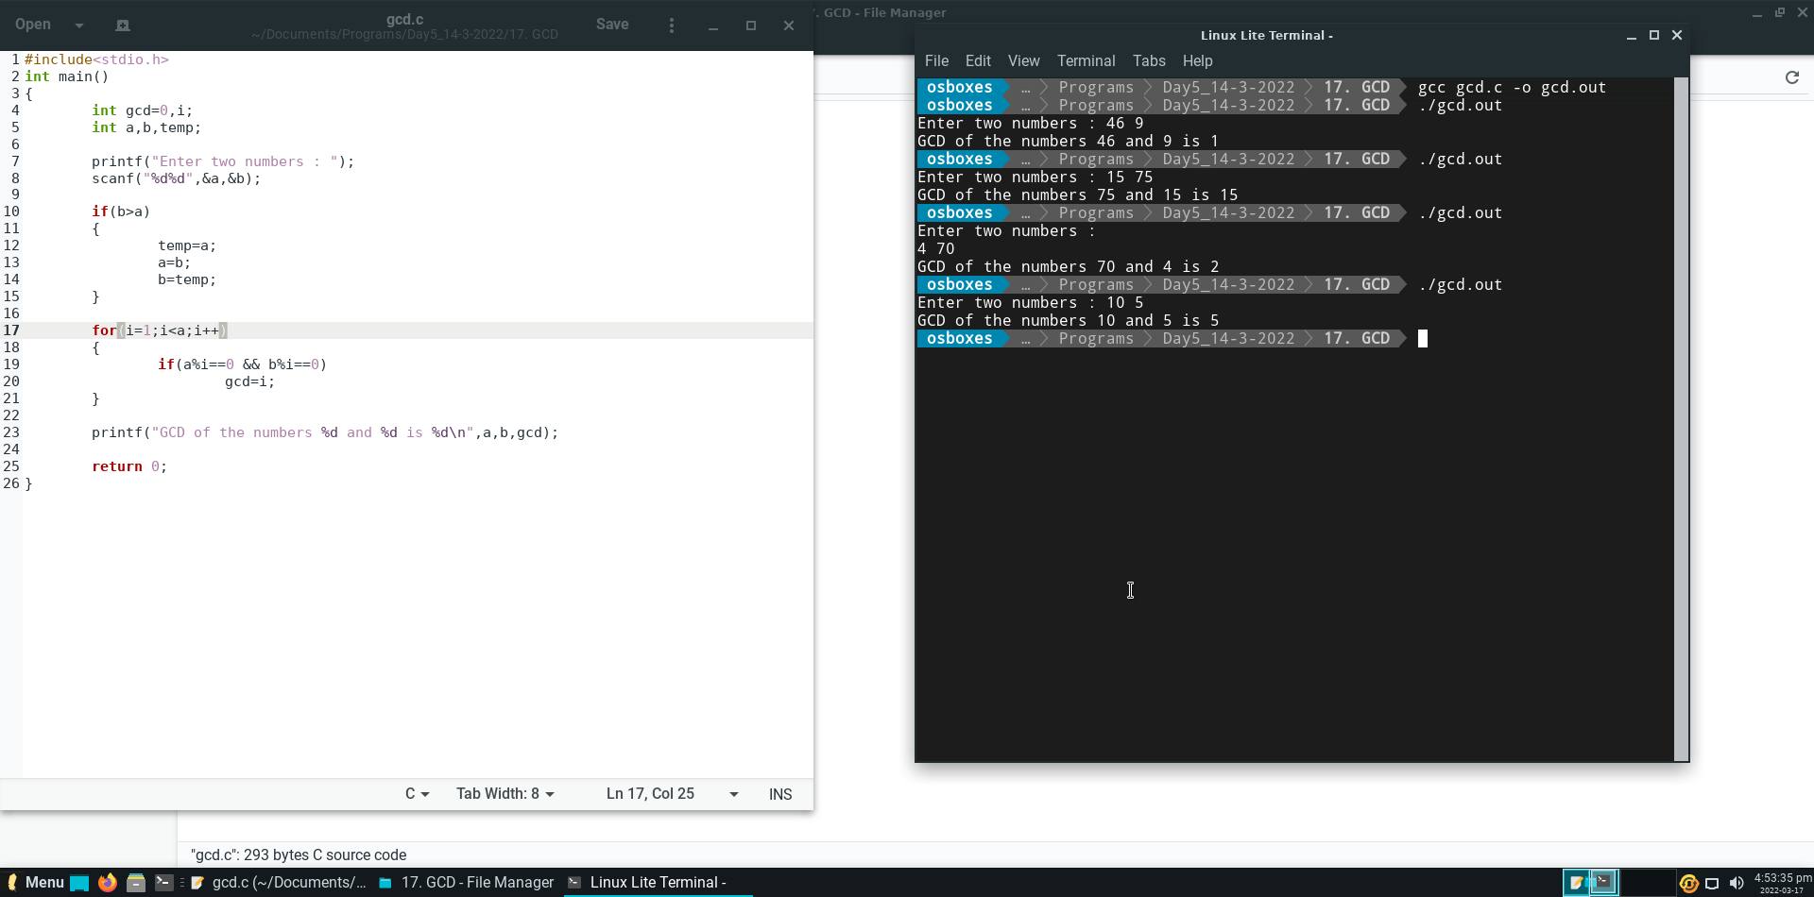

**DAY – 6 (Assignment – 5)**

**Question 1.**

Write a Program to find if a given number is Armstrong number.

Armstrong number has property:

153 = 13 + 53 + 33

**Output :**

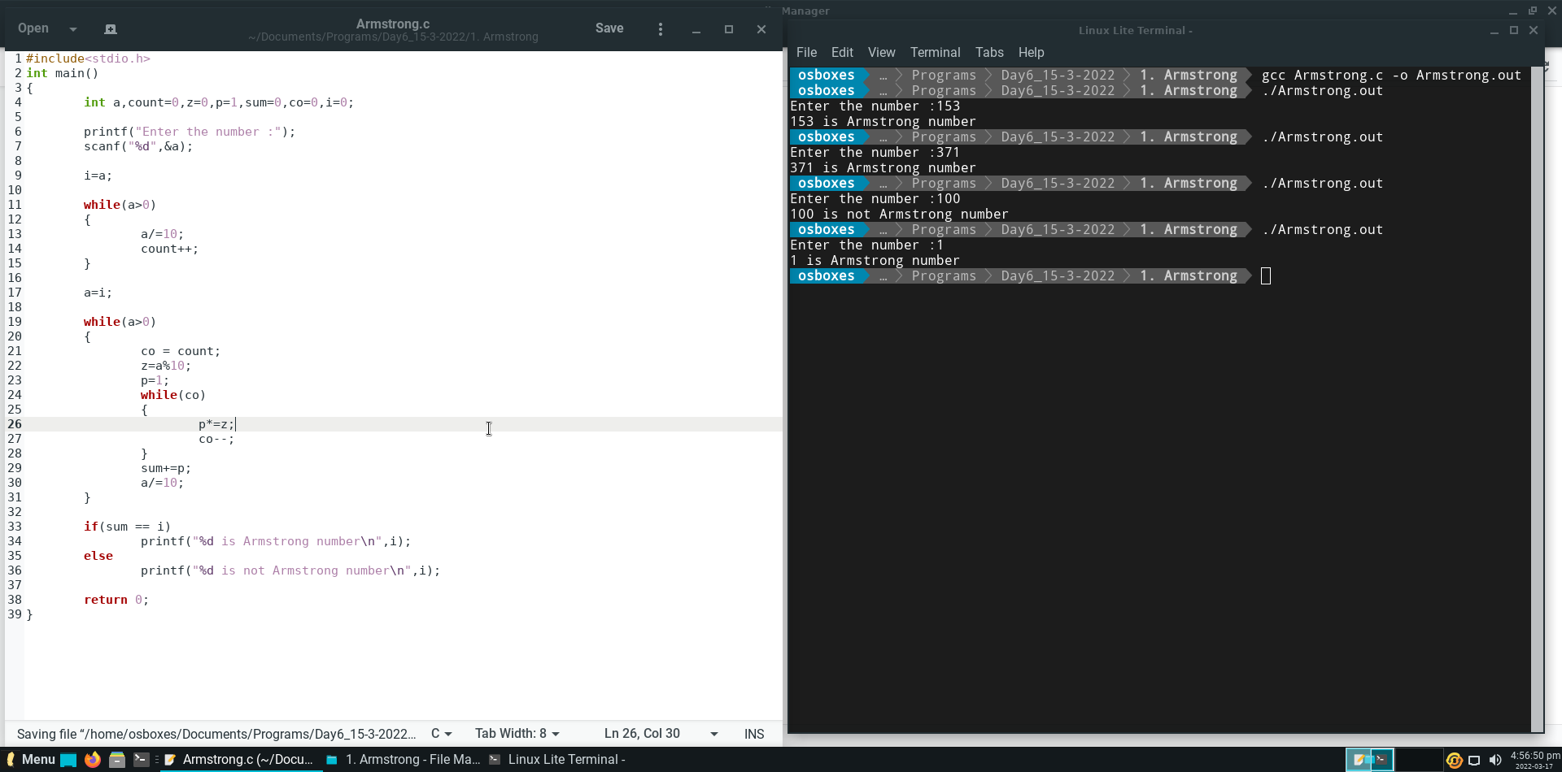

**Question 2.**

Write a program to find whether given number is palindrome or not. Palindrome number is a number which is same as its reverse.

**Output :**

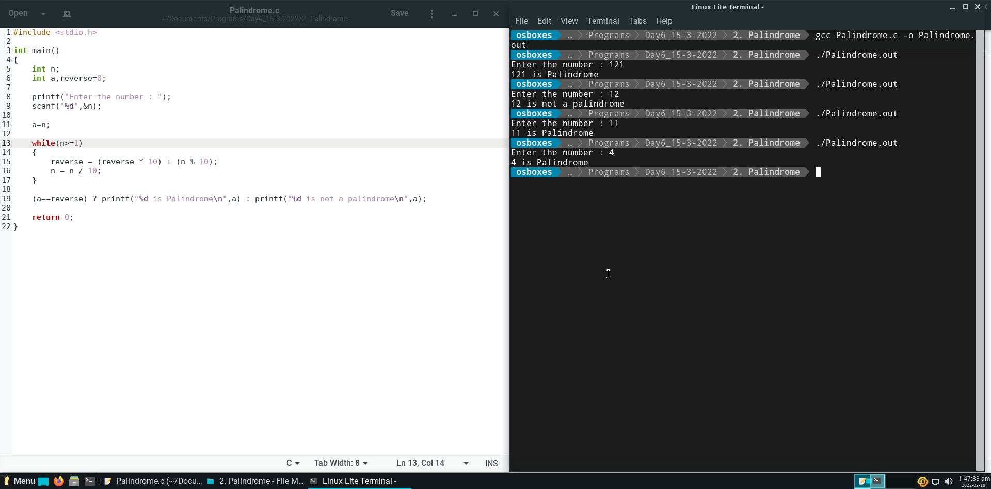

**Question 3.**

Write a program in C to find whether a number n is prime number or not.

**Output :**

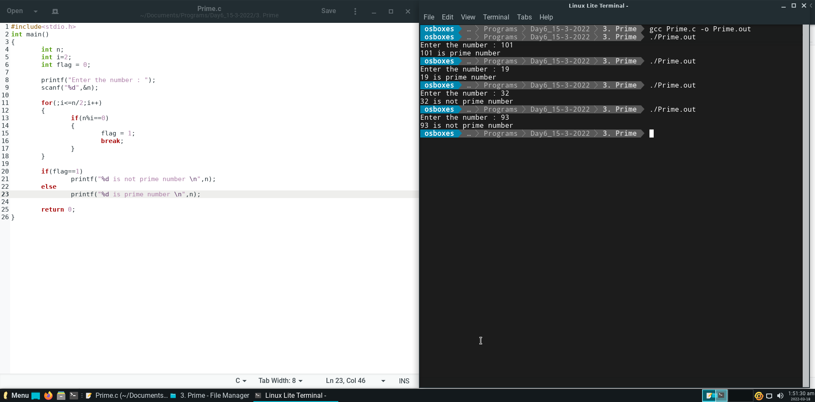

**Question 4.**

Write a program in C to find all prime numbers from 1 to n.

**Output :**

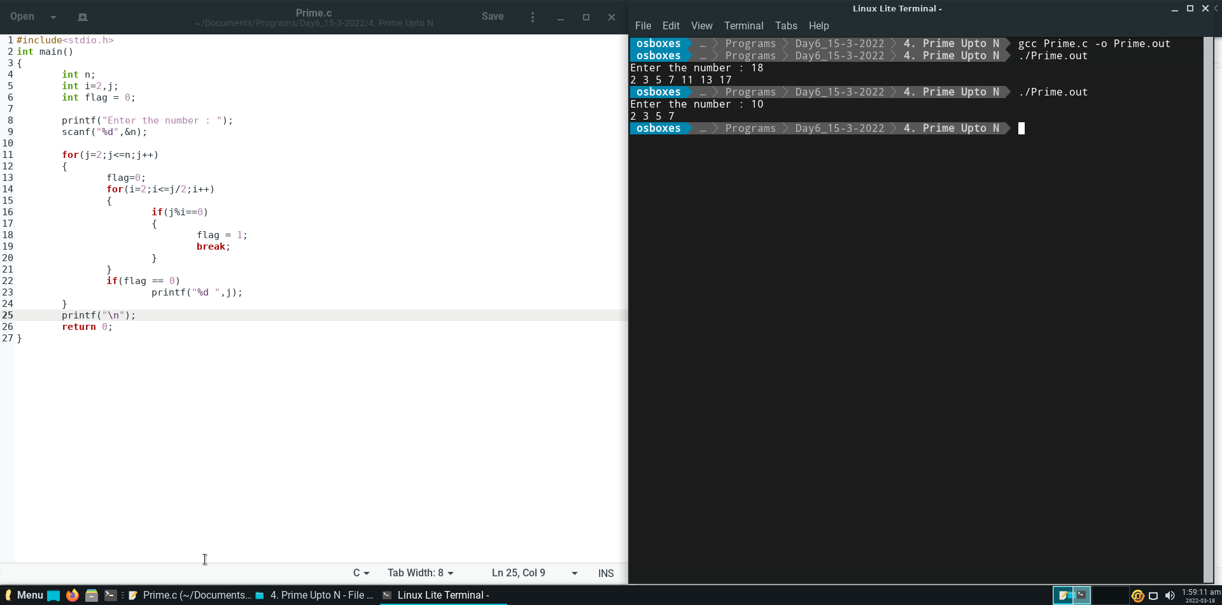

**Question 5.**

What will be the output after execution of the program?

**Output :**

4

**Explanation :**

The array a[4]={3,1,2,4} is declared,

And initially we store the first element of array in result.

Then using loop we compare every element of the array with result, and if the element value is greater than result then the value get stored in result.

In this way we get the largest number from the array.

**Question 6.**

What will be the output?

**Output :**

5

5

2

**Explanation :**

In array arr, {1,2,3,4,5,6} is stored,

1. j = ++arr[2]; => ++(3) => 4. So, j = 4
2. k= arr[1]++; => (2)++ => due to post increment, k=2.
3. I = arr[j++]; => a[4++] => 5. So, i = 5 and j = 5

**Question 7.**

What will be the output when the following code is executed?

**Output :**

IIT MADRAS

**Explanation :**

There are six elements in array of integer type that’s why the sizeof operator will return 24 when we check the size of that array.

And when we used that returned value in switch statement, it wont find any case and breaks out of the switch block and prints the last line that is IIT MADRAS.

**Question 8.**

How many ‘a’ will be printed when the following code is executed?

**Output :**

aaaaaa

**Explanation :**

The loop starts from 0 to 4 that is 5 times and every time it access the swtich case which prints ‘a’,

And at the end of program it prints ‘a’ at the last time.

So, overall 6 ‘a’ will be printed.

**Question 9.**

Find the output of the following C program.

**Output :**

4,4

**Explanation :**

The array is initialised with 5 elements as {1,2,3,4,5} and also variable a is declared.

1. arr[1] = ++arr[1]; => arr[1] = ++(2) => 3.
2. a=arr[1]++; => a=(3)++ => a=3 and arr[1] = 4.
3. arr[1]=arr[a++]; => arr[1] = arr[3] => arr[1] = 4 and a=4.

**Question 10.**

Write a C Program to find Largest Element of an Integer Array. Here the number of elements in the array ‘n’ and the elements of the array is read from the test data. Use the printf statement given below to print the largest element. printf("Largest element = %d", largest);

**Output :**

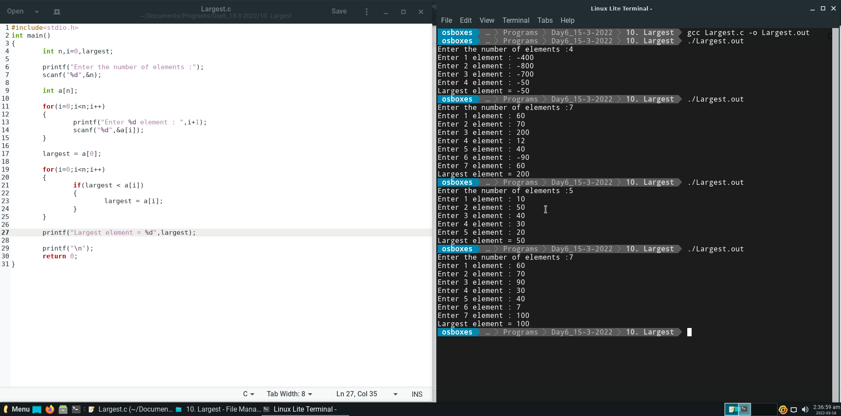

**Question 11.**

Write a C Program to print the array elements in reverse order (Not reverse sorted order. Just the last element will become first element, second last element will become second element and so on)

Here the size of the array, ‘n’ and the array elements is accepted from the test case data.

**Output :**

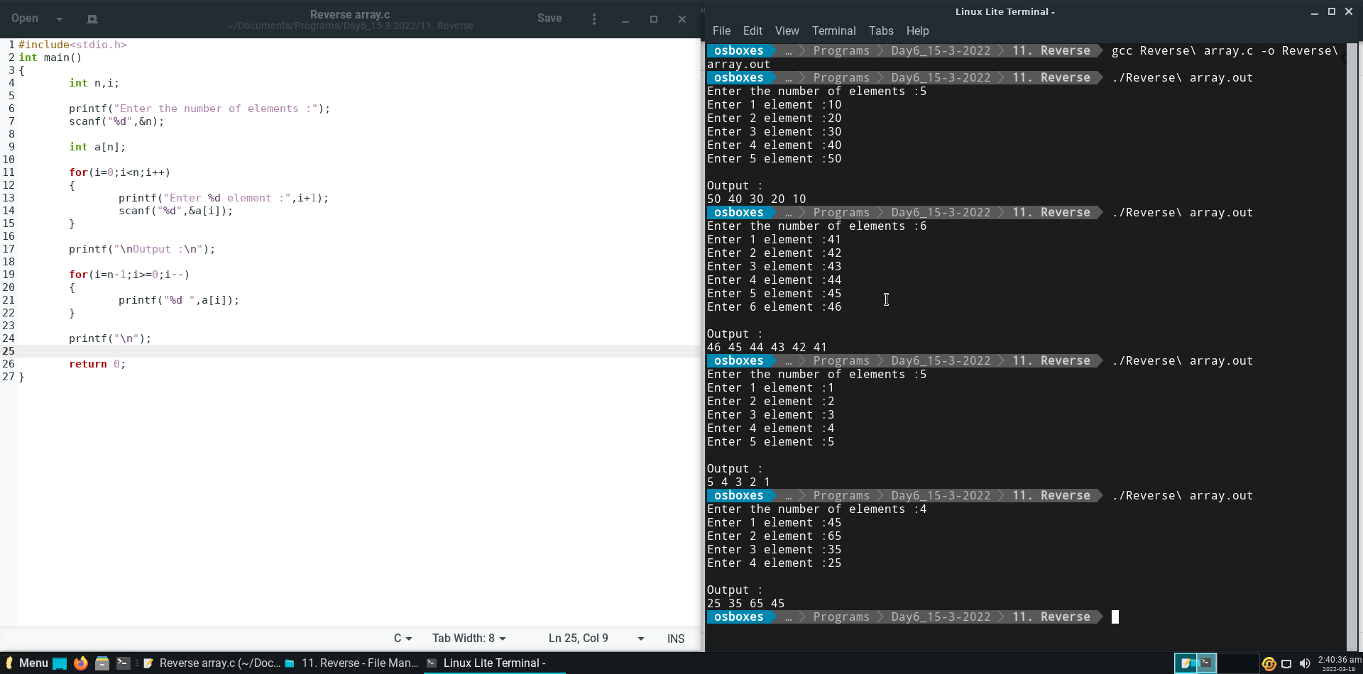

**Question 12.**

Write a C program to read Two One Dimensional Arrays of same data type (integer type) and merge them into another One Dimensional Array of same type.

First take n as size of first array, then input all n elements of first array.

Take m as size of second array, then input all m elements of second array.

At last merge these two arrays to make third array of size n+m.

**Output :**

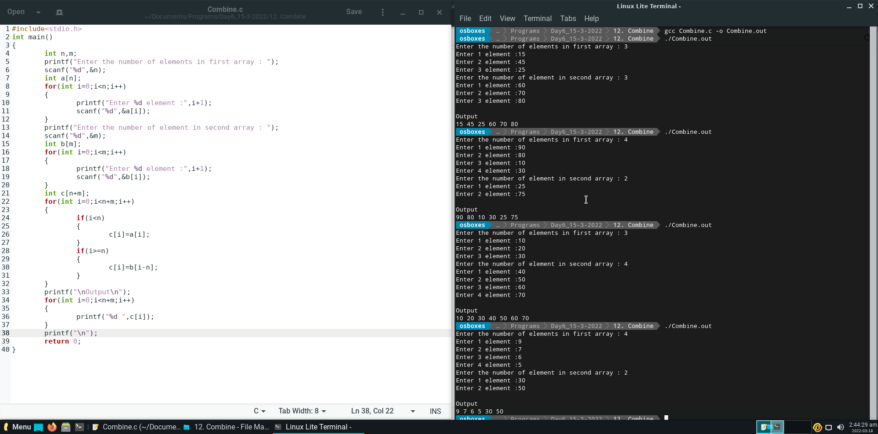

**Question 13.**

Write a C Program to delete duplicate elements from an array of integers.

First take n as size of first array, then input all n elements of first array.

Now delete duplicate elements from nested array. You can use nested loop for deleting duplicate elements.

**Output :**

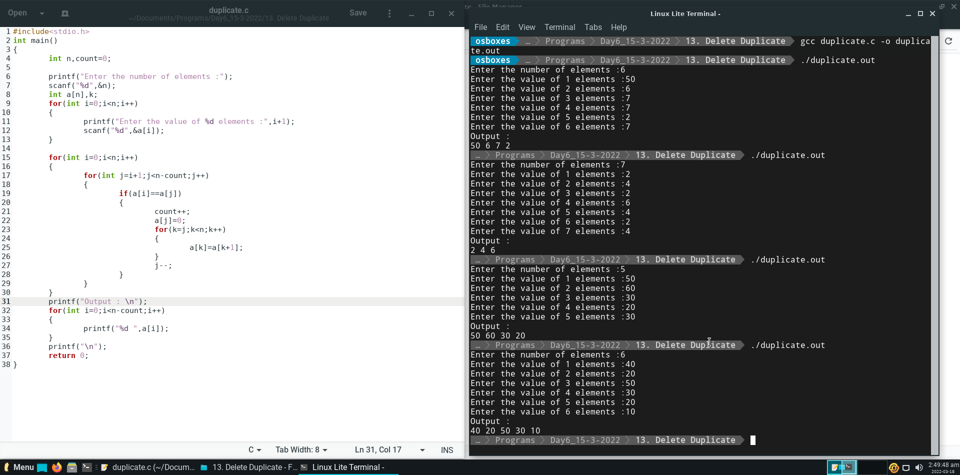

**Question 14.**

C Program to delete an element from a specified location of an Array starting from array [0] as the 1st position, array[1] as second position and so on.

First take n as size of first array, then input all n elements of first array.

Now input index value from user, print the array after deleting that index value from array.

**Output :**

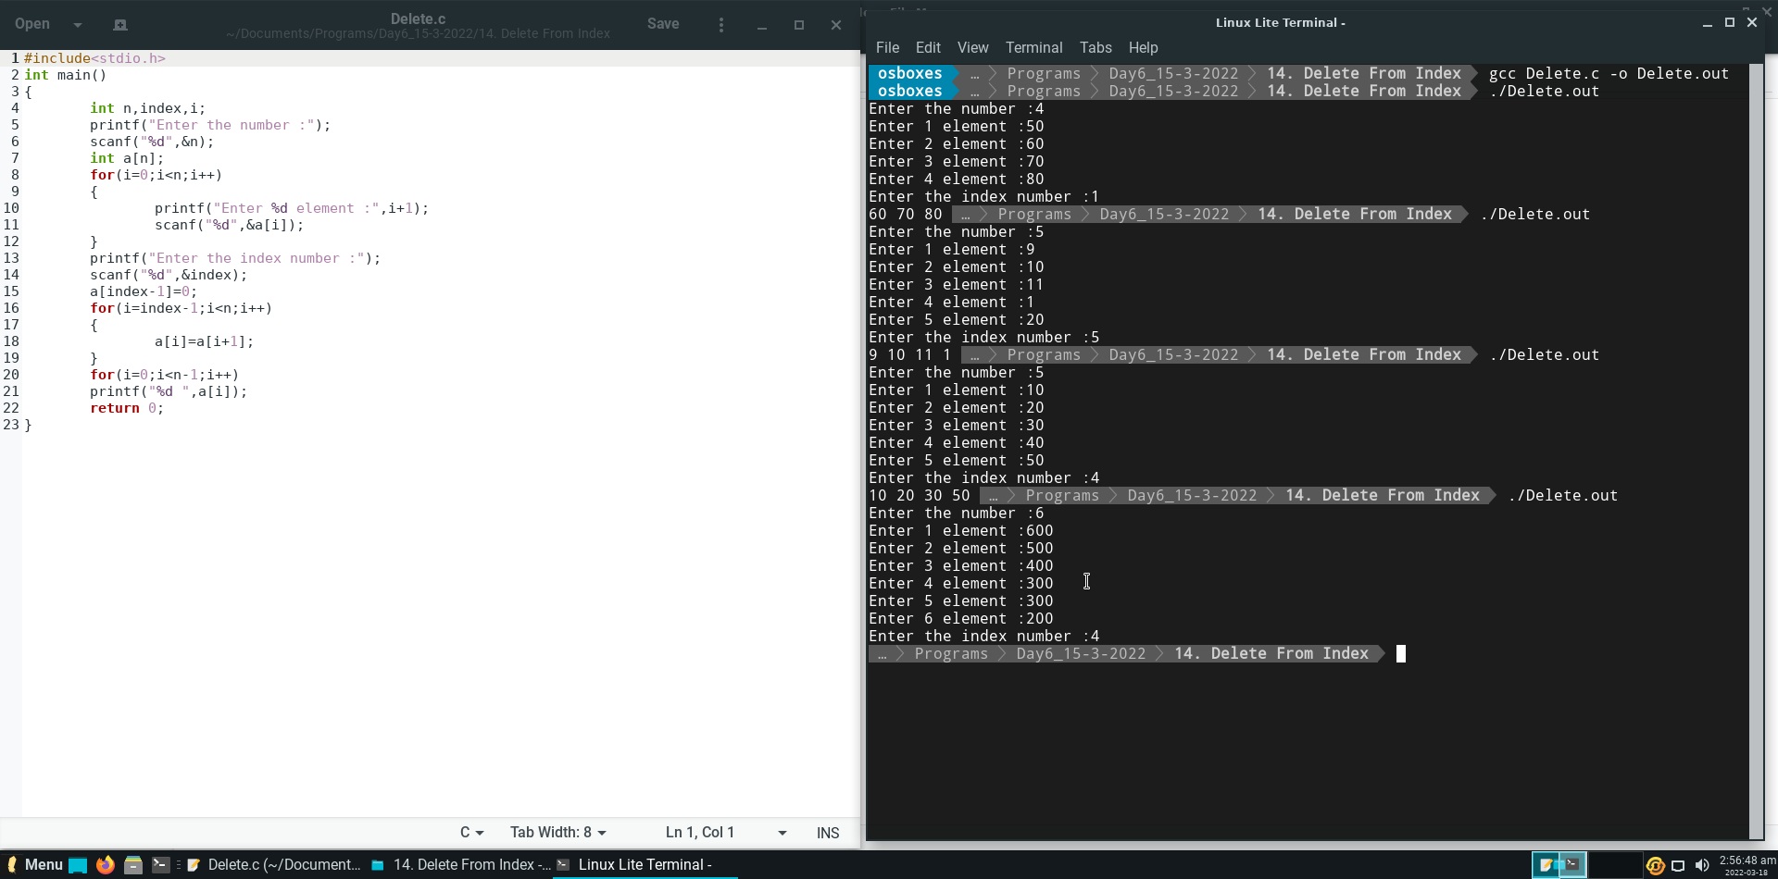

**Question 15.**

**Write a C program to find the sum of all elements of each row of a matrix.**

Input number of rows and number of cols from user.

Now input all rows*cols values from user .

**Output :**

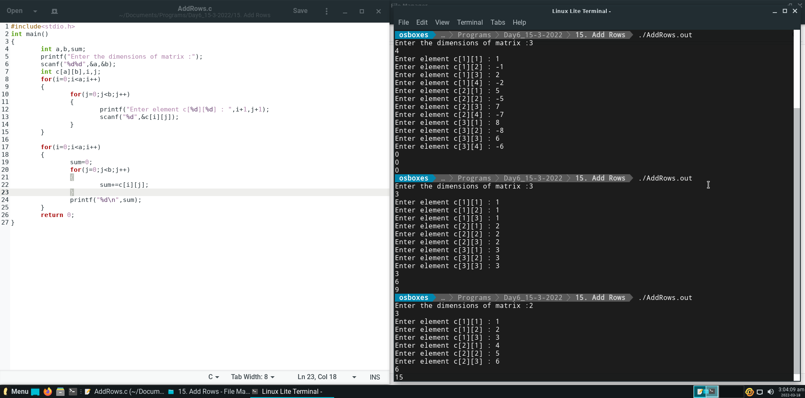

**Question 16.**

Write a C program to find subtraction of two matrices i.e. matrix_A -matrix_B=matrix_C.

Input number of rows and number of cols from user for both A and B matrix.

Now input all rows*cols values from user

**Output :**

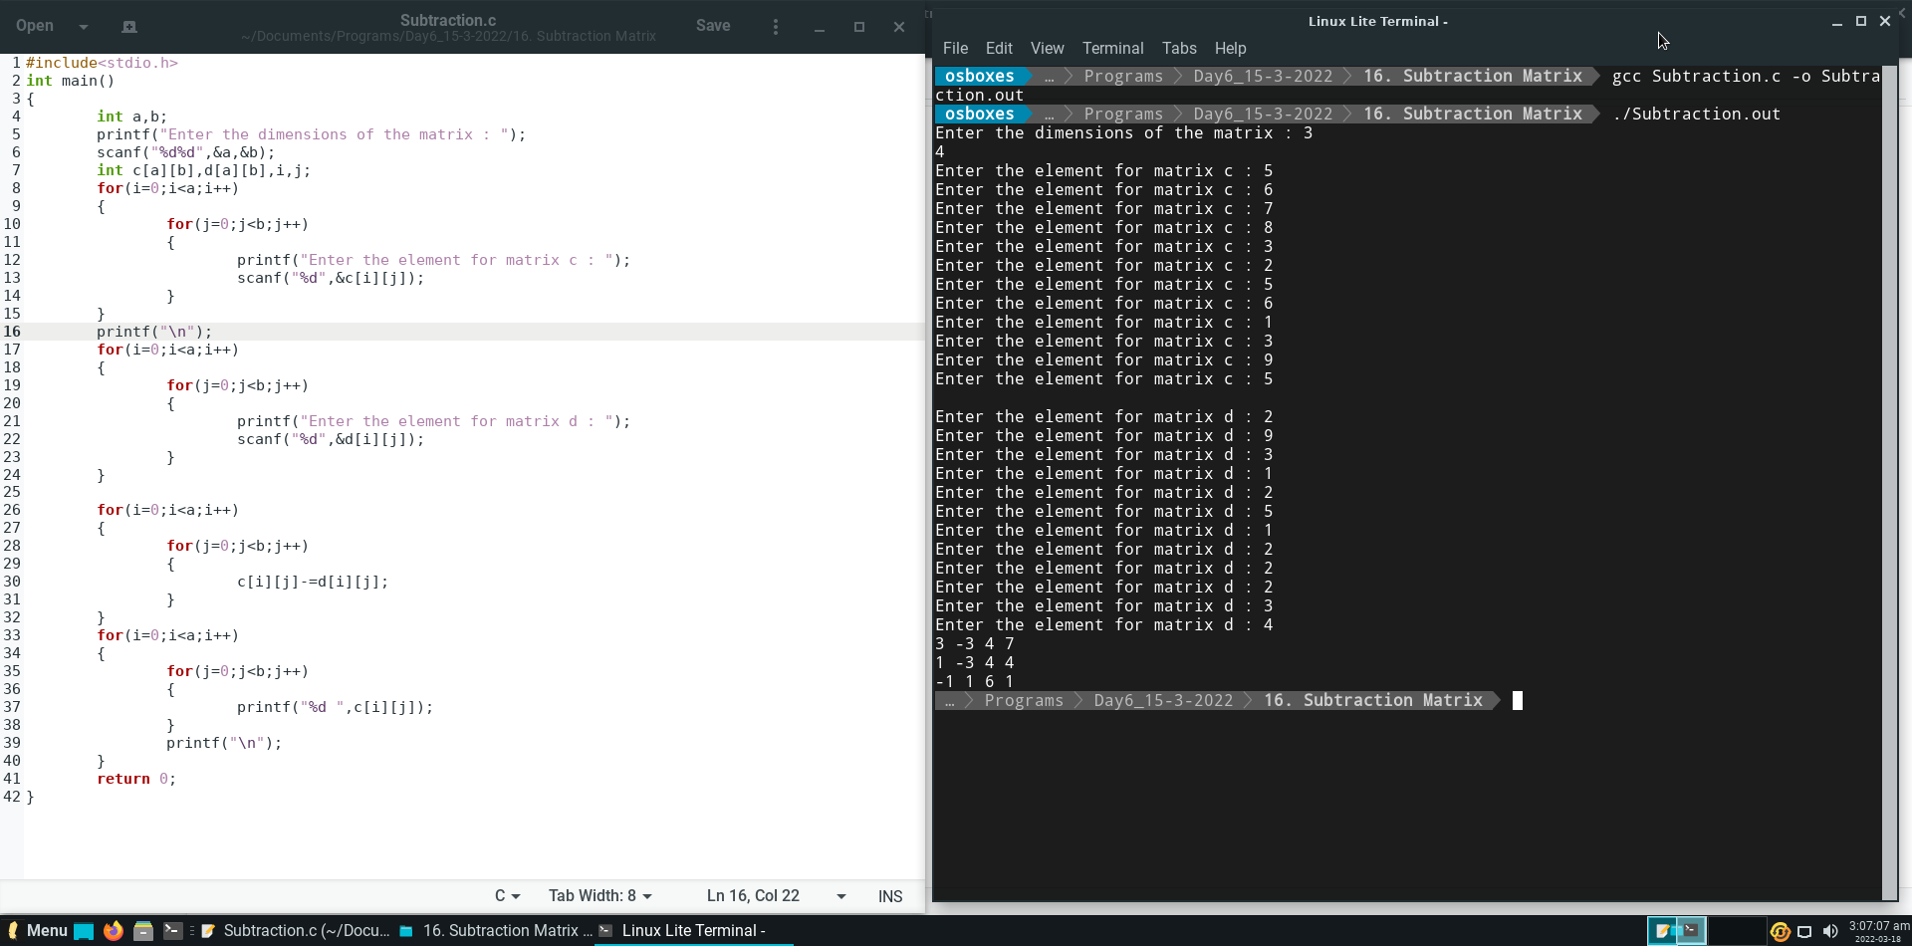

**Question 17.**

Write a C program to print lower triangle of a square matrix.

Input size of square matrix as n. Solve of nxn square matrix

**Output :**

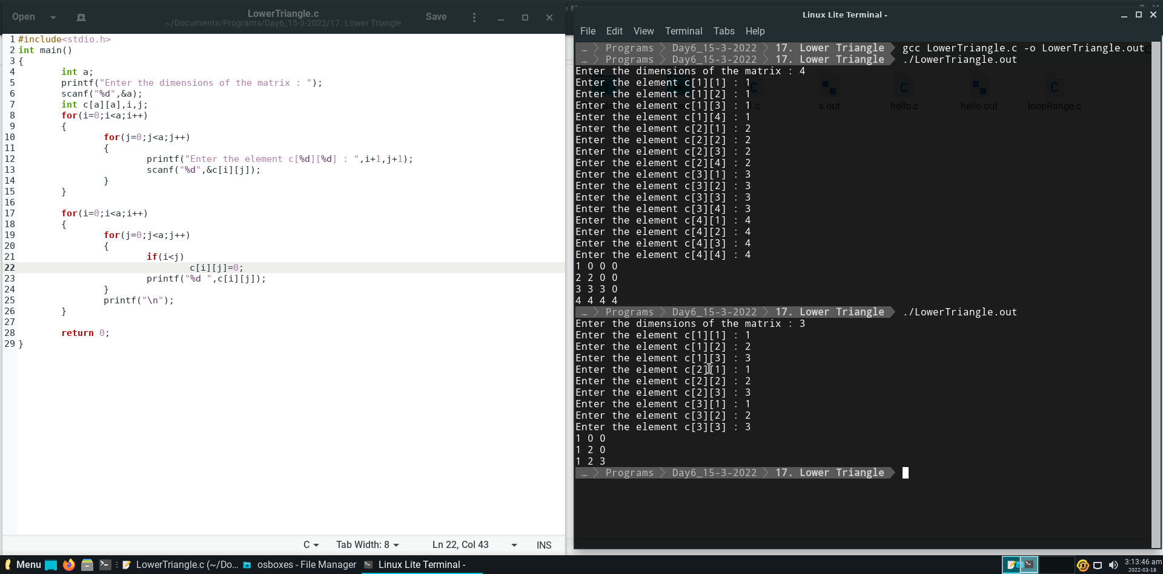

**DAY – 7 (Assignment – 6)**

**Question 1.**

Write a C Program to Count Number of Uppercase and Lowercase Letters in a given string. The string may be a word or a sentence.

**Output :**

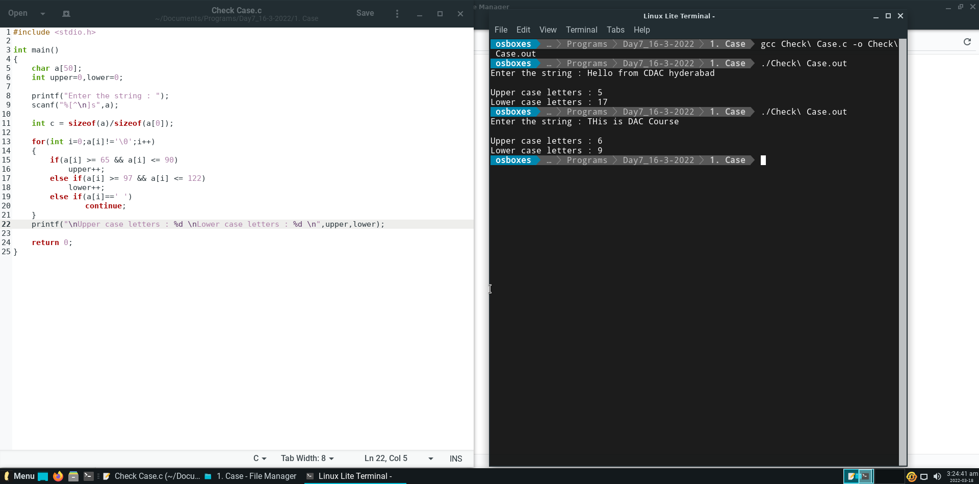

**Question 2.**

Write a C program to print Largest and Smallest Word from a given sentence. If there are two or more words of same length then the first one is considered. Here single letter such as "I" , "a" is considered as a word.

**Output :**

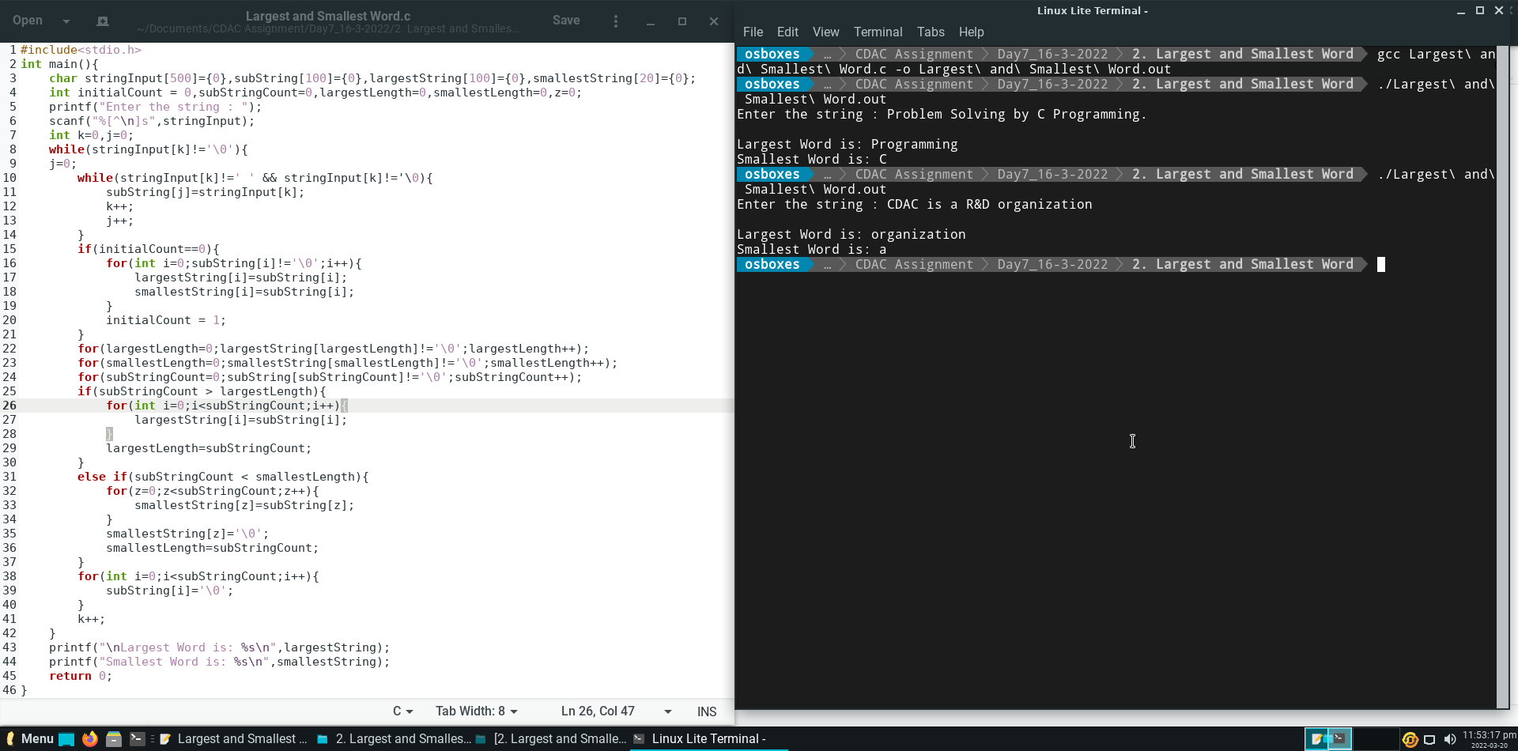

**Question 4.**

Write a C Program to reverse a given word using function. e.g. INDIA should be printed as AIDNI.

**Output :**

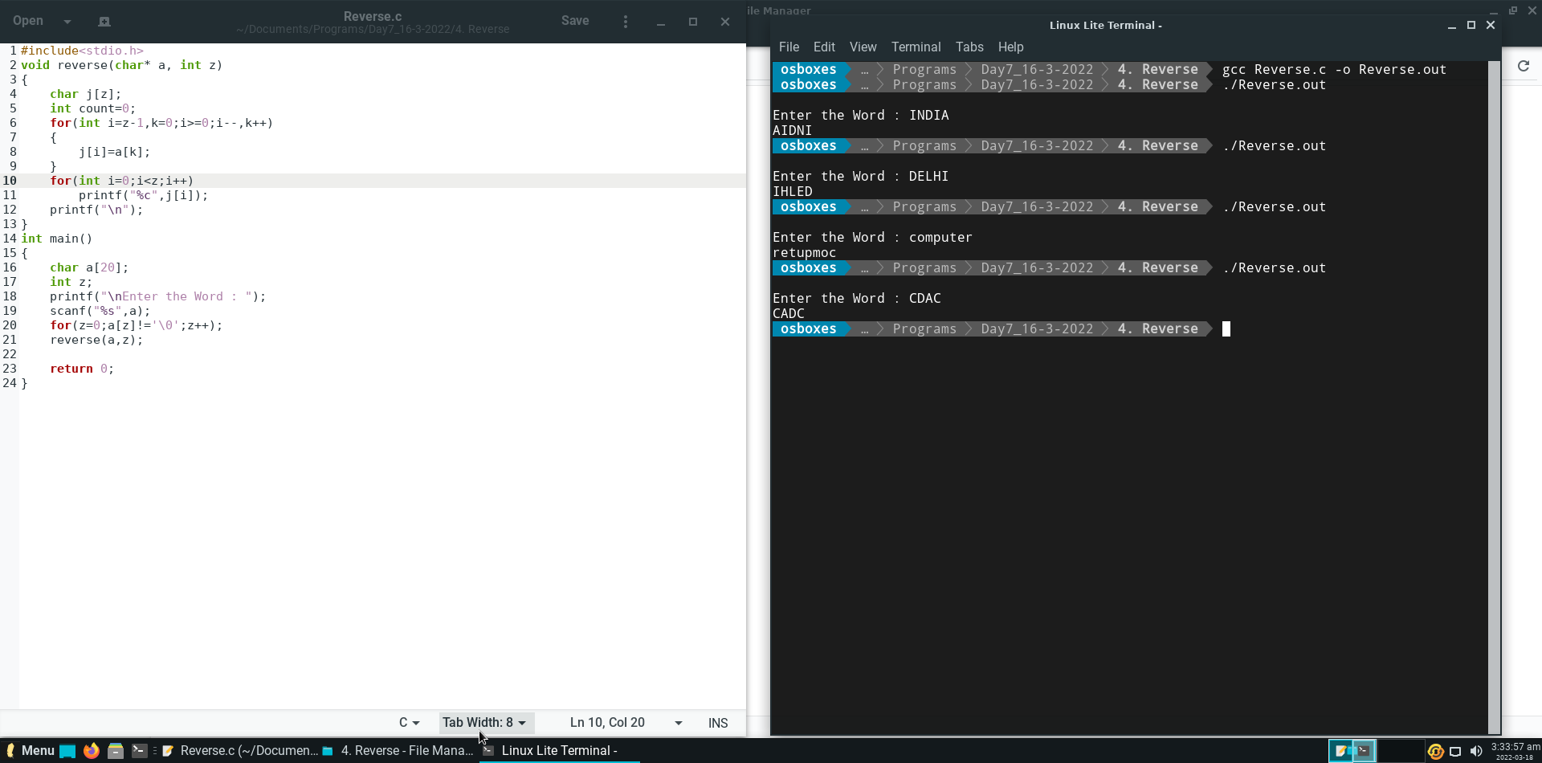

**Question 5.**

Write a program to check if a given integer is Prime Number using function.

Implement function: int checkPrime(int n);

**Output :**

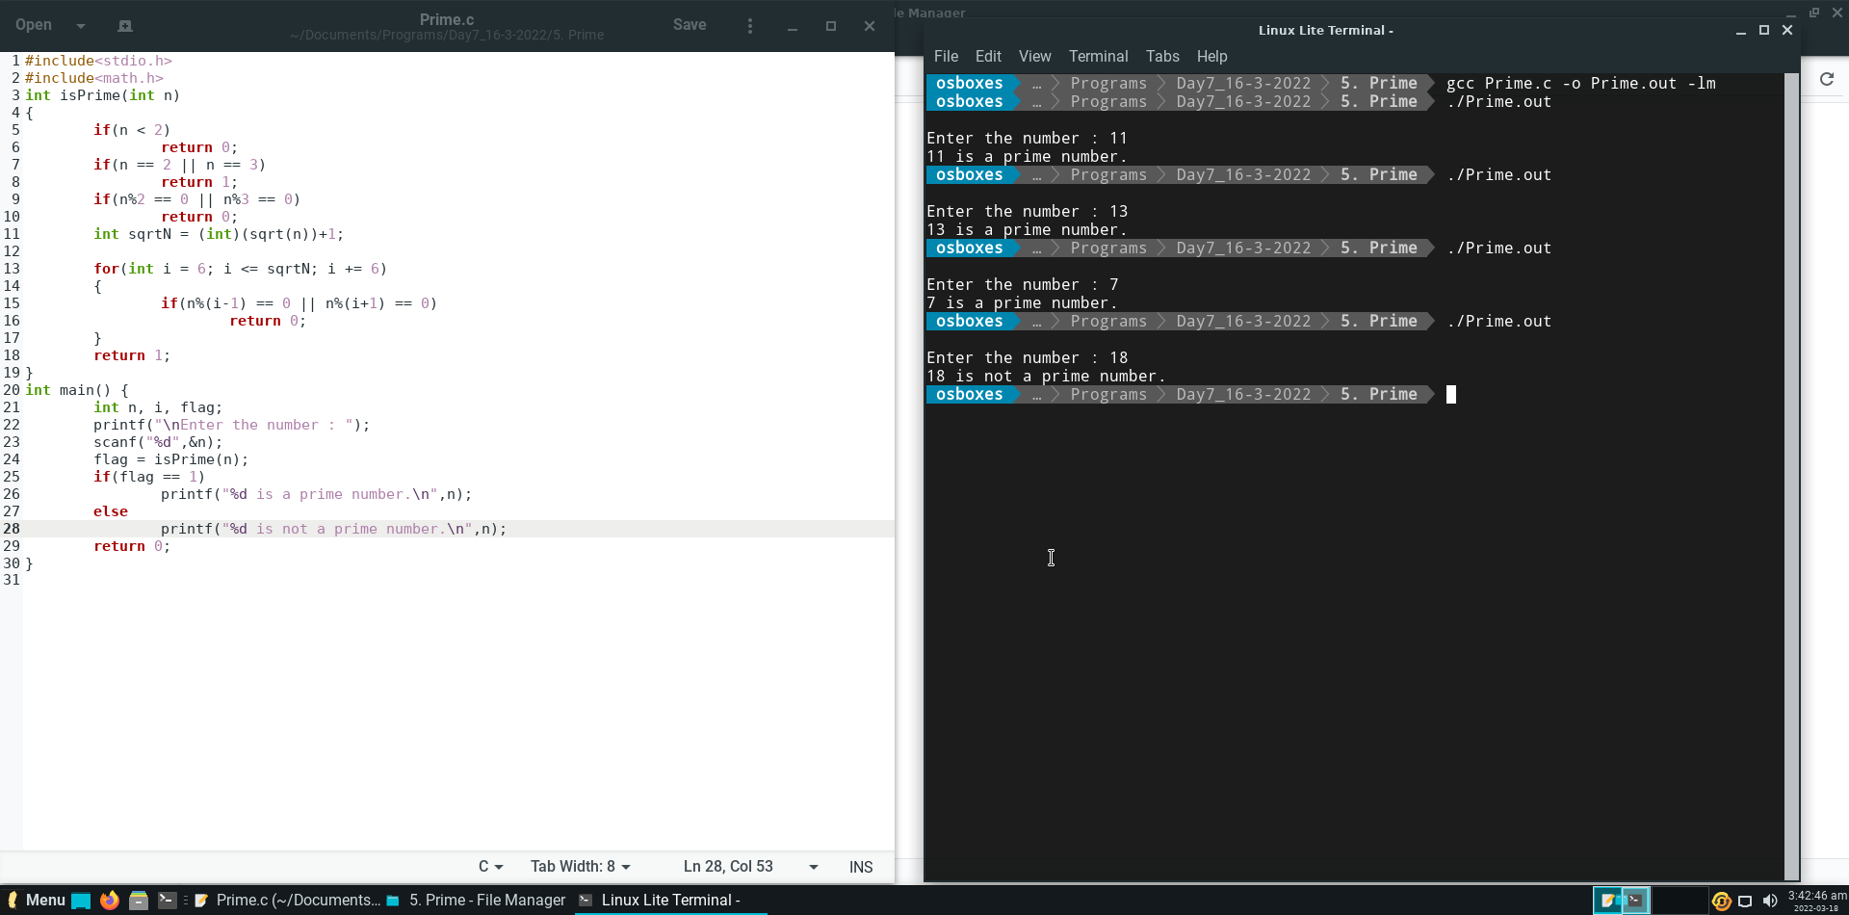

**Question 6.**

Write a C Program to find power of a given number using recursion. The number and the power to be calculated is taken from test case

**Output :**

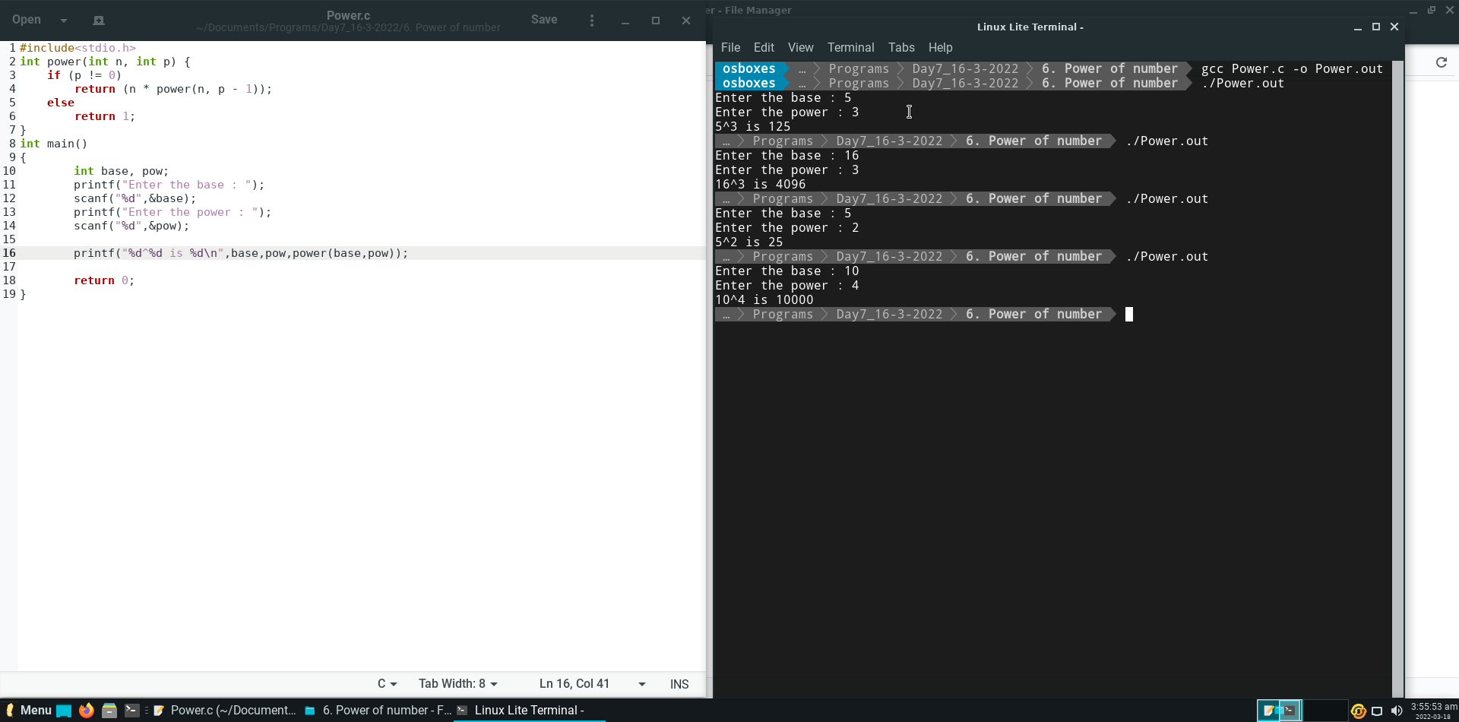

**Question 7.**

Write a C Program to print Binary Equivalent of an Integer using Recursion

**Output :**

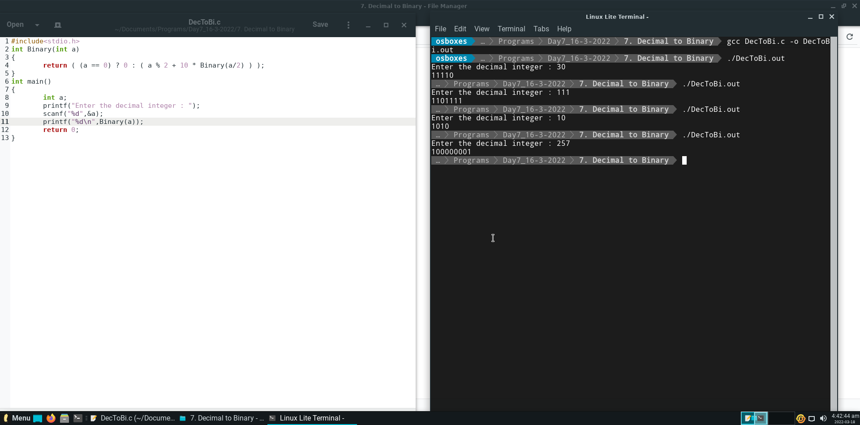

**Question 8.**

What will be the output of the following code?

**Output :**

n1 = 18,n2 = 17

**Explanation :**

Even though the content seems same in str1 and str2.

The str1 is string which end character contains null character ‘\0’,

On the other hand, the str2 is array which does not have ‘\0’ null character in the end.

**Question 9.**

What will be the output?

**Output :**

helloworld

**Explanation :**

The statement is strcpy(str2,strcat(str1,str2)) and the values stored inside str1=hello and str2=world.

1. strcat(arg1,arg2) is string function under string.h header file which is use to concatenate two strings and it stores the result in the first argument.
2. strcpy(arg1,arg2) is string function under string.h header file which is use to copy the content of second string argument into first string argument.

strcat(str1,str2) returns string helloworld and strcpy copies that returned content into str2.

**Question 10.**

To get the output as “Hwi orea”, what should be the condition inside the ‘if’ statement?

#include<stdio.h>

int main()

{

int i;

char s[] = "how is your exam";

for(i=0;s[i]!='\0';++i)

{

if(------)

printf("%c",s[i]);

}

return 0;

}

**Required statement :**

i%2==0

**Explanation :**

Above statement allows ‘if condition’ to print even index characters.

**Question 11.**

What will be the value of ‘I’ after the execution of the code fragment given below?

**Output :**

0

**Explanation :**

The statement was **strcmp(strcat(str3,strcpy(str2,str1)),"daffodills")**

strcpy(arg1,agr2) copies the string from arg2 into arg1 and returns the new value of arg1.

strcat(arg1,arg2) concatenates the two strings and returns the output.

strcmp(arg1,arg2) compares two string and returns zero (0) if arg1 is equal to arg2.

**Question 12.**

What will be the output?

**Output :**

NO OUTPUT

**Explanation :**

The content of the array p is **arrangement.** Logic inside the loop stores the null character in starting of the string. And as we know the string prints from the zeroth index to the null character. Due to this rule the print function does not returns anything. The working of the logic in that loop is given below.

|  |  |  |  |  |  |  |  |  |  |  |
| --- | --- | --- | --- | --- | --- | --- | --- | --- | --- | --- |
| **Original p ->** | a | s | s | i | g | n | m | e | n | t |
| 0th iteration | \0 | s | s | i | g | n | m | e | n | t |
| 1st iteration | \0 | t | s | i | g | n | m | e | n | s |
| 2nd iteration | \0 | t | n | i | g | n | m | e | s | s |
| 3rd iteration | \0 | t | n | e | g | n | m | i | s | s |
| 4th iteration | \0 | t | n | e | m | n | g | i | s | s |
| 5th iteration | \0 | t | n | i | g | n | m | e | s | s |
| 6th iteration | \0 | t | s | i | g | n | m | e | s | s |
| 7th iteration | \0 | s | s | i | g | n | m | e | n | t |
| 8th iteration | \0 | s | s | i | g | n | m | e | n | t |
| 9th iteration | \0 | s | s | i | g | n | m | e | m | t |

**Question 13.**

What will be the output?

**Output :**

67,67

**Explanation :**

This program function having 2 argument of int data types.

If we pass char variable as an argument then it will reflect its ASCII value due int type of argument in prototype of function.

So, in this question when we send ‘C’ as second argument it prints its ASCII value as 67.

**Question 14.**

What will be returned by the function f(1)?

**Output :**

7

**Explanation :**

Value of i is static so it is going to preserve its value even after it gets called several time.

f(1) => n = n+i = 1+1 = 2 and i=i+1=2 returns f(2).

f(2) => n = n+i = 2+2 = 4 and i=i+1=3 returns f(4).

F(4) => n = n+I = 4+3 = 7 and i=i+1=4 returns f(7).

As n>5, return n;

So, As the return value of f(2) is going to be returned to the main function which will be 7.

**Question 15.**

How many times ‘Hi’ will be printed in the program given below?

**Output :**

Hello

**Explanation :**

**Hi** will be printed 0 times. Because the loop which is going to call the fun function that will going to print Hi will get called only when the value of i will be non-zero. But the i not initialised and it has extern storage class that means it will going to have zero as it’s initial value. So the loop won’t run and the fun function which is going to get called to print Hi will never execute.

**Question 16.**

What is the output of the C code given below?

**Output :**

24.68

**Explanation :**

The array age[]={23,4,55,22.6,3,40.5,18} will be sent to the function named func.

In function func all the elements in that array get summed up into the variable **sum** which is going to get divided by 6 (number of elements in array age) and the output will be stored into **result** variable. Then the result variable is going to retuned to main function to print up to 2 decimal.

**Question 17.**

What will be the output?

**Output :**

1010101010

**Explanation :**

In this question there is a concept of scope of variable.

In the code there are two int i get declared, 1st is globally and 2nd is locally.

But the print function prints the value of local i which is in the scope of print function.

And because the local scope is run under the for loop it is going to print the value of i 10 times.

**Question 18.**

How many times the function factorial will be executed?

**Answer :**

11

**Explanation :**

Code under this question call the function **factorial** which passes one argument and returns the factorial of the number. In this code we use the concept of **recursion**. The argument passed by the function factorial have value 10. Due to recursion technique the function get called by itself again and again by decreasing the value of argument by **1** until the value of n gets zero. That’s how the function gets called 11 times.

**Question 19.**

What will be the output?

**Output :**

Before swapping num1 = 10 num2 = 20

After swapping num1 = 10 num2 = 20

**Explanation :**

In this code the function swaps the value between a and b using 3rd variable temp. But the calling function pass the data as argument (pass by arguments). Due to this the changes made in swap function, it will not affect the data inside main function. So data before calling swap function and after calling swap function will be same.

**Question 20.**

Consider the following C function definition:

int func(int a, int b, int c)

{

If((a>=b) && (c<b)) return b;

else if(a>=b) return func(a,c,b);

else return func(b,a,c);

}

The function func() is used to find…?

**Answer :**

The function func() is used to find the middle number among three.

**Explanation :**

When we call the function with 3 int arguments as a,b,c.

If the a>=b and c<b then it returns b as an middle value lies between a and b.

If the upper condition fails then it check if a >= b then it calls same function func by changing the order of the arguments as a,c,b.

If both of the above conditions fails then it the function calls its self by changing the order of the arguments as b,a,c.

**DAY – 8 (Assignment – 7)**

**Question 1.**

Write a program to implement multiplication using addition. Use recursion.

**Output :**

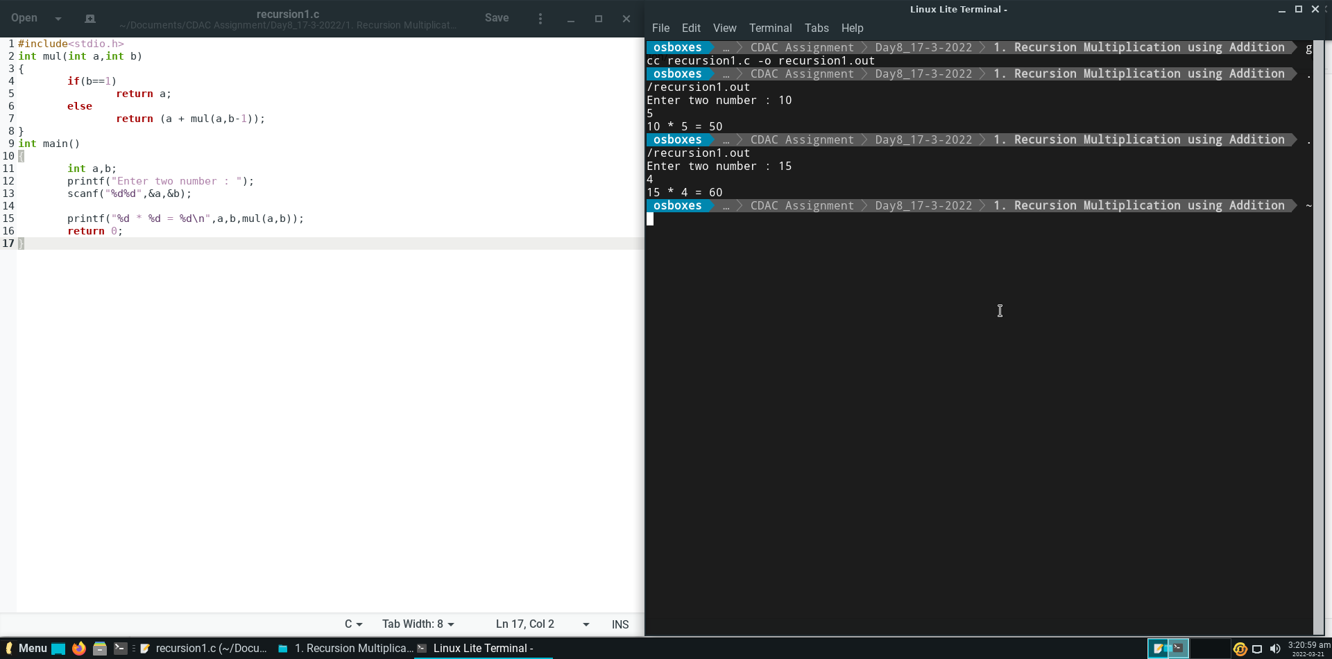

**Question 2.**

Write a program to swap two numbers.

**Output :**

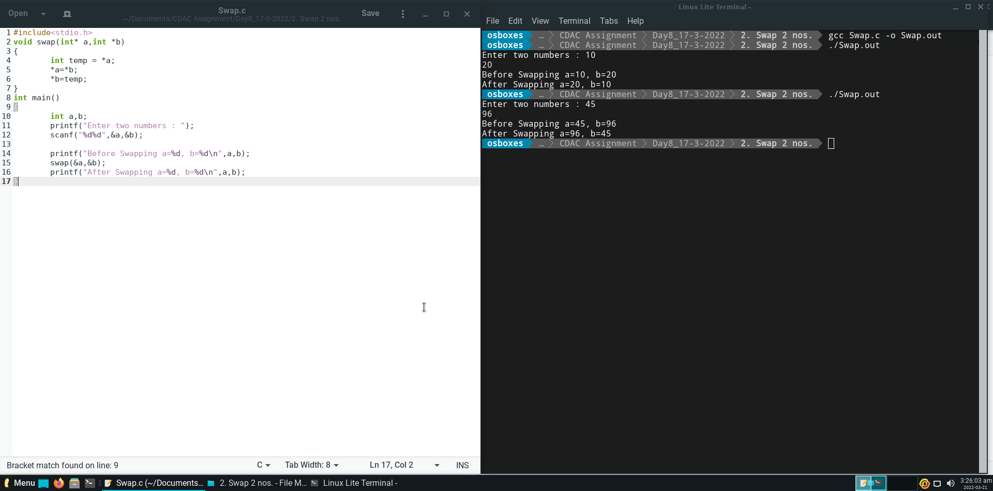

**Question 3.**

Write a recursive function to find the sum of n integers.

**Output :**

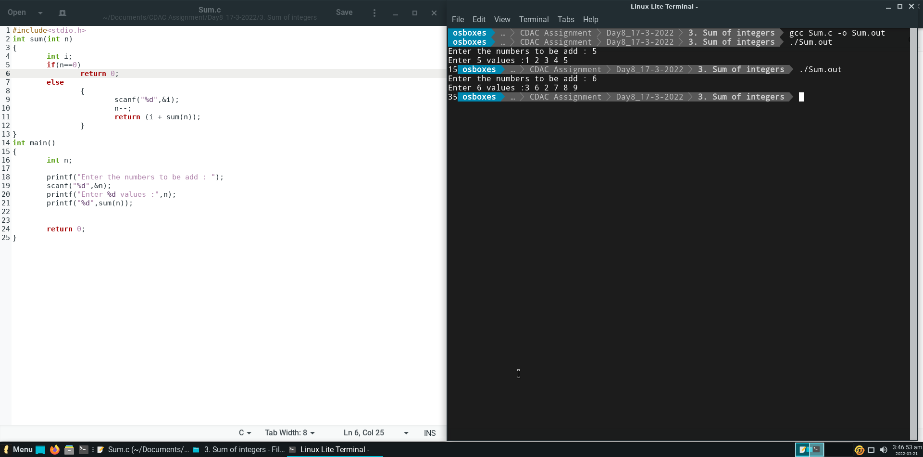

**Question 4.**

Write a c program to concatenate two strings without using library functions.

**Output :**

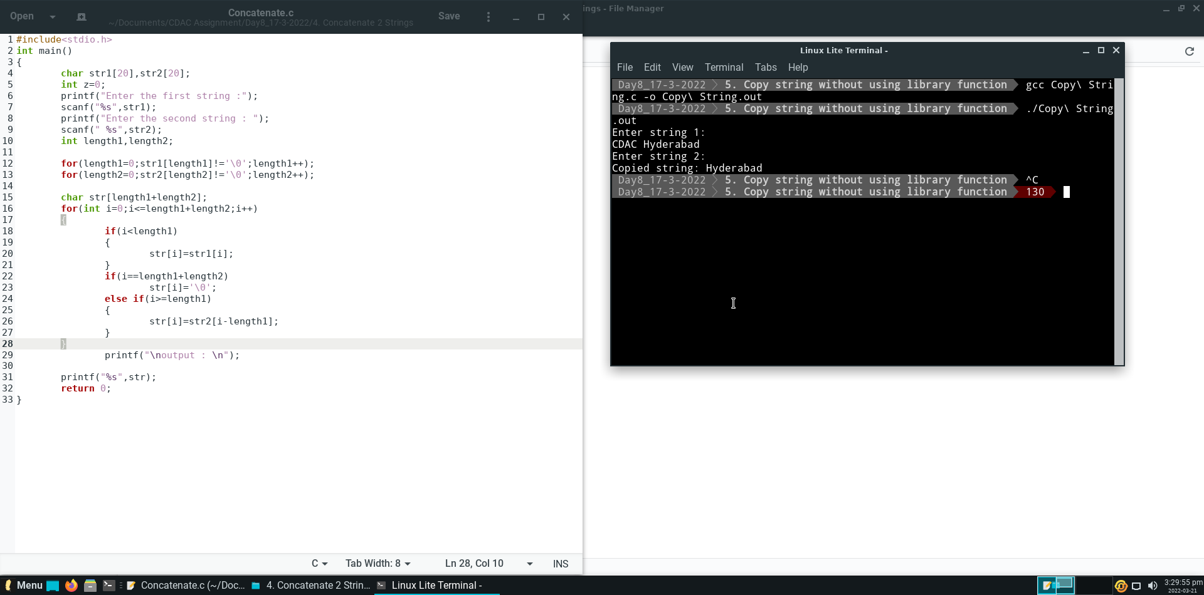

**Question 5.**

Write a c program to copy string without using library functions.

**Output :**

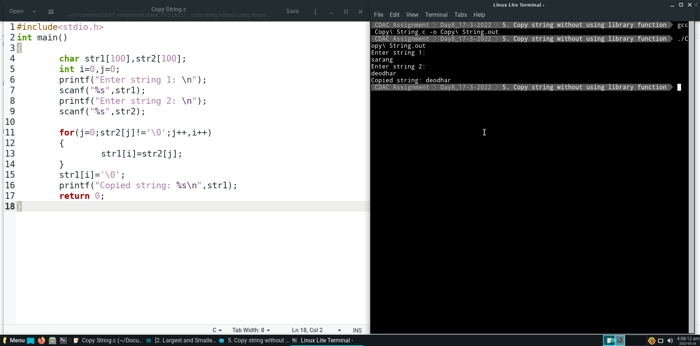

**Question 6.**

Write a c program to find length of string without using library functions.

**Output :**

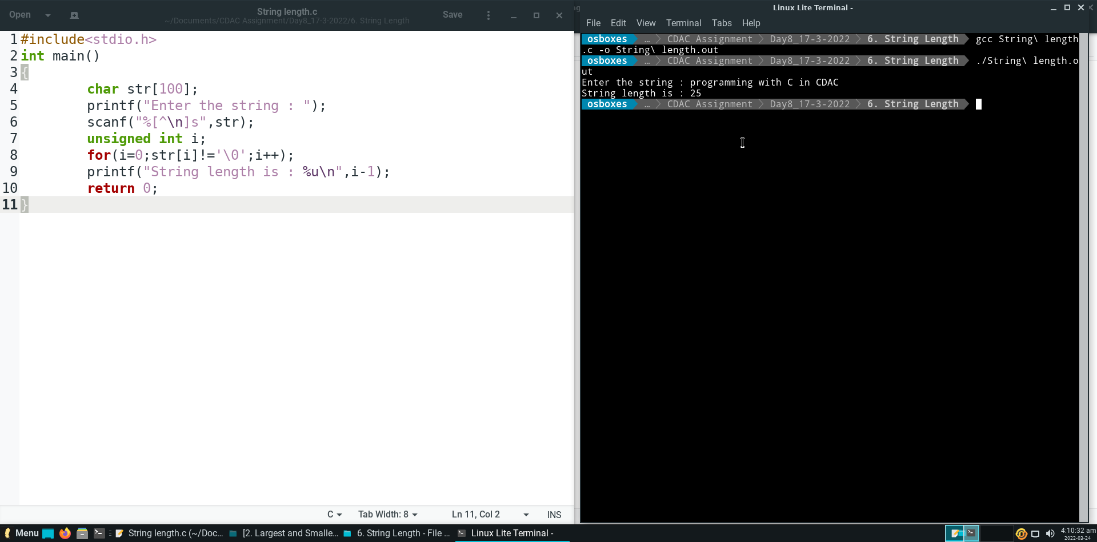

**DAY – 9 (Assignment – 8)**

**Question 1.**

Write a C program to calculate power a given number using pow(a,b) function in math.h with evaluates: ab. Use #include<math.h> in your c program. Use below command to compile :

$ gcc prog.c -o prog -lm.

**Output :**

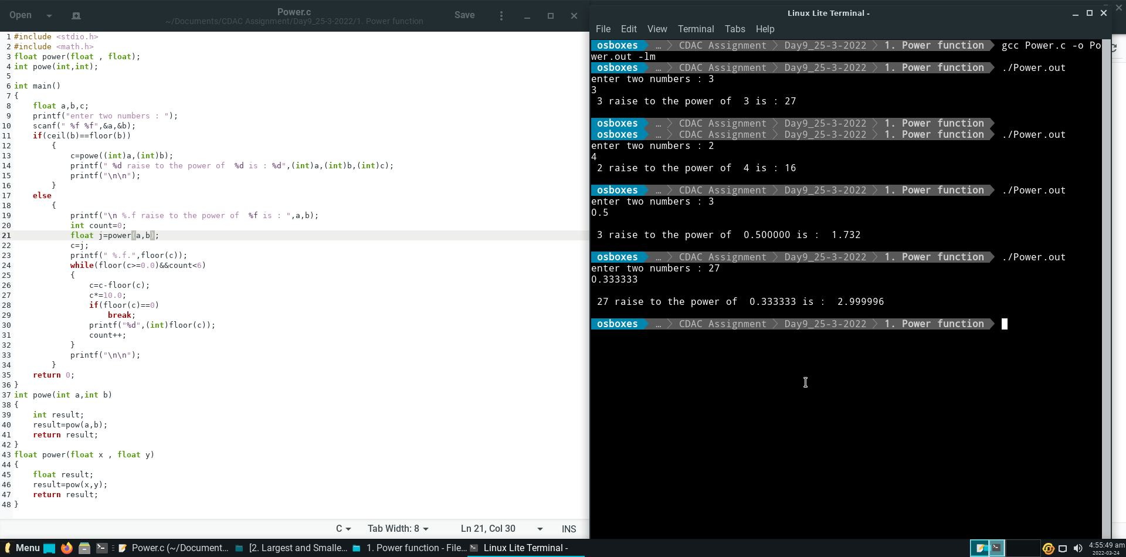

**Question 2.**

Write a program and implement a function to find if it is leap year or not. Implement below function

int is_leap_year(int year);

- is_leap_year() returns 1 if leap year,

- is_leap_year() returns 0 if NOT leap year,

Take 4 digit year as input for example: 2000.

**Output :**

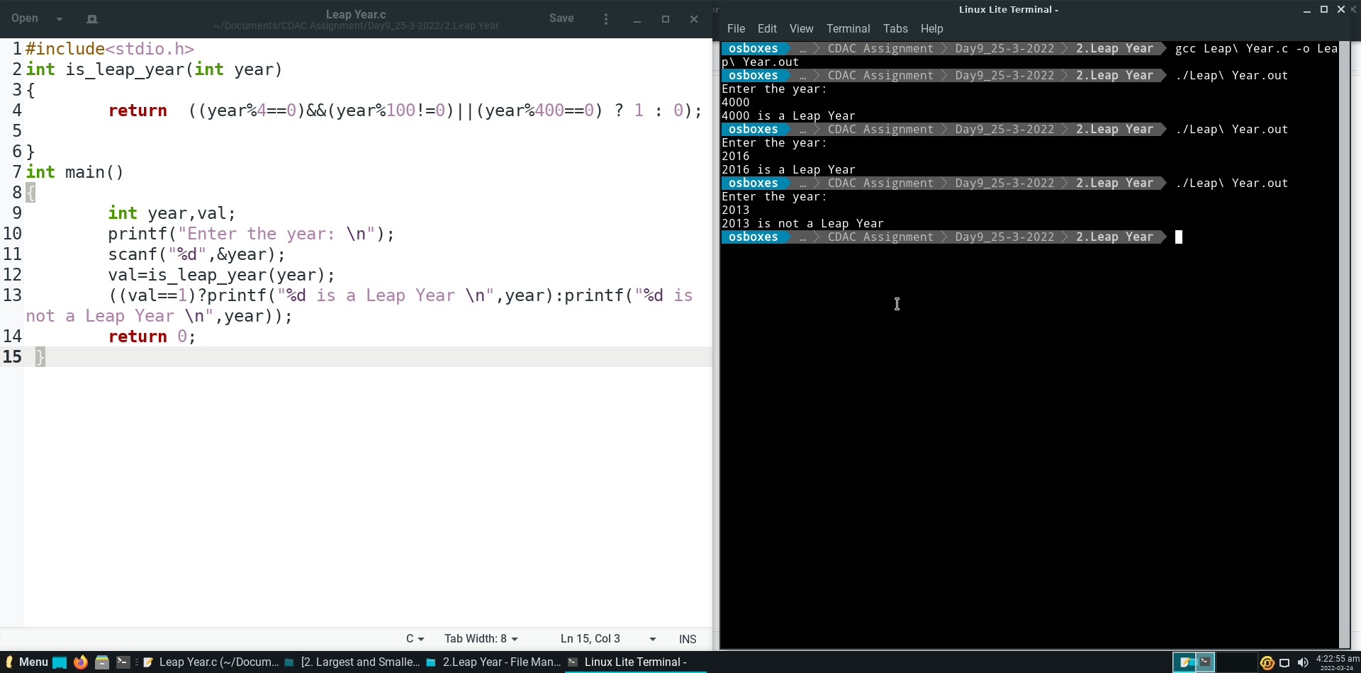

**Question 3.**

Write a program and implement a factorial function using below prototype declarations:

long int factorial(long int);

**Output :**

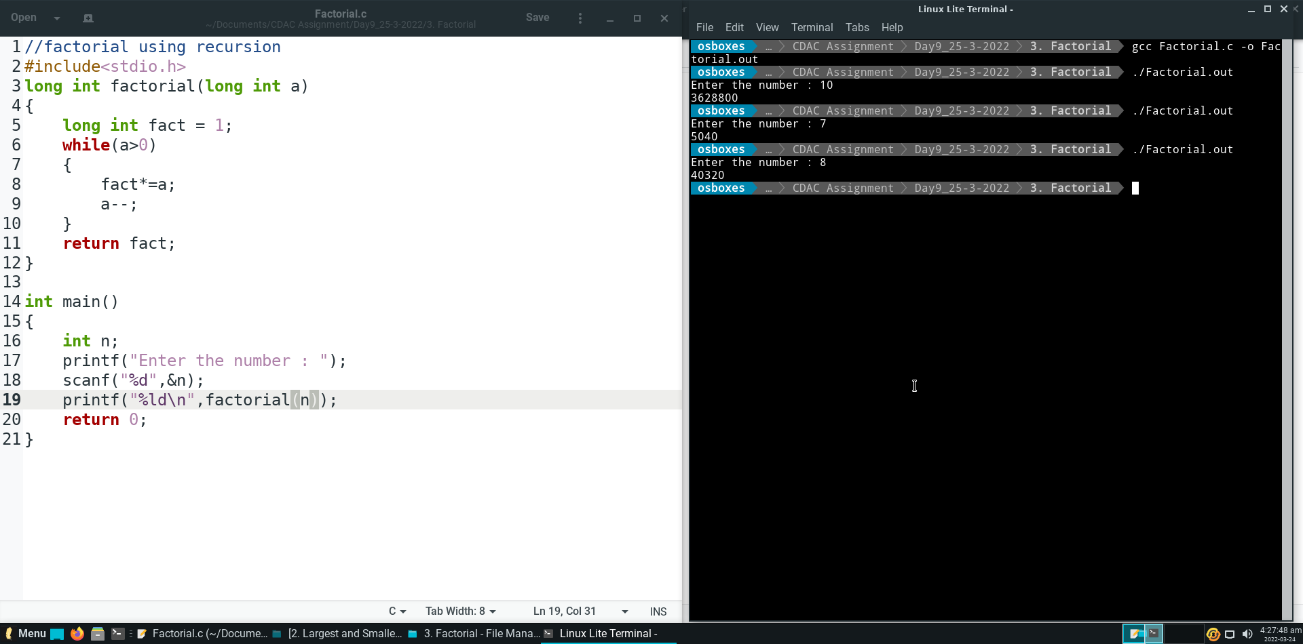

**Question 4.**

Implement average function of two numbers as below: double average(double, double);

**Output :**

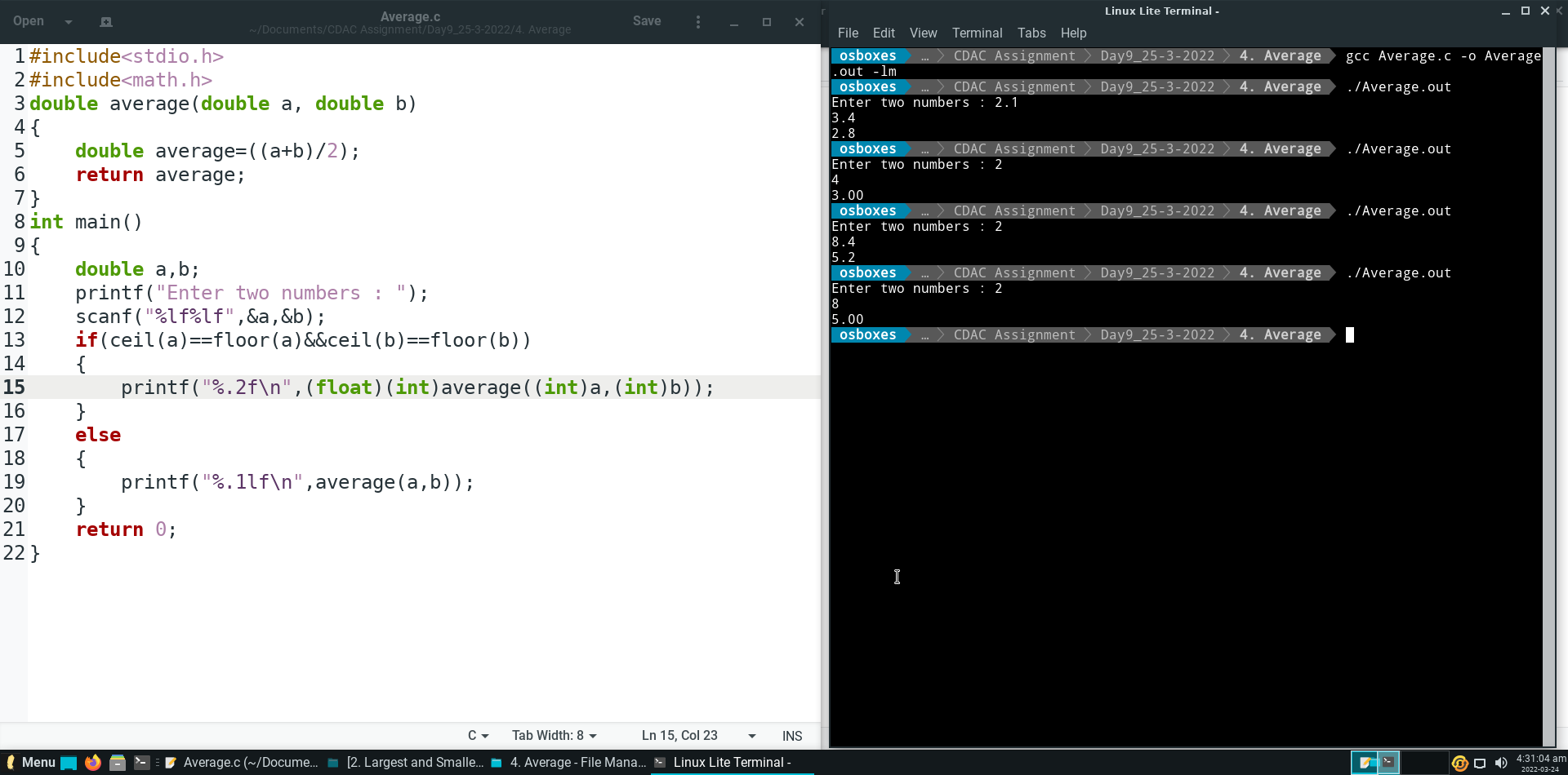

**Question 5.**

Write a program to use exp function from math.h

**Output :**

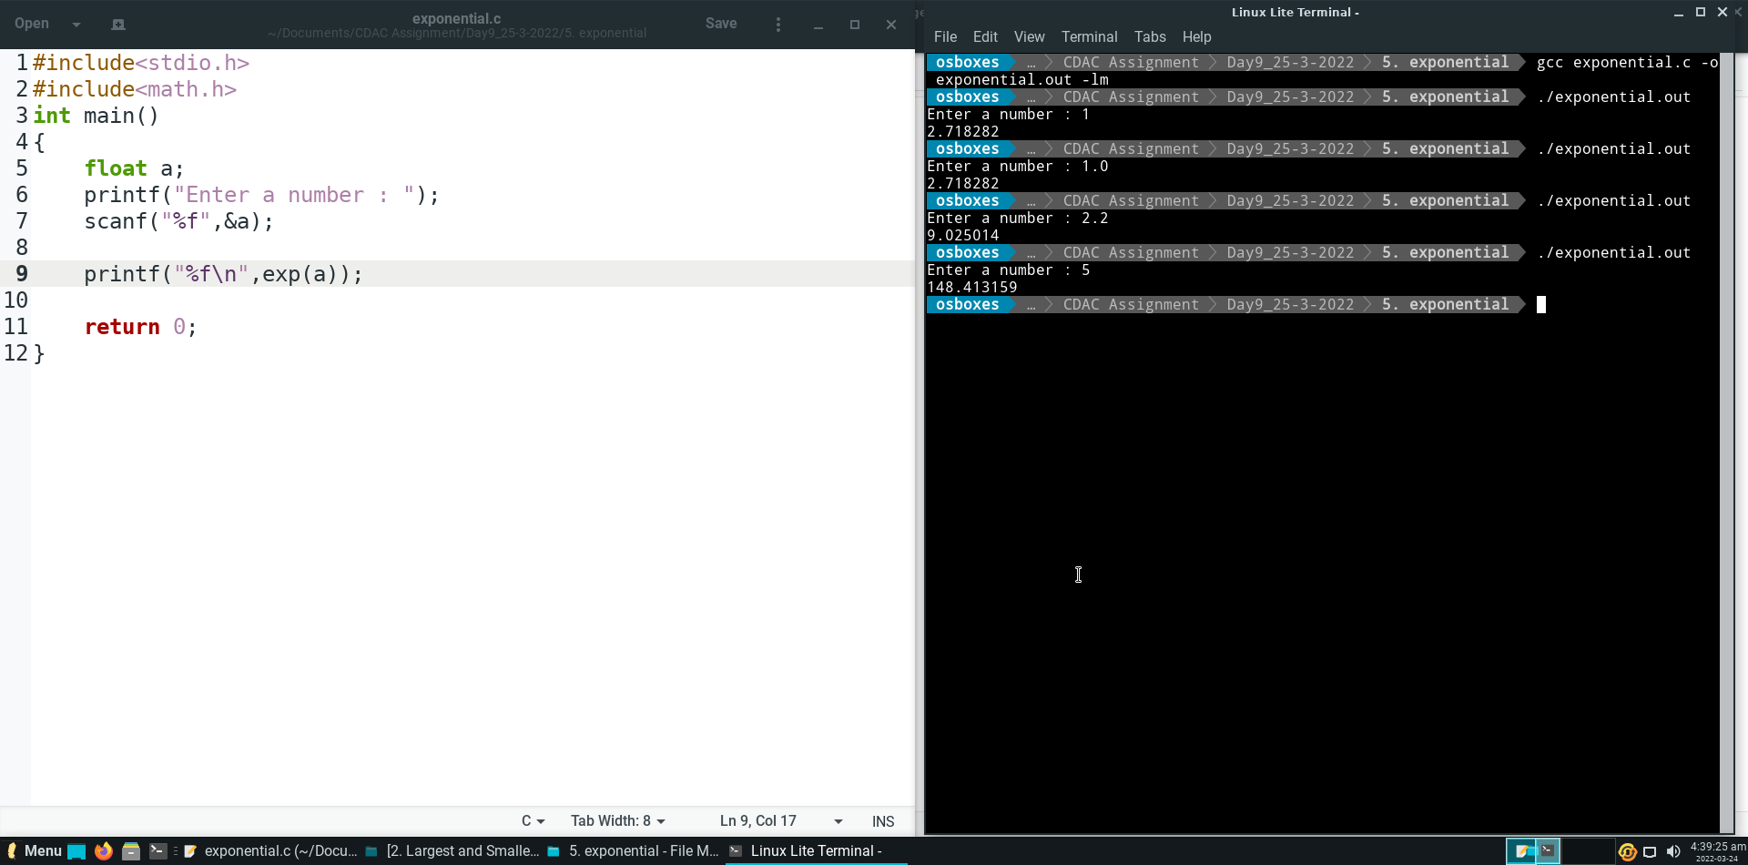

**Question 6.**

Write a program to print all the locations at which a particular element (taken as input) is found in a array and also print the total number of times it occurs in the array. The location starts from 1.

For example if there are 4 elements in the array 5 6 5 7. If the element to search is 5 then the output will be 5 is present at location 1 5 is present at location 3

**Output :**

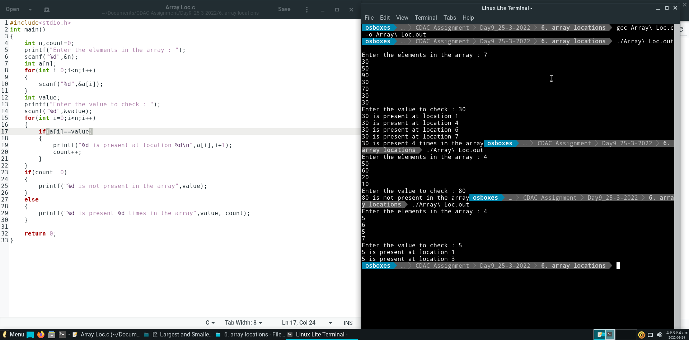

**Question 7.**

Write a C program to search a given element from a 1D array and display the position at which it is found by using linear search function. The index location starts from 1.

**Output :**

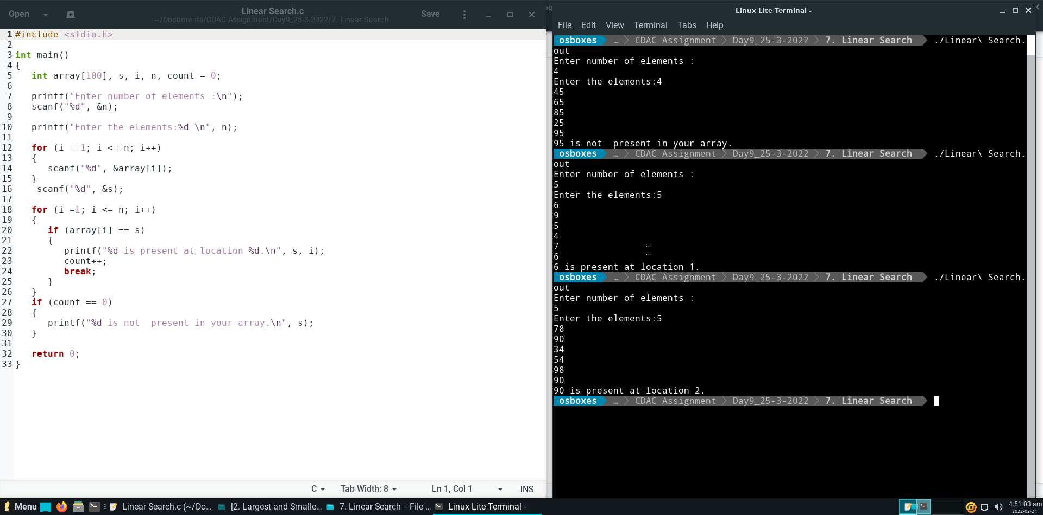

**Question 8.**

Write a C program to reverse an array by using another new array .

**Output :**

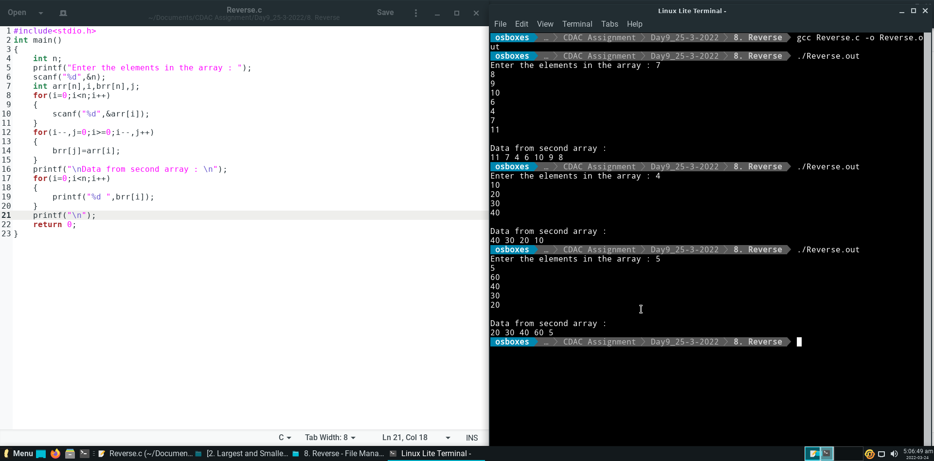

**Question 9.**

Write a C program to reverse an array by swapping the elements and without using any new array

**Output :**

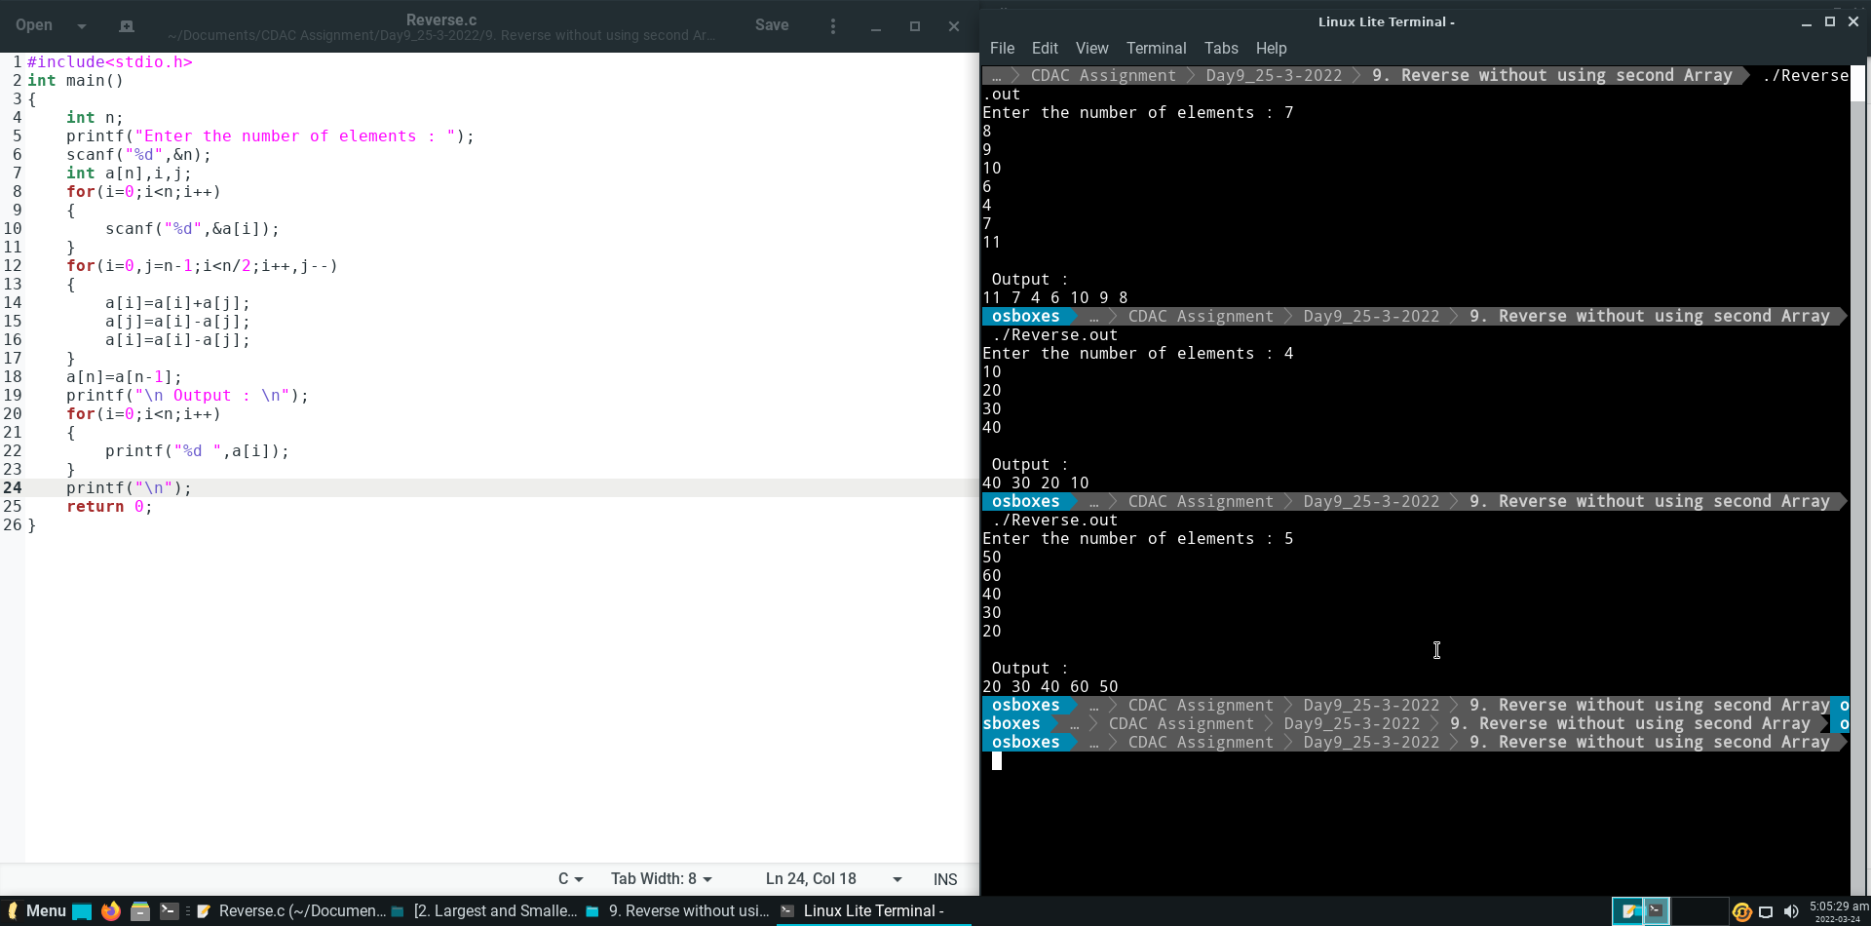

**DAY – 10 (Assignment – 9)**

Structures and Unions

**Question 1.**

Write a simple structure called student containing fields (int id, char gender and char name[size]; Create a variable of this structure(ex: std1), fill in the fields of this structure variable and use a pointer to std1 which changes the member values for std1.

**Code and Output :**

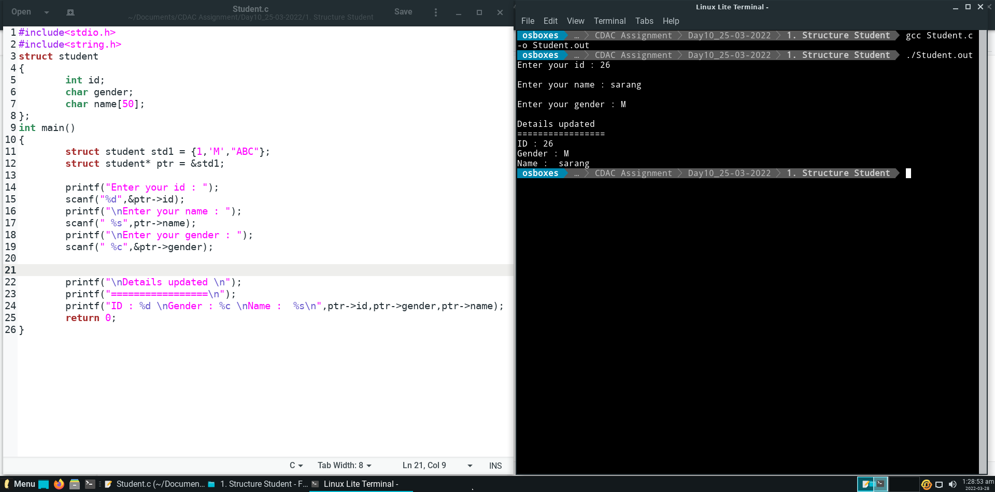

**Question 2.**

Define a structure type struct personal that would contain person name, date of joining and

salary using this structure to read this information of 5 people and print the same on screen.

**Code and Output :**

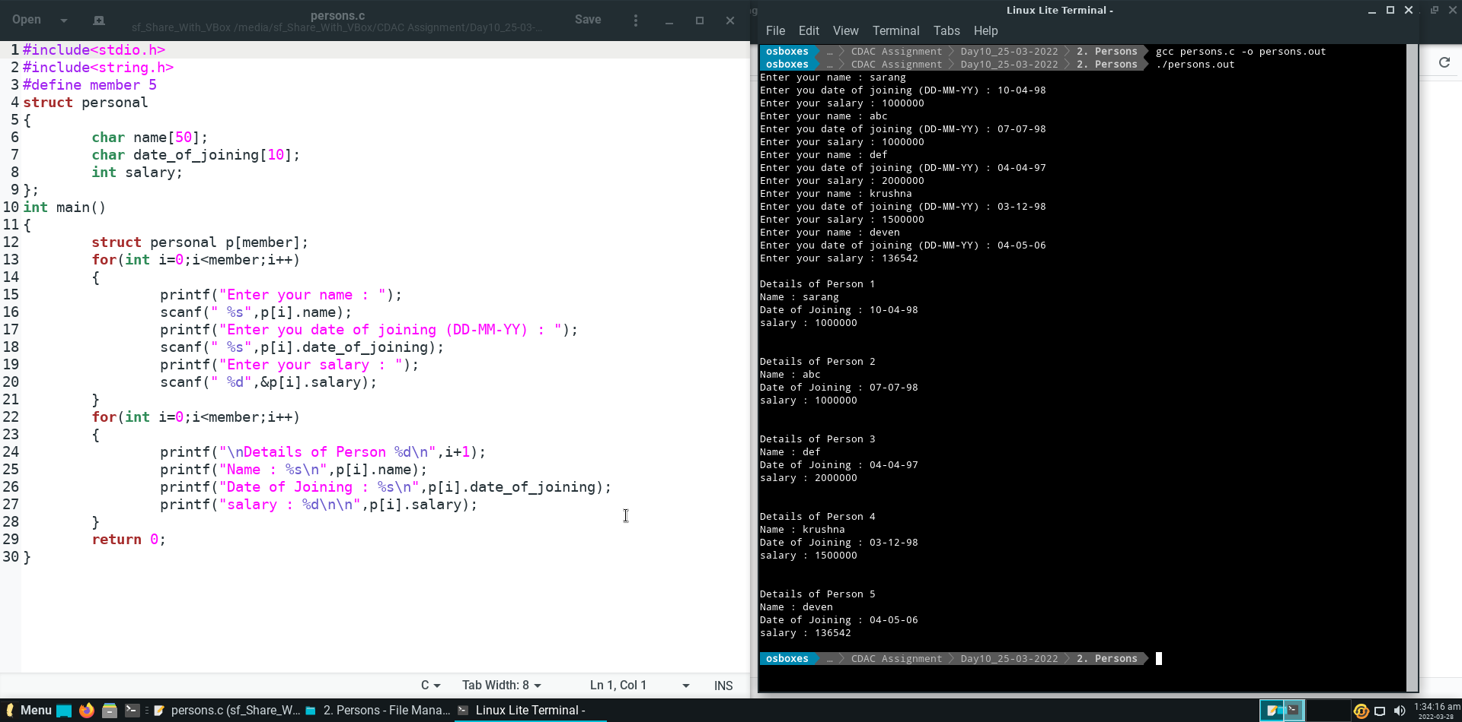

**Question 3.**

Define structure data type called time_struct containing three member’s integer hour, integer

minute and integer second. Develop a program that would assign values to the individual

number and display the time in the following format: 16: 40:51.

**Code and Output :**

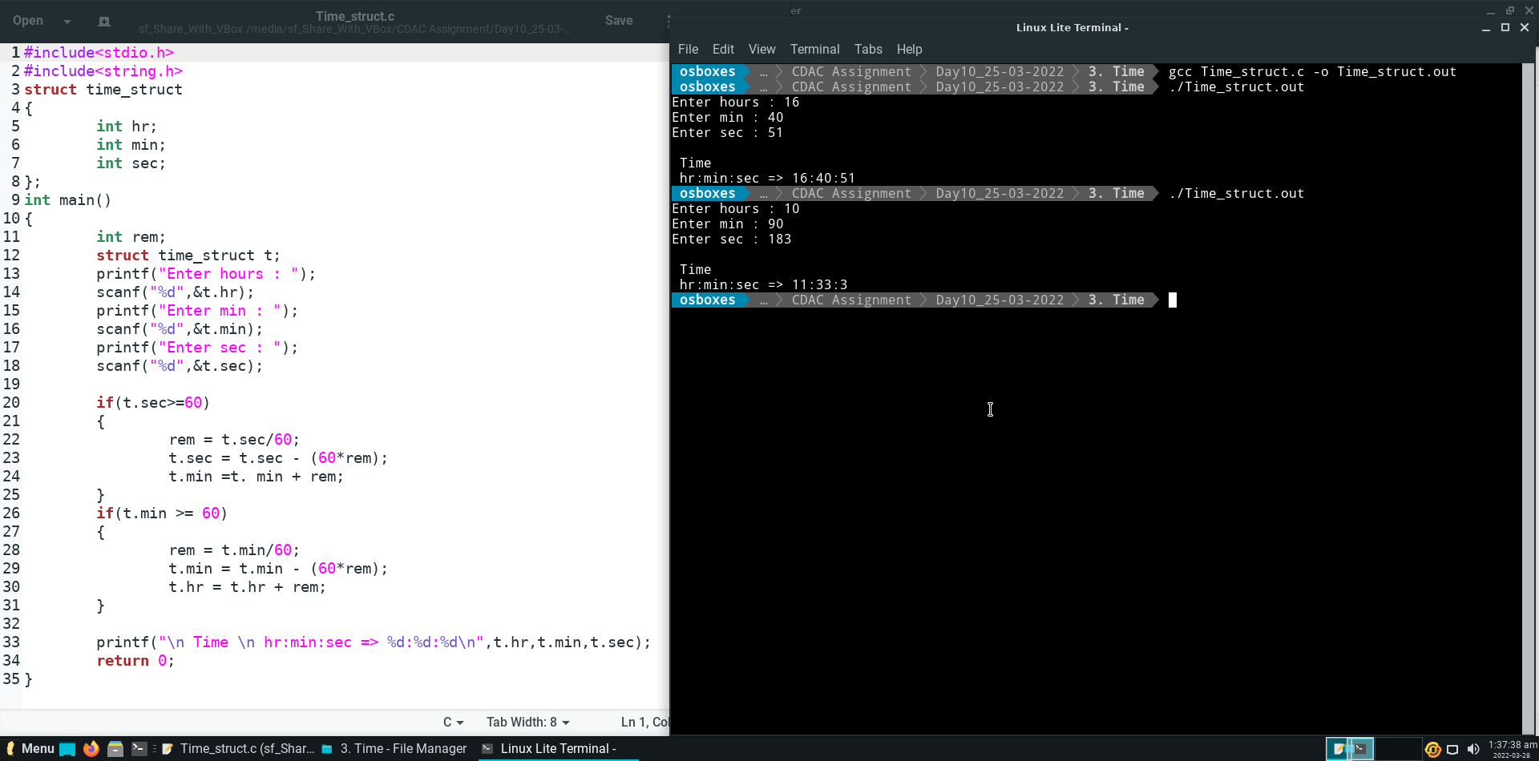

**Question 4.**

Define a structure called cricket that will describe the following information:

Player name, Team name, Batting average **.**

Using cricket, declare an array player with 50 elements and write a C program to read the

information about all the 50 players and print team-wise list containing names of players with

their batting average.

**Code and Output :**

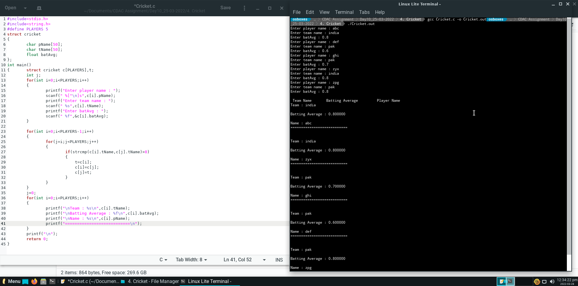

**Question 5.**

Design a structure student_record to contain name, branch and total marks obtained.

Develop a program to read data for 10 students in a class and print them.

**Code and Output :**

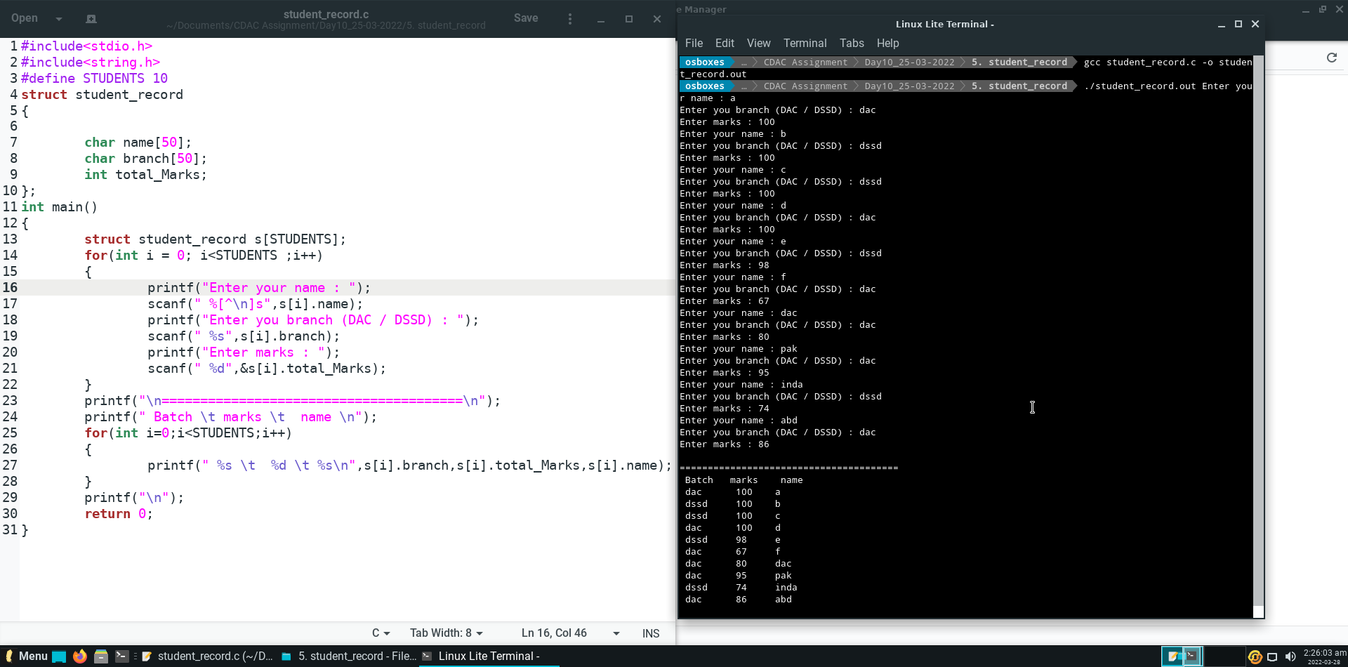

File handling

**Question 1.**

Write a program in C to write multiple lines in a text file.

**Code and Output :**

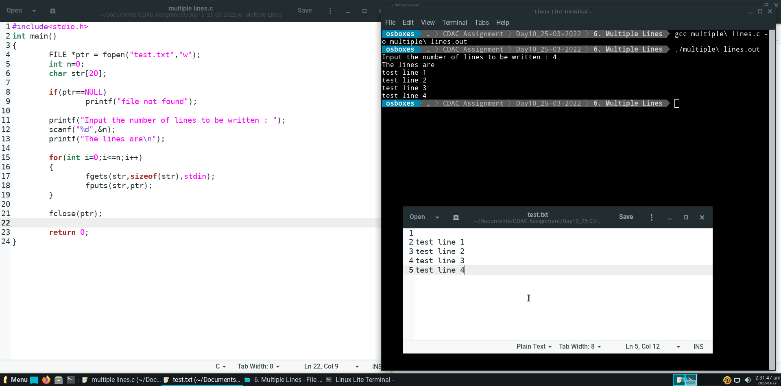

**Question 2.**

Write a program in C to read the file and store the lines into an array.

**Code and Output :**

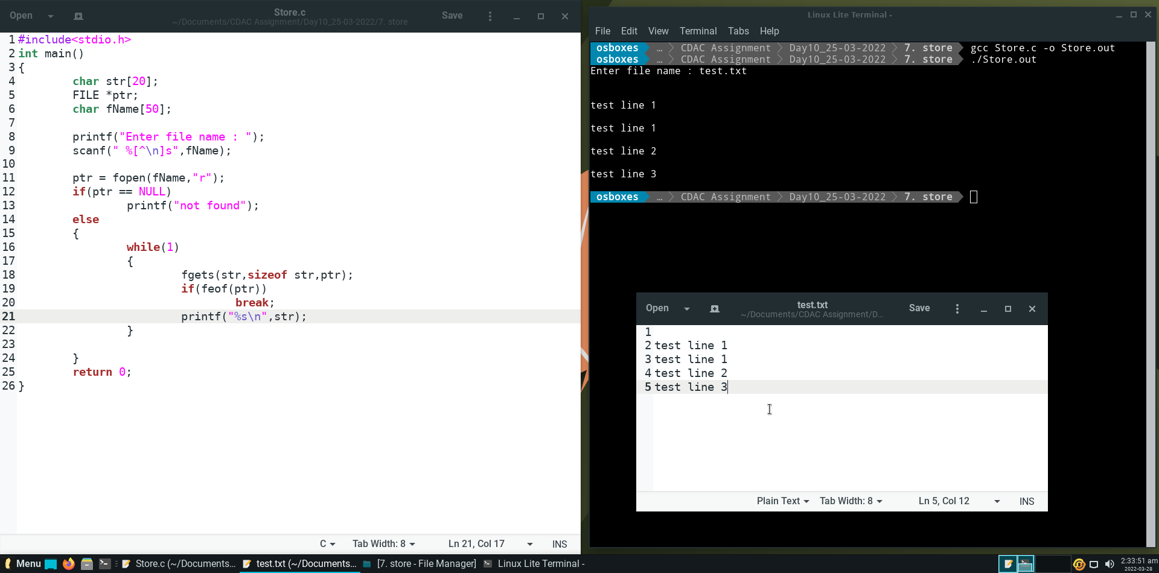

**Question 3.**

Write a program in C to count a number of words and characters in a file.

**Code and Output :**

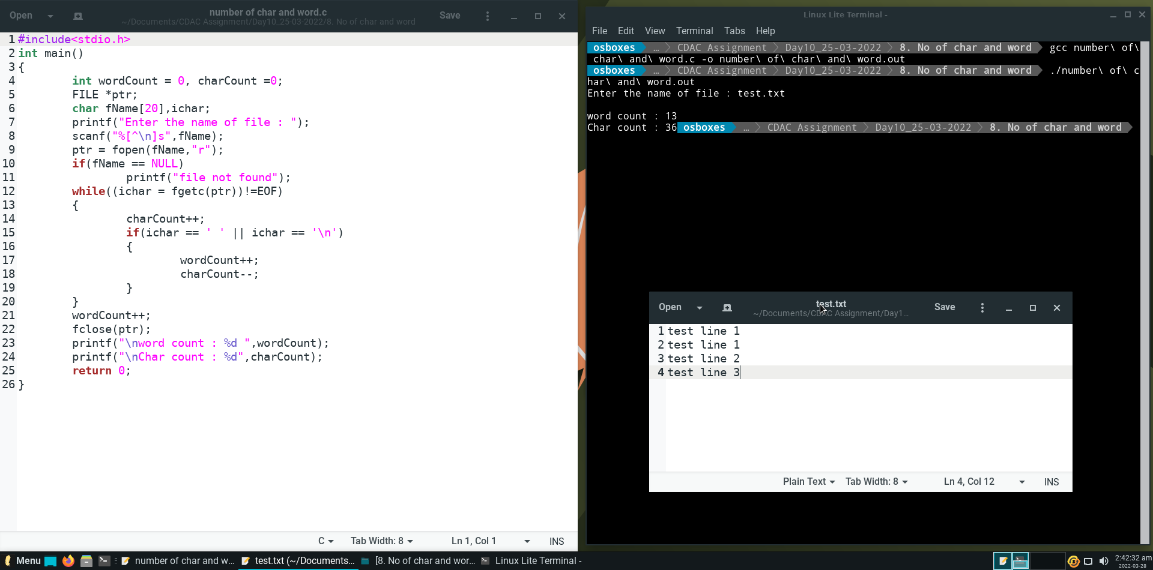

**Question 4.**

Write a program in C to copy a file in another name.

**Code and Output :**

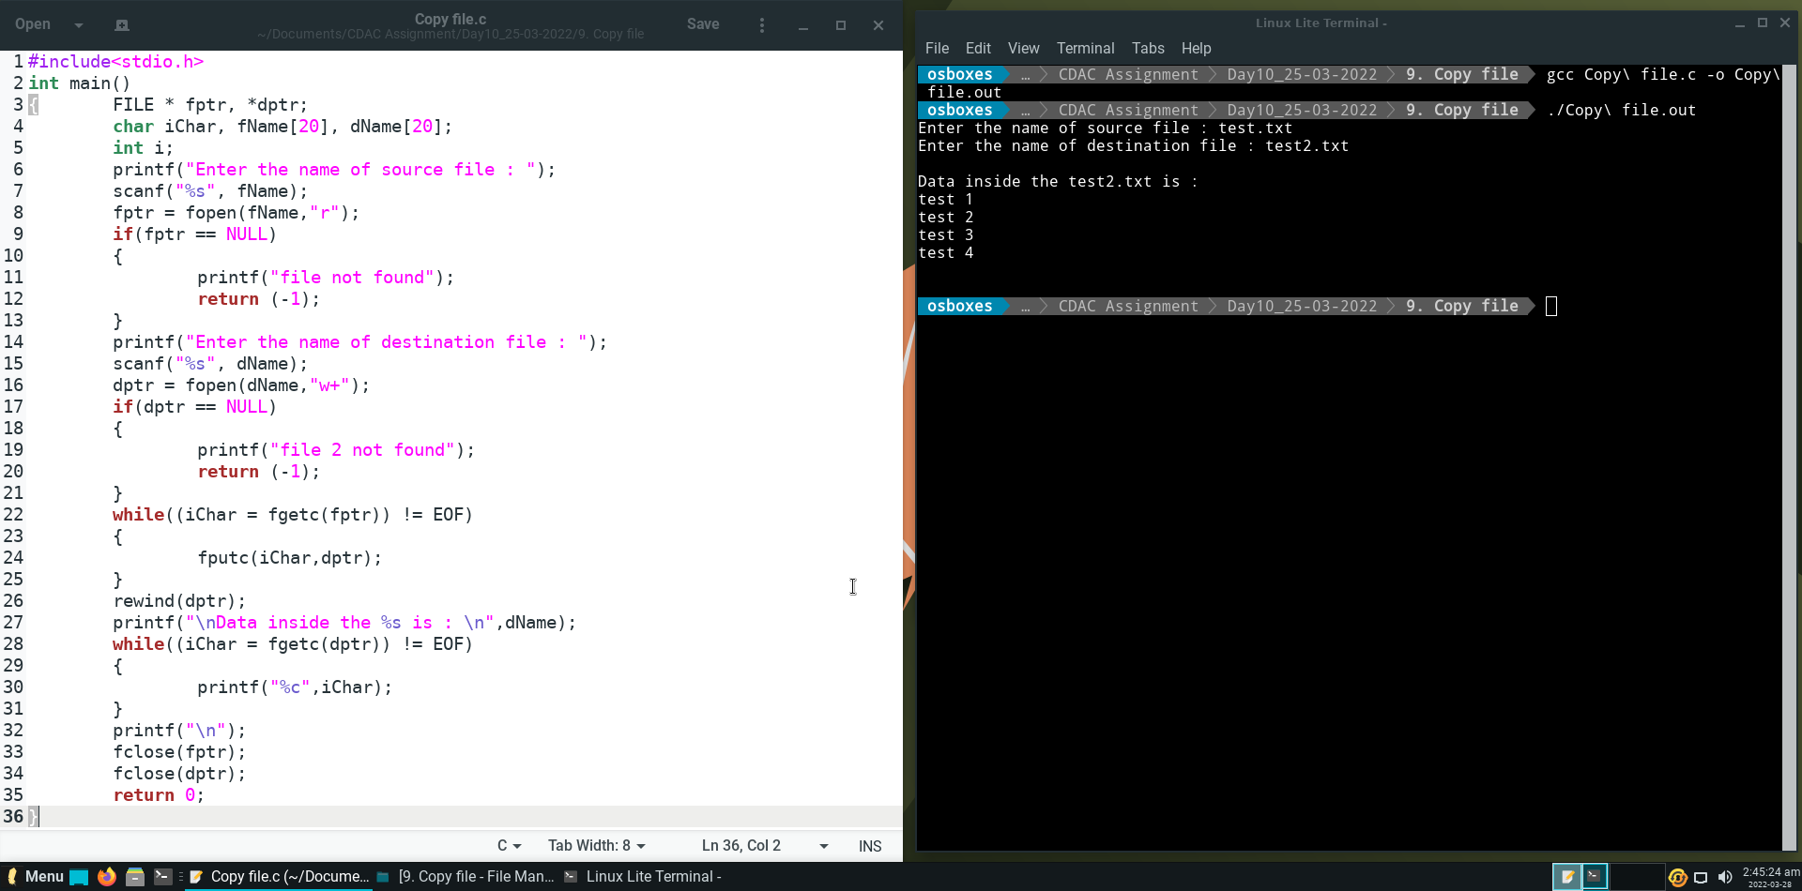

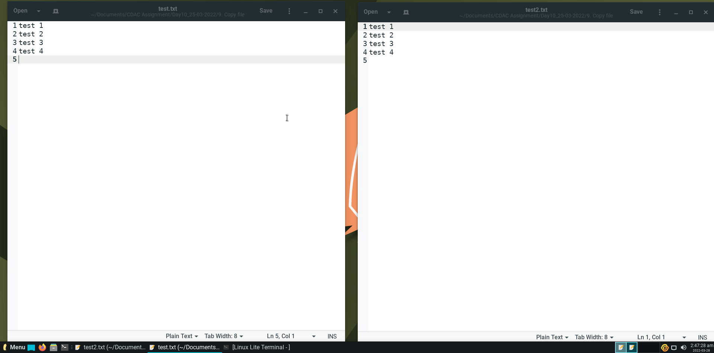

**Question 5.**

Write a program in C to replace a specific line with another text in a file.

**Code and Output :**

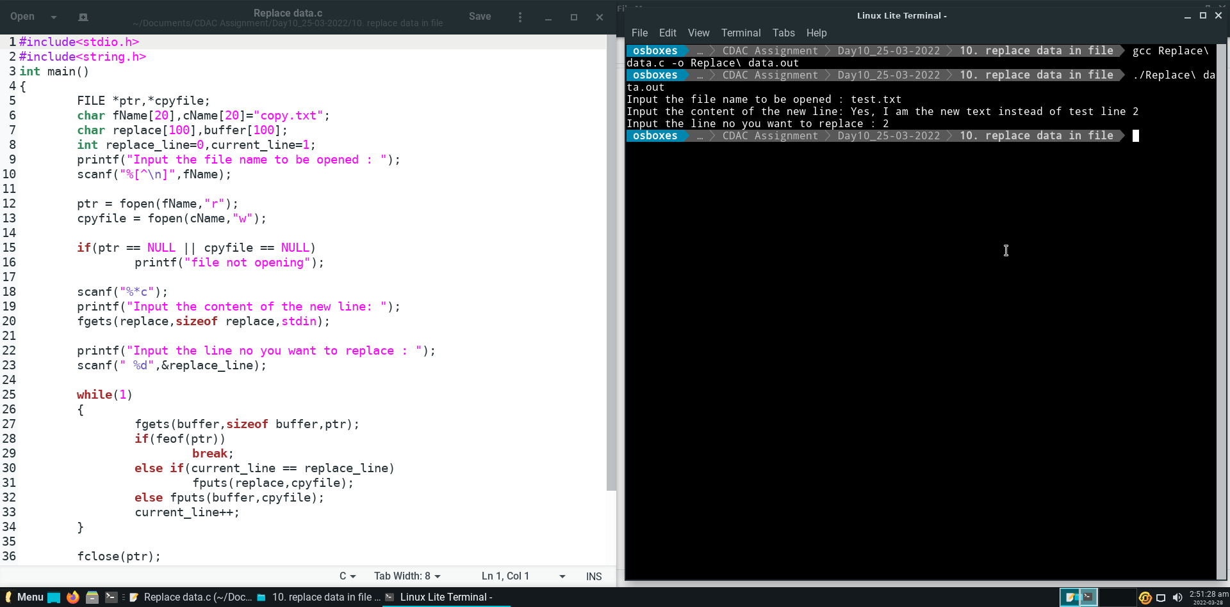

**Before After**

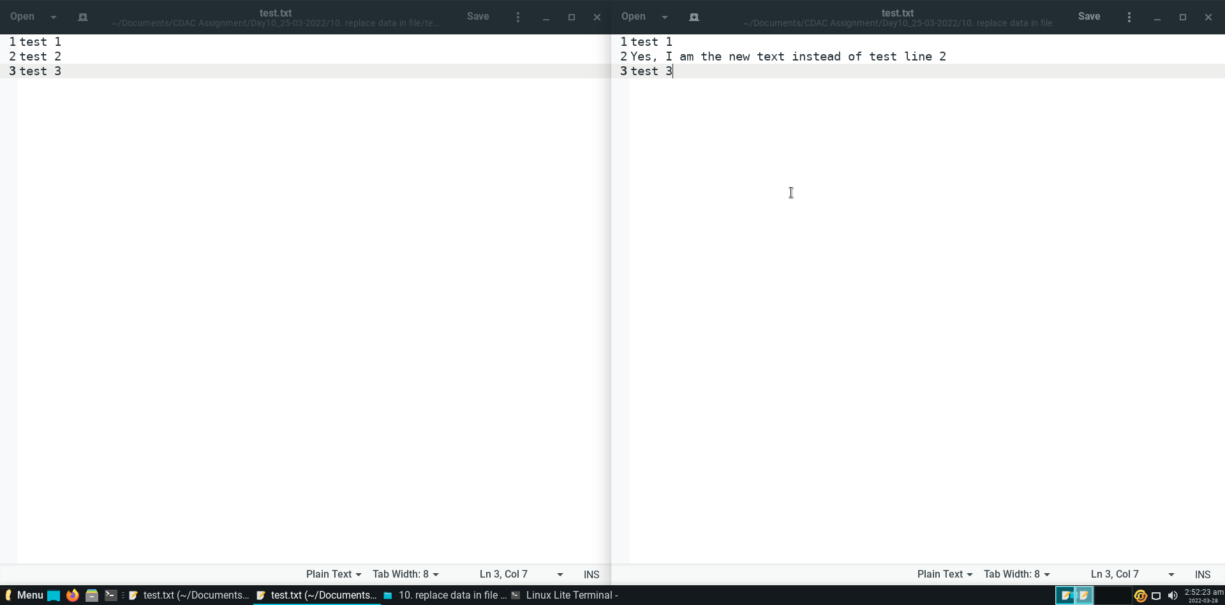

Preprocessor directives

**Question 1.**

Define a variable inside a header file, say “custom.h”, use this header file in your

program and then print the value of the variable defined in custom.h.

**Code and Output :**

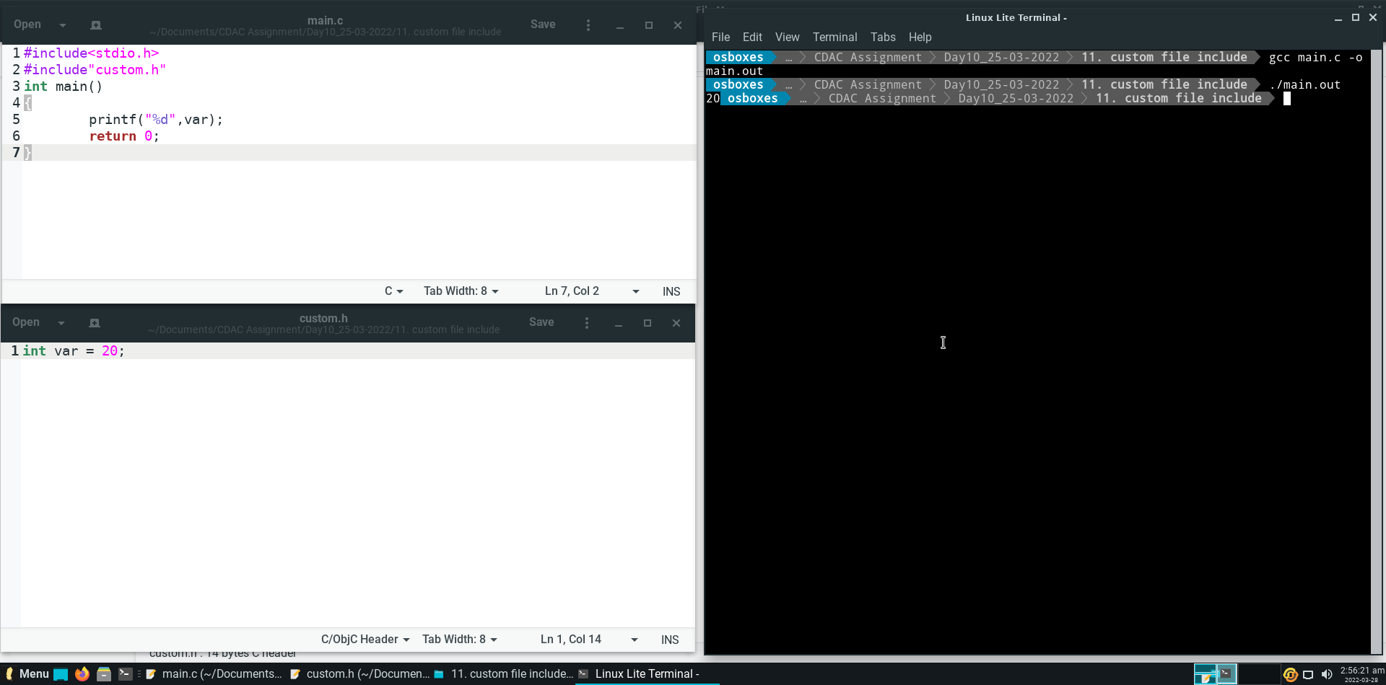

**Question 2.**

Using #define, declare a value, say PI = 3.14, and use it to calculate area of a circle,

given the radius.

**Code and Output :**

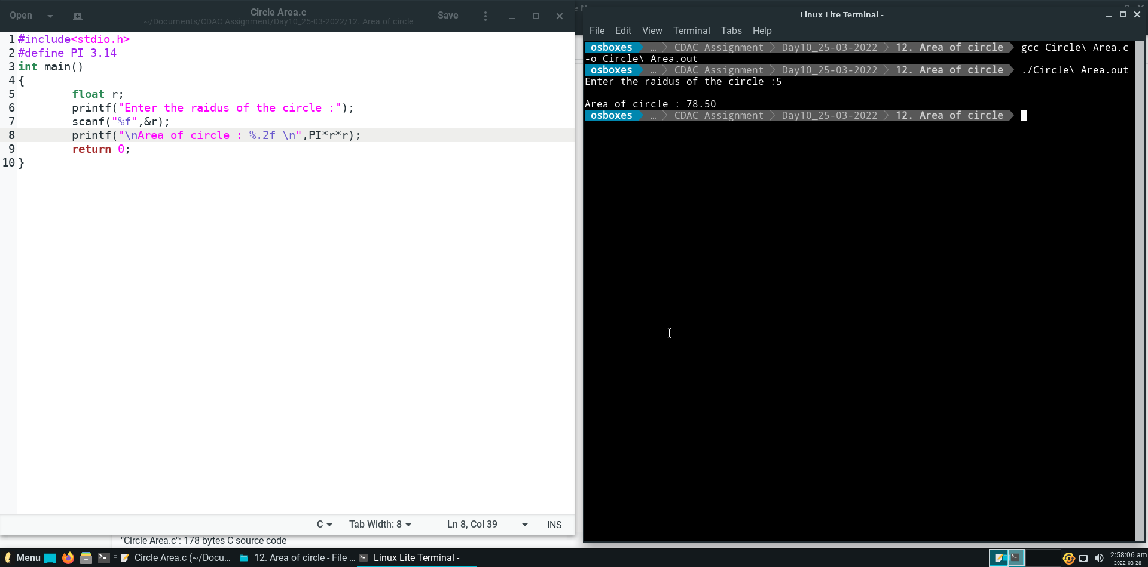

**Question 3.**

Write a for loop to print numbers from 1 to 20. The for loops has to be written as a

multiline macro.

**Code and Output :**

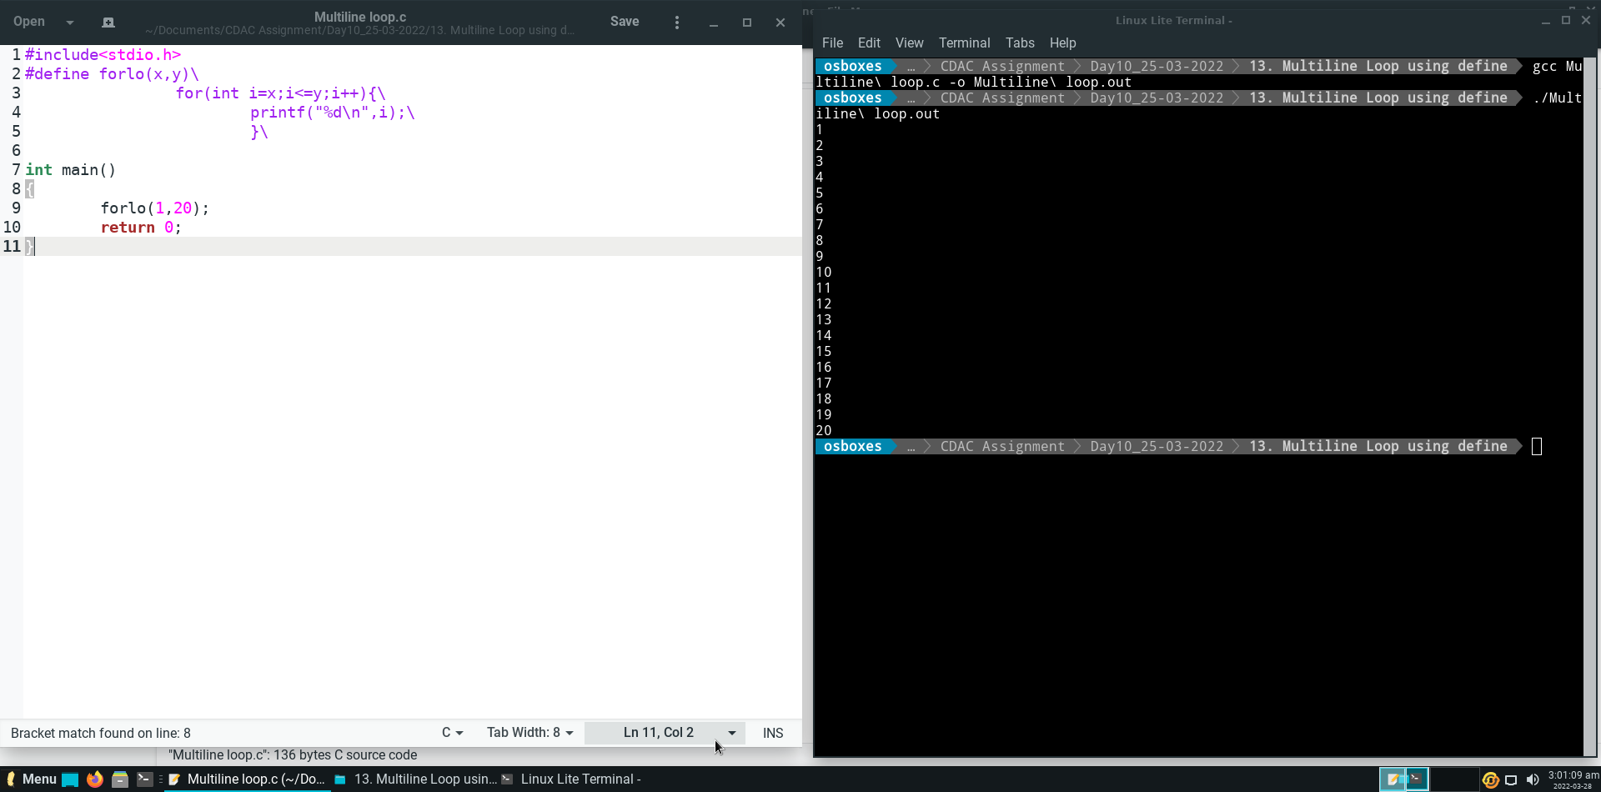

**Question 4.**

Give example usage of conditional compilation using #ifdef, #ifndef and #undef.

**Code and Output :**

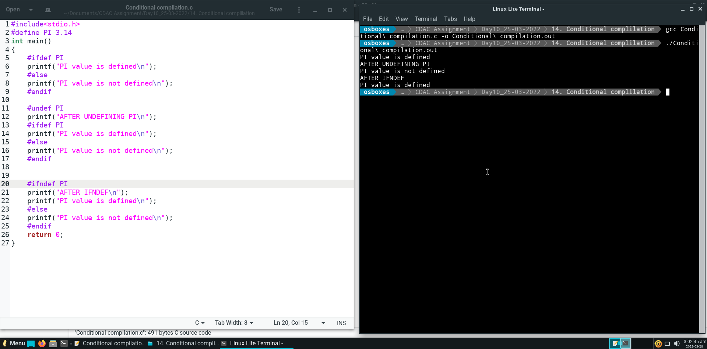

**Question 5.**

Concat two numbers to create a single number using ## operator:

**Code and Output :**

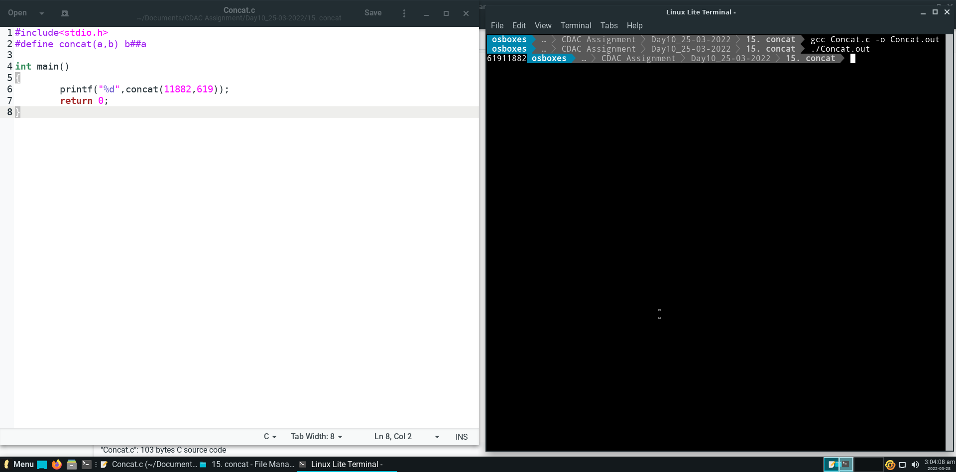

Storage Class Specifier

**Question 1.**

Using Static keyword, keep a count of the number of times a function was called.

**Code and Output :**

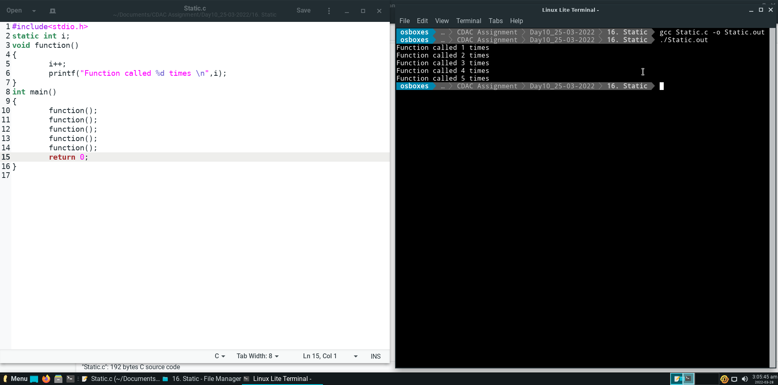

**Question 2.**

Using extern keywords, declare variable in another file(second.c) , and in another

file(first.c), utlize that variable.

**Code and Output :**

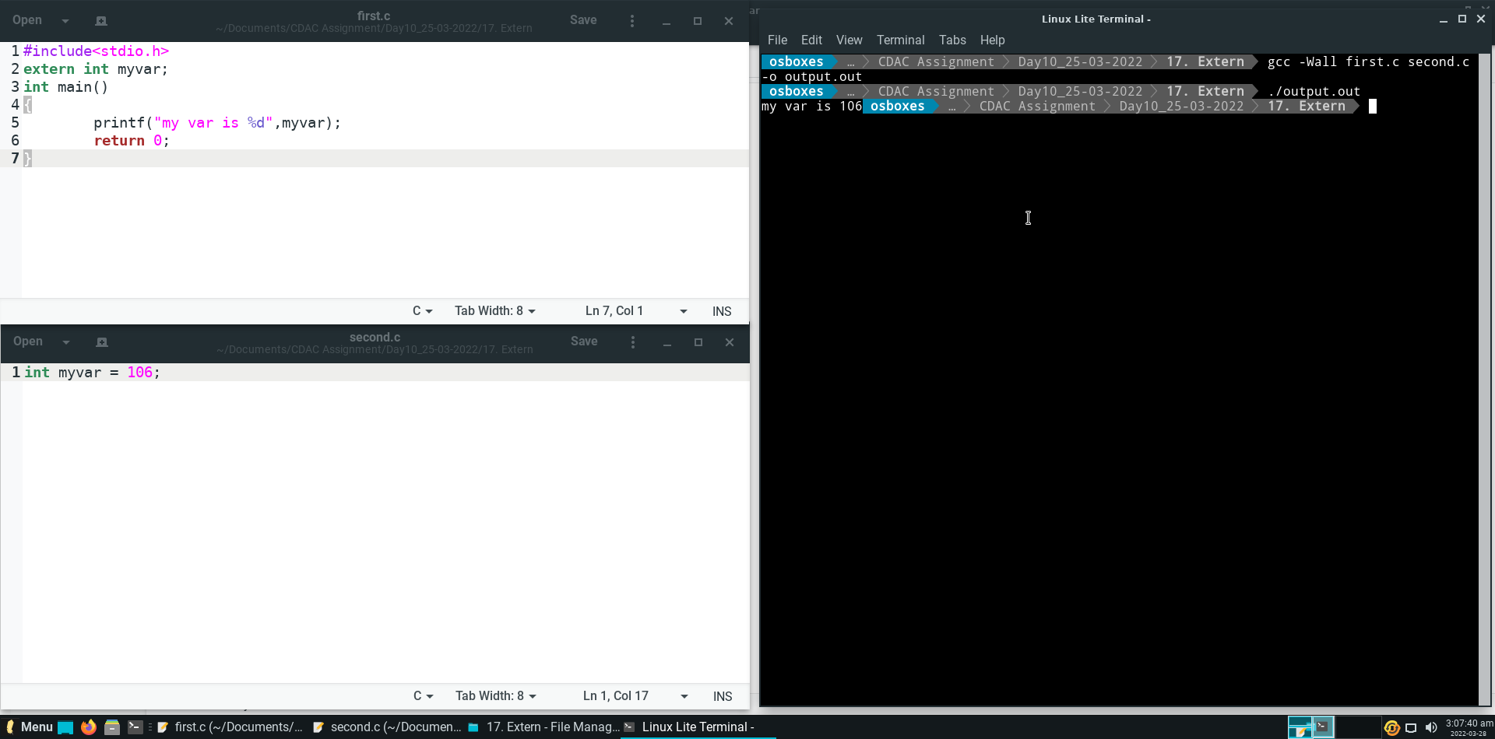

**Question 3.**

Can two functions have variables with the same name? Give example of they both have

different scopes.

**Code and Output :**

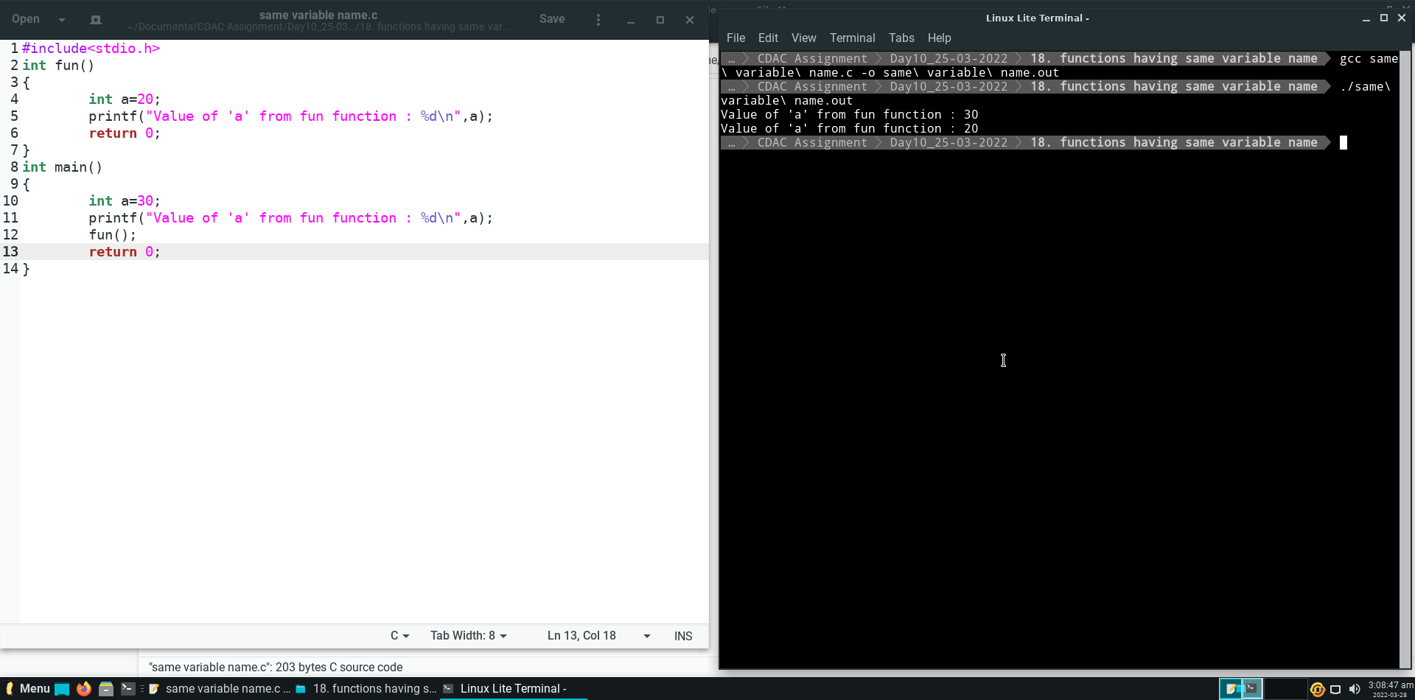

**Explanation :**

We can use variable with same name in different functions, because scope of these variable are limited to respective function.